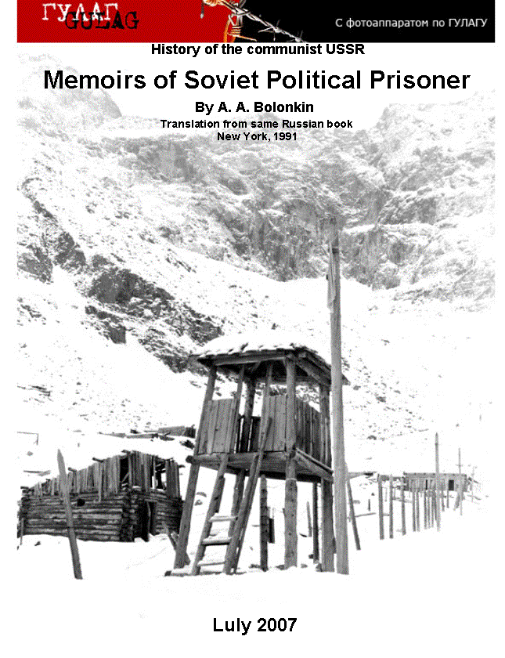

Memoirs_eng for Lulu 6 28 07

**History of the communist USSR**

**Memoirs of Soviet Political Prisoner (v3)**

**By A. A. Bolonkin**

**Translation from same Russian book**

**New York, 1991**

**The Third Edition**

**Lulu 2017**

**Title: Memories of Soviet Political Prisoner (v3)  
Autor: Alexander Bolonkin.**

ISBN 978-0-359-59090-2

Alexander Bolonkin worked in Soviet aviation, rocket and Space industries and lectured in main Soviet Universities about 15 years.

He lectured as a *professor* in Moscow Aviation Institute, Moscow Aviation Technological Institute, Bauman Highest Technical University, He contacted with Construction Bureaus of Tupolev, Yakovlev, Mikoyan, Ilushin, Sykhoy, with all main aviation, rocket and space research and design Centers of the USSR. He had many awards in the Soviet Union.

In 1972 professor Bolonkin was arrested the Soviet Secret Police (KGB) because he read forbidden political literature about freedom and democracy and listen in "Voice of America". More 15 years KGB tortures him into special prisons, concentration camps, and exile in Siberia. This period his life is described in this book.  
  
Copyright @ author

Publisher: USA, [www.lulu.com](http://www.lulu.com)

**Dr.Sci. Boris Kruglyak**

**Short Biography of Dr. Alexander Bolonkin**

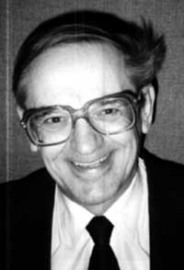

A. Bolonkin was born in (Russia). When he was young, he had   
 National and World records in aviation modelling and was awarded   
 with gold and silver medals. He graduated with awards from *Aviation   
 Collage*, Faculty of Aviation Engines, (**B.S.**)(USSR); *Kazan Aviation   
 Institute*, Faculty of Aircraft Design, (**M.S.**); *Kiev University*, Faculty of   
 Mathematics, (**M.S.**); *Moscow Aviation Institute,* Rocket Department,   
 dissertation ***"Optimal Trajectories of Multistate Rockets"*** (**Ph.D.,   
 Dr.Sci.**); *Leningrad Polytechnic University*, Aerospace Engineering   
 Department, dissertation ***"New Methods of Optimization and their   
 Applications"*** (**Post-Doctoral Degree in the former USSR**).  
 He worked in Soviet aviation, rocket and Space industries and   
 lectured in main Soviet University about 15 years. In particularity, in   
 Kiev Aircraft State Design Bureau headed by **O. Antonov**, Bolonkin   
 took part in design of aircraft AN-8 through AN-225 (*Engineer-Senior   
 Engineer-Chairman of Department*); in Rocket engine Construction   
 Bureau headed by Academician V.P. Glushko, Bolonkin was *Chairman of Reliability Department* and took part in design of rocket engines for main strategic rockets of the USSR; in TsAGI (Central Aero-Hydrodynamic Research Institute) A. Bolonkin was a *scientific researcher.* He lectured as a *professor* and worked as a Project Director in **Moscow Aviation Institute, Moscow Aviation Technological Institute, Bauman Highest Technical University**, Technological Institute, He contacted with Construction Bureaus of Tupolev, Yakovlev, Mikoyan, Ilushin, Sykhoy, with all main aviation, rocket and space research and design Centers of the USSR. He had many awards in the Soviet Union.

*In 1972 professor Bolonkin was arrested the Soviet Secret Police (KGB) because he read forbidden political literature about freedom and democracy and listen in "Voice of America". More 15 years KGB tortures him into special prisons, concentration camps, and exile in Siberia. This period his life is described in this book.* In 1988, Alexander Bolonkin arrived as a political refuge in the USA and became American citizen in 1994. He worked as a mathematician in Shearson Lehman Hutton (American Express), N.Y., (Research, computation, programming, Optimal portfolio of securities), a Senior Researcher in Courant Institute of Mathematical Sciences of New York University; two years as a Senior Research Associate in Wright Laboratory, Flight Dynamic Directorate (Dayton, Ohio), (it is the main Laboratory of the USA Air Force with over 20,000 scientists); as a professor in New Jersey Institute of Technology, Computer and Information Department. He worked as an expert of Association Engineers and Scientists in N.Y.C. (Estimation of new ideas, projects, patents. Consulting).  
 He worked two years as a Senior Research Associate in the NASA (Dryden Flight Research Center) in California, Edwards and two years as Senior Researcher in Eglin USA Air Force Base (Florida). Now Dr. Bolonkin lectures in New Jersey Institute of Technology.  
 For last four years alone, A. Bolonkin published more 35 scientific articles and books in the USA and a lot of articles in Russia-American press about scientific problems. He took part in three World Space Congress (1992, 1994, 1996), in World Aviation Congress (Los-Angeles, 1998, 1999) and more tens National Scientific Conferences in the USA. In particularly, he published monograph ***"Development of Soviet pocket engines for Strategic Missiles"***, Delphic Ass., USA, 1991, 133 p., and large Chapter ***"Aviation, motor, and Space Designs"*** in book "**Development Technology in the Soviet Union"**, pp.32-80, Delphic Ass., USA, 1990; book **“Non-Rocket Space Launch and Flight”**, by A. Bolonkin, Elsevier, 2006, 488 ps.; chapters: *Space Towers, Cable Anti-Gravitator, Electrostatic Levitation and Artificial Gravity* in collection **“Macro Engineering: A Challenge for the Future”**, edited by V. Badesky, R.B. Cathcart and R.D. Schuilling, Springer, 2006; book **“New Concepts, Ideas, Innovations in Aerospace and Technology”**, by A. Bolonkin, Nova, 2007; book "**Human Immortality and Electronic Civilization**", Lulu, 3-rd Edition, “**Macro-Projects: Environment and Technologies**”, NOVA, 2008 and others.   
 Alexander Bolonkin is the author of more 170 scientific articles (2007) and books and 17 inventions.

*B. Kruglyak, Ph.D.*

**Contents**

Preface

1. Soviet material well-being

1. Acceding to remedial activity
2. Propaganda leaflets

4. Arrest, investigation

1. Trial
2. Concentration camp JH-389/17а

7. Concentration camp hospital

1. Concentration camp JH-389/19
2. Penalty isolation ward and penalty cell (special prison)

10. Concentration camp in Barashevo

11. Road to exile

12*.* First exile

13. Second arrest

14. Ulan-Ude prison

15. Second trial. Concentration camp ОV-94/2

16. Third arrest and fabricating “a new case”

1. Second exile.

APPENDIX #1 according to the materials of radio station “Svoboda”/(“Freedom”)

1. “Amnesty International” Statement.

2. The leaflet of Civil Committee.

3. A. Bolinkin’s appeal to Chairmen of Soviet Supreme Council N. Podgorny.

4. Appeal of academician Sakharov in A. Bolonkin’s defense.

1. Appeal of Elena Bonner and other members of Moscow group “Helsinki” in A. Bolonkin’s defense.

6. From radio broadcast of radio station “Svoboda”.

7. Valreiy Rubin and Michael Litvinov, "To Alexander Bolonkin" /poems/. Russoan.  
 APPENDIX #2. Barbarities of communist secret police in the USSR  
 APPENDIX #3. Short Information of some persons mentioned in this book

**Sakharov A.D.** **-**  Academician

**Chernovol V.M**. — Ukrainian politician, Soviet dissident, journalist, one of the founders of the People's Rukh of   
 Ukraine, Hero of Ukraine (2000). Candidate in President of Ukraine (1991).   
 **Hayrikyan** P.A. - Armenian stateman, candidate in President of Armenian (2003)   
 **Soldatov S.I.** – politician, creator of Program “Democratic Movement of Soviet Union”.  
**Ogurtsov I.V.** – leader of the All-Russian Social-Christian Union for the Liberation of the People (VCXCON).

**Stus V.S.** – Ukrainian poet, hero of Ukraine.  
**Vlasov A.A**. - the head of the military organization of Soviet prisoners of war and immigrants — the Russian   
 Liberation Army (ROA).  
**The Norilsk uprising.  
Trofimov A.V.** – one of main executioners of Soviet people.

References

Alexander Bolonkin is a Doctor of Technical Sciences, specialist in aviation, rockets, and mathematics. He worked in experimental-design bureaus of O.K.Antonov, V.P.Glushko, taught in Moscow Aviation Institute, Moscow Aviation Technology Institute, and Moscow Technical University named Bauman. He is an author of more than 100 scientific works and 17 inventions. He was first arrested in 1972 on accusation of distributing works of academician A.D. Sakharov, writer A.I. Solzhenitsyn and others. He was sent to a concentration camp and then to exile where he spent 15 years. When perestroika began he was discharged and deported abroad. Now he lives in the USA.

**Candidate of Pedagogical Sciences (Ph.D.) Ivan Martynov**

Alexander Bolonkin had everything one can wish for: interesting job in the most prestigious sphere of space engineering, advanced degree of Doctor of Sciences, material well-being. He possessed all this and he resigned all this standing up against the regime in the years when the end of its existance couldn’t be predicted. He began struggling and lost everything. A new life of political prisoner, with all its dreadful aspects, began.  
 **Doctor of Historical Sciences (Ph.D.) Vladimir Gusarov**

"TWO LIVES OF ALEXANDER BOLONKIN – A SCOLAR AND A POLITIVAL PRISONER"

/From the series of programs of Russian-American radio in the USA /

/ 4 programs for 45 min. each/

**Preface**

The victory of democratic forces in the Soviet Union in August of 1991 had put an end to the bloodiest and the most dreadful regime in the history of humankind. It caused a death toll of 60 million people. The social order was based on total hypocrisy, falsehood, violation of the primary human rights and bloody repressions. The Communist party which had proclaimed itself to be the torch, the flag of all the labouring men ceased to be. The menace of basing our “bright future” and “people’s happiness” on the ashes of all the mankind in a contaminated by radiation world diminished.

We must remember, about this struggle, about the torments, sufferings and taken-away lives of people who were fighting against the existing regime in as it might seem hopeless situations.

Here are the short notes about my life in Soviet concentration camps and exiles. I’d like to apologize to the people I couldn’t mention about because of limited content. My full memoirs confiscated in 1982 by KGB haven’t been returned to me till now.

**1. Soviet material well being**

I was born in city Perm (middle Russia) and grew up, as most of Soviet children, in usual soviet poverty. My mother worked as a janitress, father died in 1936 in Soviet-Japanese encounter by Hankin-Goal (Mongolia). We lived in a small room of wooden hut with all the “conveniences” in the yard (as it is often said today).

I was an A-student beginning with the 4th form; I got interested in avia modelling quite early and took part in many competitions, held a series of all-Union records and even exceeded a World Record once. I graduated from Kasan Aviation Institute with GPA = 5 (excellent) and was sent to work to Research and Development Bureau of O.K. Antonov (in Kiev), where I bettered to the leading engineer-designer of flying data quite soon and took part in engineering Soviet planes from АN-8 to АN-124. Simultaneously I was studying on the mechanical-mathematical faculty of Kiev University, than I entered the postgraduate study of Moscow Aviation Institute.

After I defended a Doctor Thesis in 1964, I worked in Research and Development Bureau of ocket engines of academician V.P.Glushko, than I taught in Moscow Aviation Institute, in Moscow Aviation Technology University and in Moscow Technical University named Bauman. In 1971 I upheld a Post-Doctor Dissertation on Cybernetics.

By the middle of the 1972 I published more then 40 scientific works and books.

Being a scientist I saw a lot of troubles and senseless things in the Soviet System, but having no other information except the official propaganda I related them to the personal drawbacks of several people. I assumed that the aims of the socialism are honourable, the successes are great and in the length of time everything will be O.K., because the Communist Party had promised in 1962 to build Communism by 1980. My mother told me about the fear that people felt in the 30-s, when at nights prison-vans, so called “Black Maria or black crow” were taking people away. But I believed in communists’ statements that these were Stalin anomalies and they wouldn’t repeat again.

1. **Acceding to remedial activity**

In 1970 I got acquainted with Jury Jukhnivets. He said to me that he was a student of Moscow University, but he was expelled from there for critical speeches and then he was working as a loader. He told me something about the movement for right in the Soviet and offered me some samizdat[1] materials, particularly the ***“Chronicle of Current Events”*** – a magazine with information about the clandestine repressions in the USSR published on typewriter.

Truly speaking, I was filling up with horror reading that data. I was shocked by the cruelty which those “fighters for people’s happiness” (as the powers proclaimed themselves to be) were chasing people, showing other views or just interchanging some disagreeable information.

Soon Jukhnivets asked me to keep samizdat and prohibited literature for some time. He couldn’t keep it at home, because he was registered in KGB. He brought a whole trunk and I was reading it for a month without a break. I learnt about the activity of the Party and its “most honorable” and “most prominent” leaders, about such things which my hair stood on end from and all the Nazi crimes paled beside them. Being grown by the Soviet school in the spirit of fighting for happiness of the working class I saw that the worst enemies of that class were the Communist Party and its leaders, that the greatest defraudation in the history of mankind was taking place.

I decided to help that movement by everything I could. By that time Jukhnivets acquainted me with Valery Balakirev, a teacher at collage. And he in his turn acquainted me with his friend, engineer-electrician, Vladimir Shaklein. They were both registered in KGB for signing a row of protests against violating human rights in the USSR.

Balakirev introduced me to a geologist from Leningrad, Georgy Davydov and his wife Lera Isakiva. Georgy was once arrested for keeping the forbidden literature and KGB gave his neighbours instructions to spy on him.

One of my acquaintances, who knew about my interest to the forbidden literature, sent to me a student, Sergey Zarya, who was interested in it too and, on his own showing, was expelled from the University for the attempt of creating illegal group.

I was quite a good photographer and I quickly learnt reproduction. By that time some seditious works began to come to the intellectual Soviet would-be users from abroad. They cost extremely high. It became more profitable to the seamen of the foreign trade fleet, to tourists and people on assignment trips to bring the political literature rather than pantyhose and electronic watches. Of course, it was more dangerous than an ordinary contraband, but the gainings were higher.

One to three books were enough for an intellectual to begin changing literature on the principle: you give me this; I give you that just for reading. This process was greatly simplified for us. Usually one needs weeks for careful reading a thick book. But people reluctantly gave such books for long terms (that literature was in demand!), one could easily get samizdat book just for one or two evenings. This was a usual task of Valery Balakirev. But Jury Jukhnivets brought a lot literature too.

Having got the book for several hours they rushed to me, I put the book under the self-made reproducing installation and re-photographed it for 1 or 2 hours. The reading of the contents began frequently after photo-printing and the book was returned to the author.

Using that method we made photo-films and copies of many foreign books, periodicals, samizdat materials and abroad magazines. For example, the book of Conquest “The Great Terror”, Avtorkhanov’s “Technology of Power”, Djilas “The New Class”, Marchenko “My testimony”, Berdyaev “The Origin of the Russian Communism”, foreign magazines “Posev”, “Grani”, “Vestnik PSKHD”[2] and Soviet backstreet magazines such as the “Chronicle of Current Events”, “Svobodnaya Mysl” (*Free thinking* ), “Democrat”, “Luch svobodi” (*The Beam of Freedom*), “Veche”(“Meeting”) and so on.

By that time Balakirev made acquaintance with the son of ideological worker of Central Committee of Communist Party of the Soviet Union. With his help he received Soviet illegal typographical translations of foreign political books. In particular, by that way we got photo-film and photo-copy of Willy Shikling “Khrushchev’s hand organ. Getting in mankind's hair”, translated from German, published by “Progress” Publishing House, 1964, 144 pages. (It was the book about Khrushchev’s methods of propaganda). We also got the full publication of Gaulle’s “Memoirs” (France President). The last book was later published in the USSR with big cutting out.

Soon we collected quite a wide library consisting of hundreds, if not thousands of illegal books.

Photo-films were convenient because everybody could make the necessary number of printings himself.

Certainly, everything read was not taken on trust. I aimed to check what possible by myself. In one of samizdat compositions I came across a phrase that the first five-year plan was not fulfilled. Just on that time on my Department of Mathematics in the Moscow Technical University there were special celebrations devoted to the successful fulfillment of the regular five-year plan (1965-1970). I took a newspaper of 1965 with the directives for 1970 and a newspaper of 1971 with the information about the succeeded results. From 47 indices mentioned only 3 secondary were fulfilled. For example, the plan of selling of furniture (in rubles) was carried out (and even exceeded). But the compilers of the report “forgot” to write that the plan was exceeded by the rise in prices for furniture.

Many important issues were done only for 15-20%, though in general concerning the quantity of production the plan was fulfilled for approximately 50%.

I was shocked by the insolence of the authorities and surprised by the naivety of the people. At the official meetings Communist Functionaries were saying about the grand progress, about the successful fulfillment of the five-year plans and none of the educated people, not to mention ordinary working class, had a single thought to compare the pre-arranged and the succeeded indices! In consequence I assured myself the same was about any other Soviet five-year plan. Neither of them was exceeded or just fulfilled by half.

The terrible blow was checking of plan of “Building Communism” by 1980, taken on the 22d congress of the C.P.S.U. in 1961. There were given halfway indices which must have been reached in 1970. Neither of them was fulfilled. At best the fulfillment was 15-20%. Not only the students and the pupils but also all the working class were made to learn the program of “Building Communism” by heart. I don’t remember a case when somebody tried to check the statements about its successful fulfillment and tried to compare the planned and the reached points.

Second thing, I tried to check a Soviet asseveration about the unprecedented growth of soviet welfare after the “socialistic revolution” and the awful poverty of working people in the countries of the “rotten capitalism”. In particular, I decided to test the communistic saying that from 1913 to 1970 the payment of soviet workman had become 180 times bigger. (All the data I give from memory). Even if Russian workers were poor in 1913, they were not dying of hunger and the increase of payment in 180 times would bring the upper wealth in the world. My common sense prompted me to compare the prices to the major products and to the articles of prime necessity.

I tried to find the information about prices and payments in the USA and in the West countries in Soviet literature. But all that was in vain. All the Soviet sources were full of statements about poverty, unemployment, lack of dwelling in the “countries of capital”, but there were no exact numbers. After reading such literature I wondered, how the people of the country hadn’t died out of starvation.

By that time I got to know that there was a special room № 13 in the Lenin Library (Central Federal Library in Moscow). There one could find forbidden literature just for “officials” to use. That room turned to be located at the upper store of the library in the service department. One had to go through very long passages to get there. It was explained to me that to use those literature I had to get a special application from my Institute with the name of the research. An access to the special fund was usually given for one year.

I made such an application to the theme “The research of growing wealth of Soviet people” and became the reader of that special fund. There I had written out many secret statistic data about the state of health of the soviet people, about the cancer, tuberculosis, sickness rate, rate of venereal diseases, mental disorders, about alcoholism and drug addiction. I found the information about lack of medical staff, hospital wards, medicines, about the quantity of lunatic asylums, so-called “treatment-and-labour clinics for alcoholics” (i.e. concentration camps for alcoholics).

There were the data about the prices at the kolkhoz markets of the country and secret reports of people sent on mission to other countries.

Unfortunately the information about the wages and retail prices to articles of prime necessity was absent even there.

Finally I managed to get foreign statistic compendiums and works of the UN that contained the required material.

In the upshot I wrote a profound research work ***“The Comparison of Living Standards of Working Class in Russia, the Soviet Union and the Capitalistic Countries”,*** articles ***“Public Health in the USSR and in foreign countries”, “About the Results of the 8th five-year plan of 1966-1970”, “Comparing the Results of the First Decade of «Building Communism» to the pre-arranged indices of the 22d Congress of C.P.S.U.”*** and other informational materials.

Besides together with Balakirev we began publishing social and political magazine **“Svobodnaya Mysl”** (*Free thinking)* which was mimeographed in great quantities. One of the issues of that magazine came abroad and was published in the collection of works “Volnoe slovo” (*“Free speech”)* № 7, Posev, 1973.

Some samizdat works, mostly magazines, were typed on typewriter. The copies were indistinct and hard to read. I realized that the movement against violating human rights was doomed to be an eternal amusement of the few intellectuals without proper copyprinters. But where could one find a copyprinting machine in the country, where all the copiers were affixed with seals at night and placed in the special rooms where only proved KGB members could work on it. There was the only decision – to make the machine ourselves. It had to be easy to make and quite efficient.

For a long time I was sitting in the Lenin Library. In the Soviet times such literature was not published and it is clear that a prudent KGB tried to seize all the pre-revolutionary articles (before 1917) devoted to the theme. Still I found some information in the belles-lettres, old licences (patents). At the same time I learnt about the methods of enciphering, cryptography and conspiracy. All that was collected in the samizdat book of Sukhov ***“Simple Methods of Copying Technical Documentation”*** and in the series of samizdat articles devoted to the methods of copying, enciphering, cryptography and conspiracy.

I invented the method of mimeography almost anew; I technically worked the method up, making it simple and effective.

The text was typed on the fibrous paper sodden with paraffin with the help of typewriter. The obtained matrix was put on the bland print and was pressed by the roller with paint. There appeared a copy below. All the process took few seconds. The components were sold at stores. Anybody could make or buy a photoroller. Indeed the quality of the imprints was quite low.

I ordered 7 or 8 rubber rollers to one of the skilled workmen of MHTU[3], gave them to Balakirev, Ukhnovez, Davydov, Zarya, Shaklein and taught them how to use the device. It was simple; actually it was made of the rubber roller only. Later KGB didn’t draw its attention to that roller when conducting a search of Georgy Davydov’s apartment in Leningrad.

After the invention of that device the ***“***Chronicle of Current Events***”***, underground magazines were published in hundred of copies in our group, not to mention other. We began publishing social and politic magazine ***“Svobodnaya mysl”*** (“Free Thinking”); I began issuing my book “The Comparison of Living Standards of Working Class in Tsar Russia, USSR and in Capitalistic Countries”; and Balakirev started printing in parts the book of Conquest ***“The Great Terror”***. Almost everything was distributed free of charge and I incurred all the main expenses as I was the most well-off person. Zarya even rented a flat, enlisted his friend Rybalko and organized a real printing-house. Unfortunately, he acted of selfish ends and he sold secretly the printed literature to outsiders on very high prices. Till the arrestment our group had copied more than 150 000 pages of the forbidden political literature and phototakes.

Soviet authorities became anxious when mimeographed prohibited magazines, books began running all over the country and searches seized not one single book but the whole editions. They understood quite well that one couldn’t be a great propagandist producing 4-5 copies. But when almost everyone could make hundreds and thousands of copies without difficulty, that underground freedom of press could undermine the existing regime. Every member of KGB was enlisted and All-Union hunting began.

By that time I was registered in KGB as a reader of forbidden literature. In Leningrad I showed some samizdat material to V.Senyukov - sister-in-law’s husband. He was very interested and asked me to give him to reprint some material. I gave him the literature under the stipulation that he wouldn’t show it to his wife, Valentina. He hadn’t kept his promise. She brought the article ***“The Daughter of the Tyrant”*** (about Stalin’s daughter) to work, to boast before her friend. Then she remembered that friend’s uncle works in KGB ran home and burnt everything in panic. When she was called to KGB, she told that her husband received that literature from me. Still she said nothing to him about the summons. When he was pulled about, as though to social insurance company, he gave me in his fright away, but he was courageous enough to ring me up to Moscow and to say about that.

**3. Propaganda leaflets**

In June 1, 1972 it was 10 years from the day of great rise in prices for foodstuff in 1962. During that rise our Soviet officials swore that it was temporary and *“two or three years would pass and the prices would be set even lower than they were”.*

Yuri Jukhnovets decided to print and to distribute propaganda leaflets devoted to that event. I tried to dissuade him from that idea but he was resolute. He asked me to help him to draw up the text (which he later rewrote replacing facts by emotions) and to print several copies. About 3500 leaflets were made then.

On the night of the 1st June, 1972 Jukhnovets and his friends distributed those lists in the mailboxes of 6 regions of Moscow. Next day he gave the information and the samples of the leaflets to Petr Yakir, and he in his turn handed them over to foreign journalists. On the 19th of June, 1972 some foreign radio stations broadcasted the information about the leaflets, their contents and distribution.

I suppose it was the biggest leaflet distribution in USSR since 1920. Central Committee gave instructions to KGB to find the guilty. All Moscow KGB was turned on its head.

Handing over the leaflets to Petr Yakir (son of famous communist military chief marshal repressed by Stalin) Jukhnovets said that he was connected to the group of intellectuals which disposed of duplicating machines and was able to provide others with this technique and to print underground magazines and issues in large quantities.

In July, 1972 Yakir was arrested. Unfortunately, by that time he ruined himself by drinking and wasn’t able to live without alcohol. KGB promised him sea of vodka if he told everything. He told 120 volumes, including stories about our group. My phone was tapped and I began noticing spying.

**4. Arrest. Investigation.**

In September, 1972 Georgiy Davydov was returning to Leningrad from Siberia geological expedition. He telegraphed us that he would visit Moscow in passing and we prepared a parcel for him.

On 27th September he came to me, stuffed his knapsack with literature, photographic films and went to the airport. He had to wait several hours before the departure. Having decided to walk about the city, he left his things in the checkroom. That was a terrible blunder. It’s hard to say if he had been followed from Siberia (he was most surely spied on in the expedition) or he was followed (and didn’t notice it) from me.

In any case, KBG decided to check his luggage, jumped from their luck and at the same moment arrested Davydof, in two hours – me, Balakirev, Zarya and Rybalko. Next day Yukhnovets was found and in two days Shaklein was taken from his official trip.

The search at my apartment lasted 10 hours. About 10-12 KGB workers took part in it. Investigator Gorshkov S.N. headed the search. They seized prohibited literature,typewriter and radio set. It’s funny that neither of the hiding places was found, though the search was very thorough (they looked over every sheet of paper, tapped the walls, and disassembled all the household appliances). Furthermore, I managed to hide my notebooks (they were very important).

About 2 hours at night I was brought out of my room, set in car between two husky KGB men who brought me to remand KGB prison in Lefortovo (district of Moscow). There I was stripped naked, my clothes were scanned in every fold, and they examined even my asshole. “Do you seek the prohibited literature there?” I lost my temper. “As it should be”, prison matron answered.

After the examination, I was led to a dark one-man cell with iron bunk, table, cemented to floor and small barsed window, curtained outside by iron shutters. Gorshkov was soon followed by the team of investigators headed by Trofimov A.V. He resembled a rat that is ready to serve any regime for his own private profit, be it fascism, racism or communism. Only once a thought burst out of him: “You are saying about innocent victims of Stalin, but do you know how many NKVD workers had Stalin killed?”

*“The dictators annihilate executers of dirty business first when covering their tracks,”* I answered. He never recurred to that theme again.

Sometimes Konkov N.I., the head of the Moscow investigation organization of KGB (Soviet Secret Police), came to the interrogation. He reminded me of a fatten pig by his dimensions and behavior.

I hadn’t come across any intelligent person in KGB. Only Petrenko, the superior of the KGB Lefort prison, was trying to play that role. He liked to summon dissidents under investigation and talk about his taking part in the famous Rokotov case (underground clothes production), when communistic rulers used the retroactive force of the law and prosecuted the group of entrepreneurs.

Funny, that the prison guard searched the prosecuted after the interrogation by Petrrenko. Apparently, mutual spying had eaten the whole system of KGB through. I heard the talk of two KGB men, when one was inviting the other to drink with him. The person answered: *“I drink with you, and you will go and fink about me!”*

I was sitting in a 3-men cell together with whistlers. In general they were speculators, insolent bribe takers, people accused of robbing foreigners and parricide. The most conspicuous of them was Anatoliy Gritsai, accused of acquiescence for detection to the spy and attempted illegal frontier traverse. Having given up one of the great west spies, who helped him in his escape to the West, he was in service of term in KGB prison, finking, working psychologically over people and cooking up charges against many people.

Political prisoners were never put in one cell. The food was awful; there was none of medical care. People were fully isolated from the outer world (indeed sometimes there was central communist (newspaper “Pravda” to read). Sleeping at bar iron of the bunk with thin mattress was a torture.

The investigation was going on for 9 months. Trofimov was annoyed and he continually reproached me: *“You begin remembering something only when you are driven into a corner by facts! So-and-so (he named one of the members of our group) snaps away the microphone and tells everything when I haven’t yet finish asking the question!”*

KGB was screening all my life, trying to cook up as many charges as possible. They tried 12 assets: beginning with statute-banned trade (giving private lessons) ending with parricide (Balakirev told them that in case of arrestment I allegedly was ready to tell foreign reporters soviet technical secrets (but how could I do it, being imprisoned?). Nevertheless in spite of all KGB’s efforts, they couldn’t catch on anything except Asset 70 of RSFSR Criminal Code (anti-Soviet propaganda). Practically, I was almost the only prisoner in Political Mordovia Concentration Camp who had purely one 70 Asset, without any criminal “makeweights”.

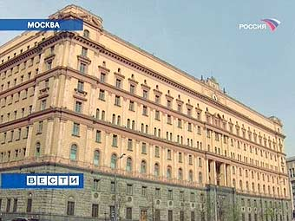

Main building of Soviet Secret Police (KGB) in the center of Moscow. There is a special prison inside this building where was A. Bolonkin in 1972.

After 9-month investigation, I was served a verdict, cooked up by Trofimov. It was formed in one sentence of approximately 20 thousand words, where all the titles of “anti-Soviet” documents were written with small letter. None of the facts of slander was quoted. All of them were announced “anti-Soviet, slandering fabrications, defiling Soviet political and social system” not furnished with proof.

Even my quotations (with precise indication of sources) from the decisions of past C.P.S.U. (Communist Party of Soviet Union) conferences and CC[4] plenary sessions with promises of better living standards of people were called “anti-Soviet and slandering”.(All they were taken from official communist publications with issue, page, and published date). As all the terms, indicated in those documents had passed long before, they caused laughing. When I asked Trofimov, how he could name the decisions of C.P.S.U. conferences “anti-Soviet”, he answered frankly: *“Bolonkin, you are a clever person! What had you been delving into the past C.P.S.U. meetings for? There are new meetings, new promises!”*

**5. Trial**

The trial took place on 19 - 23 November in 5 months after the end of investigation, what was the infraction of the law by itself. Balakirev and I were judged in the building of People's Court in Babushkin Region of Moscow; the chief justice was Lubentsova V.G. Other cases were singled out in separate legal procedures.

Entrance, stair cases and corridors were encircled by KGB. In the hall about 10 KGB workers were trying to make themselves out to be the “audience”. Even my wife was kept out of the hall of so-called “open court”. Academician Sakharov tried to get in the hall of court session thrice, but failed to do it.

In 1973 communistic rulers were playing “defusing” with the West. They conducted a Congress of Peace – Loving Forces in Moscow and organized speeches of Yakir and Krasin about their repentance. That’s why they lingered with our trial.

Court decision read: *“Concerning the accused Bolonkin court commission takes into consideration his actions in commission of crime – production of copying machines for copying anti-Soviet documents in great quantities… and also large quantities of literature produced, copied and distributed by him in person and has found obligatory to choose punishment of 4 years of concentration camps of special regime and 2 years of exile”. “Radio-gramophone, radio set “Spidola”, photographic apparatus and typewriter must be turned to State income as the instruments of crime”.*

“*Concerning the accused Balakirev court commission takes into consideration that he made a frank confession both in course of investigation, and in court commission. By his behaviour he COOPERATED in thorough and full revelation of the crime. The court commission had found possible to apply Asset 44 of RSFSR Criminal Code in his case and to choose punishment not concerned with deprivation of liberty”.* He had aconditionalsentence for 5 years.

Balakirev held all the connections in his hands; KGB began 12 new cases according to his testimony and was very happy.

Zarya and Rybalko were released in 4 months after the investigation as they made frank confessions and cooperated in revelation of the crimes. Vladimir Shaklein was granted pardon (before the trial) and released in Oktober, 1972. On the basis of his testimony KGB produced a new case against 3 members of his “Cultural and Educational Association”.

Concerning Yukhnovets, KGB’s “psychiatrists” gave him their conclusion that he was irresponsible of his actions a year before (in spite of the fact that they didn’t observe him, when he distributed the propaganda leaflets) and that he was psychiatrically healthy in the time of court and could give testimonial evidences. He was released and was registered in psychiatric center (i.e. under the threat of placing in prison psychiatric clinic on any moment).

Thus only I was sent to concentration camp out of a whole arrested Moscow group.

Two people were arrested in Leningrad group: Georgy Davydov and Slava Petrov. Their criminal procedure was less known and they were treated more cruelly. Though they had 4-5 times less items of prosecution than Balakirev and I, Davydov got 5 years; Petrov got 3 years of strict-security camp.

**6. Concentration camp JH-389/17а**

In February, 1974 I was sent from Lefortovo KGB prison to Mordovia political concentration camp (about 500 miles to East from Moscow). Before sending off, they searched me thoroughly, took away my notes. Late at night they brought me to the rear yard of Kursk Railway Station (Moscow) by the prison-van and in huge mass of prisoners they pushed me into the Stolypin (special prison) carriages. There carriage guards searched me over again and took everything that was valuable. They beat me when I tried to protest against the robbery, and put me in separate small compartment-cell as political prisoner.

In Potma (Mordovia) train stopped at the high railway embankment and during our going out the guards amused themselves kicking the prisoners out of carriage and laughing till he moved down the embankment.

First concentration camp, where I was brought, was situated in the village *Ozerniy* and was encrypted as a main defense objective under the mail box JH-385/17а. Later I made sure that encoding the information about the location under the mail boxes concerns all the concentration camps of the Soviet Union, including criminal ones.

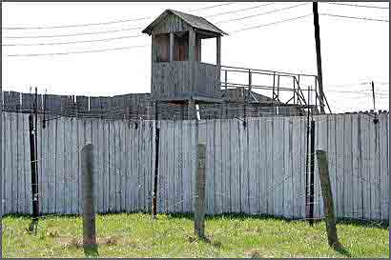

Political concentration camp #35 in Perm

Political prisoners received me well. They were Egorov (Russian), Mikitko Yaromir (Ukrainian), Misha Korenblit and Ilya Gleizer (Jewry), Rode Guner, Alex Pashilis, Vilchauskas Brotislav (Baltic countries), Graur Valeriy (Moldavian), Mikelyan Suren (Armenian) and others. There I met Slava Petrov. Lots of people were there: members of national liberation movements, religious people, imprisoned for the attempted escape from USSR and former Nazi collaborators.

Political prisoners brought me up to date about all camp affairs, and I told them about the old (1.5 years) news from outside.

We worked 6 days a week, sewed mittens. Rates of output were very high for elderly people and every year they were increased for 10%. The food was poor and unvaried (bad porridge and oats). We felt the lack of animal protein, animal fat and vitamins. But most of all we felt lack of information. Our attempt to make a radio set failed because we had no necessary details.

Besides continual sudden searches, sometimes, several times a day, made that undertaking very dangerous.

We had to be content with an official political hour lead by semi-literate heads of the camp officers, who read lectures sent from the leaders stammering. We were prohibited to ask questions on public. To know something one had to stay and to speak with them privately. But they couldn’t even explain even the things they read. So there were no people wishing to be politically informed.

Misha Korneblit was a participant of a famous airplane case, when the group of Jewry bought all tickets to the airplane and tried to fly to Israel with the help of their own pilot. Alex Pashilis and Rode Guner were advocating for separation of their occupied republics, and Candidate of Biological Science Ilya Gleizer was sent to concentration camp just for unwillingness of living in the USSR.

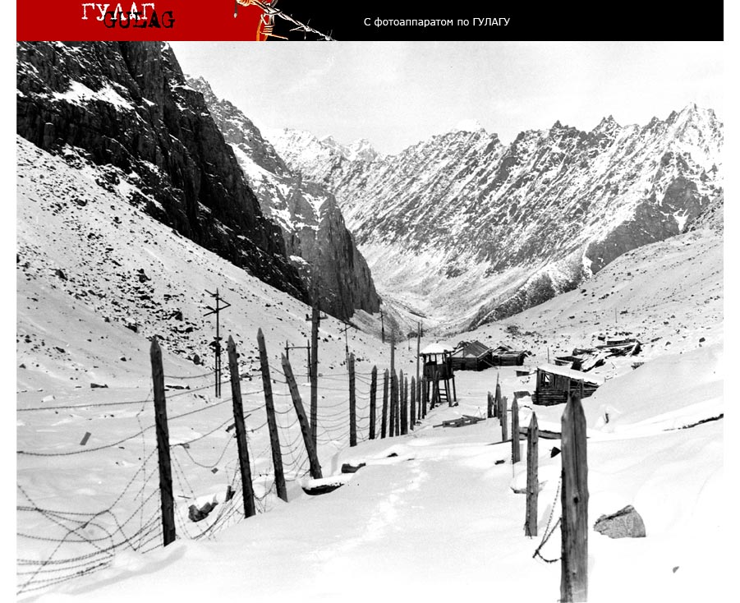

Derelict communist (Soviet) concentration camp in Marble Canyon. Main production is uranium autunite (ore). The terrifying truth about this concentration camp is a big secret in the Russia.

Picture by Sergey Melnikov from http://gulag.ipvnews.org .

I was especially shaken by the life of Old Believer priest Mikhail Ershov, who had died in that camp. I read his verdict and wondered how one can be sent to prison just for prayers and organizing a chapel.

I was given the bunk near Vladimir Kuzykin, former officer of soviet troops in Germany, accused (us he told) of distributing anti-Soviet literature and who worked at the cushy lob as a sewing-machine maker.

I entrusted my notes to him and they were rendered to KGB, though he assured me that he had burnt them. Later he was charged with finking and, it seemed to me, got an early discharge.

I made friends with Slava Petrov. He was involved in similar case of Georgiy Davydov in Leningrad. He was just a plain worker, who helped Georgiy in distributing literature. He got the smallest stretch – 3 years. Davydov himself was sent to Perm concentration camp (Ural, middle part of the USSR) . Slava said that they applied to him psychotropic preparations causing talkativeness. However, judging by his verdict, they didn’t manage to know much. May be, he didn’t know more.

In his verdict I found myself as a witness for the prosecution, though till that moment I hadn’t even known him. When I was asked at the trial (it was a common trial for him and Georgiy Davydov), I claimed that I saw Petrov for the first time in my life. I wrote a protest to the Supreme Court of RSFSR, where I accused them of fabrication and I demanded to strike me out of the list of the witnesses, as *“I didn’t want to sit with the judges at the Nuremberg dock for fascist criminals”.* I had received no answer.

Slava cheered up in most difficult situations. I remember when he, in agreement with us, handed in an application to the head of the prisoner group Pyatachenko that he wanted to become a member of Section of Inner Order (grovellers’ organization, created by the administration for terror and spying). KGB and the supervisors of the concentration camp were confused. But it was impossible to let an evident anti-Soviet person listen the instructions to the supergrasses. He was politely rejected as one who hadn’t proved his reform.

The concentration camp undermined his health greatly and he died in 1989 leaving alone his paralyzed mother.

Graur Valera was a participant of the group which demanded to return Moldova to Rumania. They made contact with Rumania leaders, who waited 2 years and then delivered them up to the Soviet KGB.

**7. Concentration camp hospital**

After several months due to drastic worsening state of health I was sent to concentration camp hospital in Barashevo (village in Mordovia) , where I stayed till November, 1974. That hospital was an important junction point where all ill political prisoners from Mordovia and Perm concentration camps were brought to. There I made close friends with such remarkable people as Edik Kuznetsov, an organizer of the famous airplane escape, Igor Ogurtsov, the leader of the “All-Russian Christian-Democratic Union”, Vasiliy Stus, Ukranian poet, and others.

During my stay in hospital I carried out great coordinating work on organization synchronous hunger-strikes and protests all over the concentration camps, on information interchange, on teaching political prisoners cryptography, enciphering, connection and information transfer to the outside world. The most important action was the organization of first Day of Soviet Political Prisoner and synchronous hunger-strike in this connection all over the political concentration camps in the USSR. Somewhere in September, 1974 Edik Kuznetsov was brought to the hospital from the special regime camp (in Sosnovka, Mordovia, JH-389/1-6). He was kept in a solitary cell and was allowed to walk only once a day. Though there were lots of spies around us, I met him and discussed that idea. He proposed 30th October as the Day of Political Prisoner in the USSR. I reported about that to all concentration camps. A report was sent to outside world too. That date was announced by academician Sakharov and all foreign radio stations. Hunger-strikes, discussions and demand of political prisoner status took part in all political concentration camps.

In that hospital I got acquainted with many political prisoners: Matviuk Kuzma (Ukrainian), Popadnuk Zaryan, young fellow, former university student. Osadchiy Michail underwent his medical treatment there. He told us a lot about bloody stifle of a rebellion in Kolyma (East-North of Soviet Union near Alaska, USA) .

It’s naturally that such an organization of the Day of Political Prisoner had its consequences, as well as stirring up prisoners and leak of information to outside word. In November I was caught, sent to concentration camp ЖХ-389/19 in settlement Lesnoy (Mordovia). From that moment all my wandering from penalty isolation wards to penalty cells began. The head of Mordovia concentration camps KGB officer Vladimir Drotenko used my refusal to carry corpses from mortuary to prove his order. I’ve read the report on that theme. It turned out that administration was constantly taking care of me, sent me to the hospital and at the same time made me work as a stoker in prison bath, carried great political-pedagogical work with me, explained the blessings of the communism and I, being so ungrateful, not only rejected the way to correction but also rejected to bring corpses to carts.

I managed to do something for prisoners in hospital in relation to life conditions – I repaired and cleaned out bath heating system, which hadn’t been repaired and cleaned for several decades and there was awful cold in the bath.

It was hard to see how people suffer in the hospital, where the “treatment” was formal. I felt especially uneasy for Ukrainian poet Vasiliy Stus, whom I made close friends with. He had developed gastric ulcer, and felt continual pain. He suffered a lot and needed medicines desperately. But they said there were no medicines and forbade to pass him medicines which his wife brought to him, even such sedative analgesic as *Vikalin*.

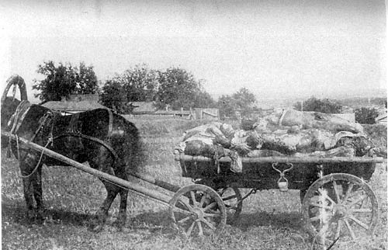

Kharkov. Corpses are in a telega (cart). Corpses were delivered in a concentration camp hospital morgue from the nearest concentration camps and a jailer damaged from A. Bolonkin to unload them.

**8. Concentration camp JH-389/19**

Concentration camp JH-389/19 in settlement Lesnoy was several times bigger than JH-389/17а. In general they produced wooden cases for wag-on-the-wall clocks of past century pattern there. I hadn’t seen them long before even in the USSR and I wondered if someone needed those antiquities in our electronic century at all.

There I got acquainted with many remarkable people who later became my friends. They were Paruir Airikyan, Sergey Soldatov, Vladimir Osipov and many others.

We spent long days and months together with Paruir Airikyan in penalty isolation ward (so-called punishment cell) and penalty cells (officially - the room of prison-cell type and in reality – special inner camp prison of high strong regime) and made close friends. He amazed me by his resistance, fortitude and utter devotion and love to Armenia. All Armenian prisoners admitted his authority. Neither tortures nor malicious insults of KGB workers could break him. All Armenia knew him; many outstanding Armenian cultural workers wrote to him, risking their careers.

Sergey Soldatov was the founder of the Democratic movement in Estonia in Brezhnev (former Soviet leader) times. I think he was an author or a co-author of the **“Program of Democratic Movement of the Soviet Union”.** Our group was accused of distributing that document. Apparently, he was one of the publishers of underground magazine **“Luch Svobody”** *(“Beam of Freedom”)* and many fundamental documents such as **“Memorandum of Democrats to the Supreme Soviet Congress of the USSR”,** which was mentioned in our verdict too. He was an erudite, who knew a lot in politics, history. He was and ideologist in his way of thinking.

Volodya Osypov served his time for publishing magazine **“Veche” (“**Meeting**”)**, which was also mentioned in our verdict. He was a verily Russian highly religious person who stood upon the ideas of Slavophils, Russian self-consciousness. He was close to ideas of Russian writer Solzhenitsin in his beliefs and he was always speaking in his support in his own articles.

There was lots of Jewry demanding departure to Israel. For example, famous writer Mikhail Kheifits, Kaminskiy Lassal, a participant of Leningrad airplane case, the members of Democratic Movement (such as Kronid Lyubarskiy who had been brought to another concentration camp not long before my arrival), members of liberation movement of Ukraine, Baltic countries and nationalists of all the USSR republics. Almost all types of underground trends, ferments and movements in the USSR from monarchists to “true” communists and “Communists - Leninists” (Lenin was the first Soviet communist leader died in 1924) were there.

Unfortunately, little size of the brochure doesn’t let me dwell on them or even list the names of all outstanding people, I met with. Most of them were ardent enemies of the present regime. In hard conditions of concentration camps and KGB terror many of us were friends and helped one another in different ways, made common protest actions, spoke in support of persecuted, went on hunger-strikes when someone was tortured particularly mercilessly.

I remember the warm feeling I felt to my friends when I returned from 15-days’ hungry stay in cold punishment cell to the barrack and found food and cards with sympathetic words my friends had left for me.

There were a lot of defectors, cooperating with Germans during WWII, people accused of parricide (for example, Yuriy Khramets), diplomat – deserter (Sorokin, Petrov) who returned under the “firm” promise of Soviet government, that he would be safe and sound, religious people (Evgeniy Pashnin) and criminals, who believed in tale about wonderful life conditions in political concentration camps, who became “political” abusing Soviet Authority and transferred from criminal camps.

Many of then soon became KGB’s “third ears”. Neither of political prisoners communicated with them and the only thing they could fink was what person did and whom he met with.

When I went to the toilet at night (all the conveniences were located outside the barracks) someone of the spies got up and went with me.

Criminals who became political soon understood that the conditions in political prison were even worse that in the criminal one, as it was fully isolated from outside world and administration was so terrified by KGB that it refused to intrigue with prisoners.

Even the head of my group talking to me in his office mentioned: “I hope there’s no KGB’s microphone in my room”.

My letters to relatives and friends were confiscated as slandering. Sometimes I couldn’t send one letter half a year. Then I made such an experiment. In our scanty library I found a complete set of Lenin’s works. KGB thought it might help political prisoners to understand how great communism was and how wrong they (prisoners) were. I took the volume with Lenin’s correspondence and began rewriting his letters to Gorkiy (well-known Russian writer), Krupskaya (Lenin wife), Armand (Lenin mistress and communist revolutionist) and others and gave them to censor as MY OWN. I didn’t change a word in those letters. Some really long ones were abridged, some names were omitted. Neither of Lenin’s letters passed the censorship. All of them were confiscated as “anti-Soviet”, “slandering”, and “cynical”. As a result I was brought to a psychiatrist, because only a psyche could write such letters, said KGB. I avoided diagnosis “mentally incompetent” only when I said that those letters had been copies of unforgettable Ilyich’s letters.

Sometimes pedagogic delegations were sent from the Soviet republics. They narrated about the wonderful life of soviet peoples. Ajrikjan dissuaded his delegation so much that they stopped coming to him at all. Once an agitator from Moscow Municipal Committee of the CPSU was sent to me. He came with refreshments to create heart-to-heart talk. I knew that agitators are usually given 3 rubles for refreshments of one political prisoner. When I had counted the cost of everything brought, I asked, where 2 more rubles were. The communist was confused. I didn’t manage to support heart-to-heart talk with the person who tried to profit by hungry prisoner.

My verdict was the biggest of all Mordovia political prisoners’ verdicts in size (it contained about 20 pages of compact text). It was even bigger than verdicts of 10 other political prisoners. It contained more than 40 items of accusation, 5 names of written, copied or kept documents and hundreds of distributed copies in each item. I managed to take it out of Lefortovo KGB prison and show it to many people. I succeeded in taking this unique document with me after my discharge. Now it is handed over to one of American libraries.

There were a lot of interesting dissidents and wonderful people in that Mordovia political camp. They were Fedor Korovin, Artem Yushkevich, Herman Ushakov, Azat Arshakjan, Ukrainian Vasil Ovsienko, Vasil Lisovoj, young persistent man Ravinsh Majgonis and others. There were interesting people among fugitives, “parricides”, members of liberation movements, deserters (“vlasovtsy”[5]), and religious people.

Unfortunately there is no opportunity to dwell upon the sorrowful destiny of those people, who suffered a lot for their dissidence, unwillingness of living in the communistic heaven, their religion or fighting for liberation of their republics.

**9. Penalty isolation ward and penalty cell**

Political actions, protests, hunger-strikes followed one another. Not only free dissidents, but also foreign radio stations got to know about many of them the same day. KGB got it on the nose from Central Committee of Communist Party and began rushing about in search of intelligencers, isolating the suspected. In total I was kept (only in Mordovia concentration camps) in penalty isolation ward 110 days and 9 months in penalty cell (special internal camp prison).

Punishment cell represented a torture cell, where a prisoner suffered not only from hunger (though it came down to starvation and hunger hallucinations) but mostly from cold. One was placed there in thin cotton prisoner’s wretched clothes. There was no bunk and the temperature was low. Wooden plank bed was unfastened from the wall only for 8 night hours. Chill tormented prisoner’s exhausted organism. It was especially difficult to survive nights. One had to jump out of bed 5-10 times, do exercises to warm up a little. It was hard to fall asleep even in warmth on those rough snaggy plank beds with iron screw-bolts. The food was scanty – 450 grams (one pound) of raw brown bread. Huge iron close-stool was producing such “odours” which made breathing hard.

It was a bit better in a penalty cell. One got bedding for 8 night hours and a tureen of watery skilly to dinner.

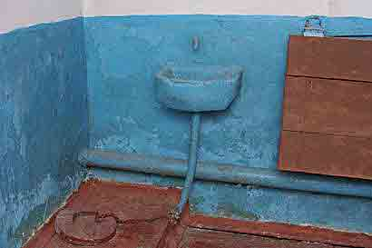

Very “good» punishment cell (Concentration camp #36). It has small wash-hand-stand and bund for drain. A. Bolonkin was more one year in punishment cell where was only a big fetid filthy cask with defecations.

We had to polish wooden case for wag-on-the-wall clocks by hand. That gave cause for administration to punish us any time for failure to carry out “rates of output”. Some cases were not counted as improperly polished.

One of the reasons to next dispatch to punishment cell was a refusal to give the “necessary” testimonies against Andrey Tverdohlebov. Moreover I behaved defiantly with that case investigator: after long wrangles I insisted on writing the testimonies myself. I wrote that Andrey was a remarkable person, that his case was fabricated by KGB; that we, political prisoners, resumed our gratitude for his remedial activity; that Human Rights were being violated in the USSR and so on.

After such testimonies I was dragged to penalty isolation ward. As I knew later, my testimonies were not included in Tverdohlebov’s case and the case investigator noted as though I refused to testify.

I was the single Doctor of Science in Mordovia political camps in those times and all the coming directors were brought to penalty isolation ward as to the Zoo to see me as some exotic animal. I remember one general from the Ministry of Internal Affairs who couldn’t understand what I lacked under the Soviet regime; I grappled with him (by words, of course). I remember MIA[6] colonel, specialist in locks. After his visit my cell was enriches with one more (the sixth) lock.

Time and again public prosecutor came, once he had a claim: *“Last year about 650 complaints came from Mordovia Penal Colonies. 440 of them were written by you, 168 – by Ajrikjan and 42 by other prisoners. What’s the matter? I don’t have so many workers to answer you”.*

Of course all those complaints about administration outrage were useless, as well as the requirements to observe at least scanty soviet law. Only once we succeeded a little in that. In penalty cell guardhouse I saw “Nutrition norms for prisoners”, there was written that we eat 30 grams of meet every day. That table was hanged for different committees. I began writing to chain of command asking where that meat was. What idiotic answers I received: that meat is full of bones, that it is being boiled up to 60%. Finally, the heads gave up and began giving small bit of meat as large as a finger-tip (they contended that it weighed 16 grams – after boiling away) to prisoners in prison camps. That bit was not enough even for a mouse. But if you were utterly exhausted and hadn’t seen meet for years then even such small bit could bring you a minute of delight. All following generations of prisoners in penalty cells were grateful to us for that small victory.

Of course, there were a lot of political prisoners, who considered that it was better to be humbler than the dust, not to irritate KGB, not to get to penalty isolation wards and penalty cells and thus not to suffer and try to preserve their health. Most of all they were people who acquired the status of “political” by accident for incautious criticizing the regime, reading “spicy” literature or even for disagreement with bosses. KGB machine was vindicating its existence and taking a run it crushed sometimes innocent people. But I don’t think there was any sense in fighting. Finally concentration camp outrages and tortures were made known and disturbed world (and Soviet - through foreign radio stations) public opinion. Not without reason everything in the camp was spinning around one question. KGB tried to isolate us, and we tried to bring the information to the outside world.

There were lots of ordinary people in concentration camps. For a long time I was sitting in the penalty cell with Petr Sartakov, a worker. He described his staying at Stalin concentration camps and tried to pass this description to American, and was imprisoned for that. He strived to competent people, tried to liberalize, to become educated.

1. **Concentration camp in Barashevo**

In the end of 1975 when I was in a camp zone, patrol caught me at writing a list of gerrymander, theft and stealing of concentration camp administration. The heads alarmed for real. They saved their skin. Doctor Sjaksjasov whom I met that evening with two cans of paint exclaimed: “That really is too much if you put me in that list!” Next day I was given 5 minutes to make ready in guards’ presence, I was searched and sent to concentration camp in Barashevo (Mordovia). There were kept especially dangerous political prisoners.

Most imposing of all those political prisoners was Vyacheslav Chernovol from Ukraine. We conversed with him about our condition, discussed different undertakings, took part in joint actions, and shared a crust of bread. He was a former journalist and knew Ukraine life, history and culture well. He loved Ukraine, and was a born politician with broad outlook and deep understanding of historical processes. I can’t even count how many hours we spent in conversation with him, walking round the perimeter of the barbed wire. I had never heard of a single escape affair and I was amazed by that huge complex and expensive system of guarding soviet concentration camps. First there came two rows of barbed wire, provided with signalling. Then there was ploughed land, then high dense fence with barbed wire at the top, then one more such fence. Between those fences killing system of high tension and watch-towers with gunners was located. Then barbed wire was put again so that nobody could get into the territory of concentration camp from outside.

Slava said to me the case when KGB tried to bug his conversation with Stus, who was imprisoned in that camp before. They summoned Stus and announced that he got ready to deportation the next day. They took away his quilted jacket as if for searching and gave him another in return. It was naturally that on that day they began discussing their own and common plans, talking about communication lines, agreeing upon methods of connection. Slava expressed his surprise at the change of his quilted jacket, began feeling it and found micro transmitters as large as a pea. They tore them out and dug them at once. In several minutes KGB workers ran and took the quilted jacket away. He showed me microphones’ burial place.

In that concentration camp we managed to hear the trial on former KGB workers **Braverman** and **Pachulija**. Bravernan was the head of KGB investigating department in Leningrad and Leningrad region. Pachulija was the head of Abkhazian KGB. Both of them were closest Berija associates (former head of the USSR central KGB). And Bravernam was put forward for rank of a general. When in Hrushchev’s exposing “cult of personality” Berija was proclaimed to be an “imperialistic spy” and public enemy, they were convicted for torturing and killing people under investigation.

[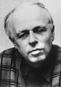](http://images.google.com/imgres?imgurl=http://www.nndb.com/people/823/000079586/sakharov-1.jpg&imgrefurl=http://www.nndb.com/people/823/000079586/&h=257&w=182&sz=14&hl=en&start=6&tbnid=hs5isau8jwbDxM:&tbnh=112&tbnw=79&prev=/images%3Fq%3DSakharov%26gbv%3D2%26svnum%3D10%26hl%3Den%26sa%3DG) [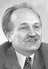](http://images.google.com/imgres?imgurl=http://www.kontrakty.com.ua/ukr/gc/nomer/2000/2000-37/37chernovil.jpg&imgrefurl=http://www.kontrakty.com.ua/ukr/gc/nomer/2000/2000-37/37gc-10.html&h=143&w=100&sz=3&hl=en&start=20&tbnid=d2MUAyo-zt6EgM:&tbnh=94&tbnw=66&prev=/images%3Fq%3DChernovil%26gbv%3D2%26svnum%3D10%26hl%3Den%26sa%3DG) [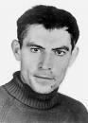](http://images.google.com/imgres?imgurl=http://gulaghistory.org/exhibits/nps/onlineexhibit/dissidents/portraits-src/images/stus_detail.jpg&imgrefurl=http://gulaghistory.org/exhibits/nps/onlineexhibit/dissidents/prisoners.php&h=500&w=356&sz=24&hl=en&start=8&tbnid=jhiPvIqRMku6fM:&tbnh=130&tbnw=93&prev=/images%3Fq%3DStus%26gbv%3D2%26svnum%3D10%26hl%3Den%26sa%3DG)

Nobel Prize Academician **Viacheslav Chornovil**  **Vasil Stus**. Famous Ukraine

**Andrei Sakharov** – designer of He was candidate in Ukraine poet. He was Candidate for Nobel

Russian Thermonuclear bomb President when Ukraine received prize. He was tormented to death

and defender of Human Independence. He perished in in Soviet concentration camps.

Rights strange car accident

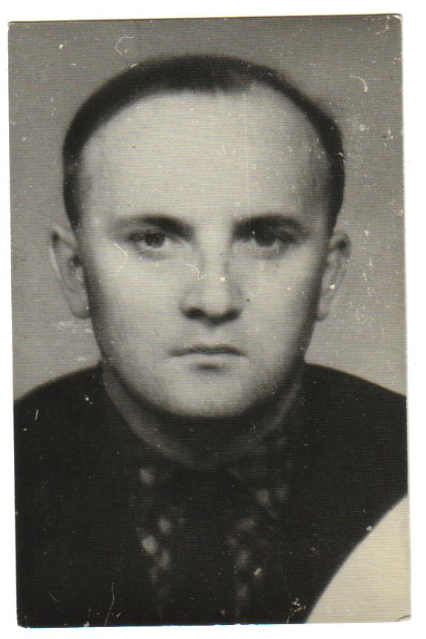 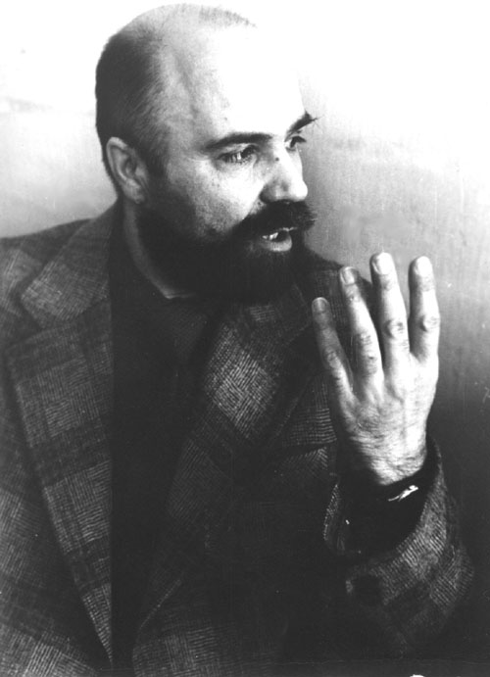 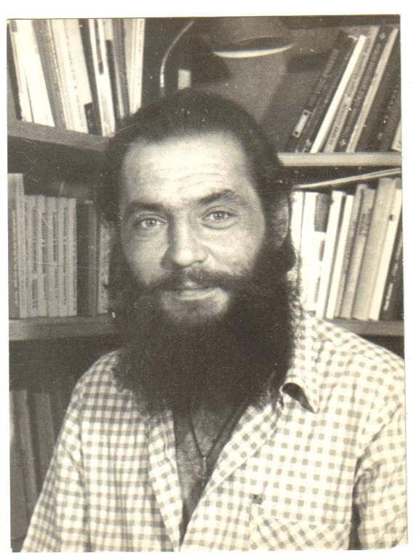

**Sergei Soldatov –** author **Igor Oqurtsov** – leader of “Christian **Viacheslav Petrov** – worker from

of “program of Democratic -democratic Union” in Saint- Saint-Petersburg (Russia)

Movement of the USSR Petersburg.

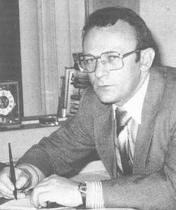 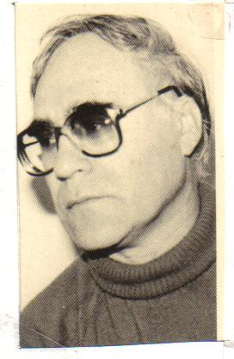 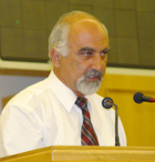

**Eduard Kusnetsov –** writer **Ilia Gleizer** –biology **Paruir Airikian** party leader

He is editor of newspaper “Vesti” Scientist. Now he is He was candidate in President

in Israel now. In the USA. Of Armenia.

They both became “third ears” and got a snug little job. Pachulija became a librarian, Bravernan – an office worker.

Even defectors disdained them, not to mention political prisoners; they had to communicate only with one another and scribbled denunciation saying that the other understands a new Central Committee resolution in a wrong way.

There came a trial to reconsider the cases, generally, KGB cases. Slava and I sat in first line. But the heads drove us out however hard we had tried to protest saying that everyone who wishes could visit the “open” court.

Fortunately, room for boiled water, joined to barrack was divided from the courtroom by thin plywood partition. We got there and heard everything.

Our hair stood on end when we knew what those “guardsman of law” did. Pachulija even hit upon an idea of throwing people to holes putting them at the mercy of rats. They were judged not for fabricating cases and tortures, but for killing people under investigation. Pachulija tried to prove his innocence telling that he built a road to Stalin’s cottage, which he hadn’t visited even once.

The court reduced Bravernan’s time of confinement because of his “reform” and “good behaviour”. The court refused to reduce Pachulija’s stretch only by personal request of Georgadze (Supreme Soviet Secretary) as Pachulija had tormented his close relatives to death.

**11. Road to exile**

Half a year before my discharge according to KGB’s procedure I was sent to the inner camp prison JH-385/19. That procedure was invented with the purpose that the concentration camp latest news couldn’t come outside and was applied to especially dangerous criminals only.

On the day of my discharge many political prisoners gathered by the fence dividing isolation cell from production area. Each of them tried to shout good wishes, requests and news at parting. I knew Sergey Soldatov, Volodja Osipov, Artem Yushkevich and others by their voices.

But I didn’t go to outside free world after concentration camp. A whole month of exile in Siberia and wandering over the prisons of almost all Soviet Union was ahead. The place of my exile was kept secret. I was said that I was transported to Irkutsk and I knew that I was in Buryatiya (Siberia) only after arrival there.

That deportation was continuous nightmare. They transferred me from one transit prison to another: Potma, Chelyabinsk, Novosibirsk, Irkutsk, and Ulan-Ude. We were transported by Stolypin carriages at low speed, stopping for 2-4 days on every span. About 20-25 people sat in a compartment without windows; it was isolated from the corridor by iron fender. Normally that compartment was supposed for 4 passengers. There was no food for 2 -4 days in a road. We received a slice of bread, a herring and a tea-spoon with sugar before the next stage. The guard brought water and took out to the toilet at best once a day, not asking when we want, but doing it according to their schedule. I slept sitting as all the lying places were occupied by criminals.

Abusing, stench, searches, criminal’s and guard’s robbery accompanied every span.

Indeed life wasn’t sweet in transit prisons as well. Prison-vans were stuffed with prisoners to the eyeballs: 20-30 people in one car. Taking into consideration that about 2/3 of inner body was partitioned off for gunner and 2 solitary cells one might amaze how could so many people get in the iron box as large as 4 square meters with all their stuff. That box had no chinks but the exhaust managed to penetrate in it. Moreover some young criminals began smoking makhorka[7]. Usually in a minute I began suffocating and throwing up. I lost consciousness frequently. That humiliation lasted several hours, not to mention hours of transmittance the prisoners from the carriage guard to the prison-van guard and from the prison-van guard to the prison guard.

Every person was called, asked name, patronymic, asset, stretch, compared photo at sealed papers and searched over.

In one of transit prisons I was put in small standing cell, which walls were upholstered by the sheet iron, resembling the grater. After the long and hard stage I was groggy. But I had to stand strictly vertically because at the least movement sharp thorns gat stick into my body. It was impossible even to knock at the door, as it was covered with such sheet iron too. Whole night I was unwillingly listening to wild cries, sound of beating the glass coming from the neighboring cell, where the guards were beating the prisoner. He went mad at dawn.

The guards let me out of there only in the morning. I was hardly conscious. Jailers laughed (“You are like Lenin”) and brought me to the cell. When I asked the chief warder why they hadn’t done it yesterday, he answered: “We forgot”.

Next time I was put in a penalty isolation ward with incuse windows. Wind blew the snow in the cell and I had nearly frozen to death.

In one mass cell a toilet was made as a high pipe. One had to climb up there by the ladder. During the process the others could not only “take pleasure in smelling” but also in looking the whole procedure from below.

I don’t even mention such trivial details as striping to the skin before women working in prison who searched for newly made caps (tattoo).

**12. First exile**

In 1976 after 4 years imprisonment in political concentration camps of high security I was brought to exile in Siberia, in village Bagdarin of Buryat ASSR[8] and handed over to the local police station. There I spent a night in the lockup. Then they kicked me out to the street without giving any place of living. I had no money and was dressed in prison shabby clothes. It was very cold, as always in October in Siberia. They graciously permitted me to sleep and eat with scourges, bums and hooligans arrested for 15 days.

That little wooden house had probably been a village bath before. It was located in the closed police station yard and was converted to a cell with bars on windows closed for night. Usually it was overcrowded and prisoners slept side by side on the attic, on the dirty floor, covering by their worn-out ramshackle clothes.

All people imprisoned for 15 days already knew that a new political prisoner came to Bagdarin. They were very friendly, tried to pour more skilly, abused soviet authorities and the most embittered (those who were beaten black and blue by police) threatened to burn down that house.

First day I was out I telegrammed to Irina Korsunskaya and in a day I received little money order. That allowed me to change my lodgings to local squalid wooden hotel.

Rumors peddled fast in such small settlements as Bagdarin. The maintenance staff of the hotel treated me well. Lubov Govenko, hotel’s administrator, felt great pity for me. She helped me to settle down and to subsist at the start, though she was summoned to KGB and tried to browbeat many times. I was met with kindness and pity by many people, in spite of all stories and rumors peddled by KGB. But people were afraid to show their attitude to me in public. When once a supergrass saw a person talking to me tête-à-tête, that person was dragged to KGB and they began finding out what we had spoken about, made a person write explanations, browbeat him and solicit the necessary testimonies about picking on the Soviet authority and appeals to blow it up. After that a person began avoiding meeting me and talking to me.

Regional town Bagdarin represented a small village of little wooden houses with population of about 3 thousand people. The house of a district committee was the only two-storied building. There were 2 shops, small canteen, service centre, school, KGB regional department (highly essential to soviet people) and none industry at all. Small village Malovskiy which included about a thousand homesteads was situated near it. Taiga lied thousands kilometers around.

According to the law local authorities had to find a work for me and give me lodgings. Somewhere in two weeks police official Vaganov set me up in geological survey group (GSG) in village Malovskiy and settled me in GSG dormitory.

I was attached to general worker Vinnikov E.K. – secretary of party organization in GSG. My duties were to carry a measuring rod after him and to keep it strictly vertical in indicated places. Of course, they couldn’t find the work better for a doctor of science in the USSR. Later it became known that Vinnikov was obliged to spy, ask provocative questions and write denunciations. It means he had to do it according to the soviet decree of 1918, as all the members of the Communist Party (in contrast to ordinary soviet people) for free.

Vinnikov turned out to be a very eager supergrass not only in my relation. He wrote reports about workers, complaining of life and work conditions. However other members of the party were no different from Vinnikov. For example, Palienko G.S. or deputy party chief Turgenko’s L.A. wife. In the reports they didn’t write things which happened in real life, but the things KGB told them to fabricate a new case.

The dormitory I was settled in was a wooden building with a long corridor and two rows of rooms on both sides. Builders, gold-miners, visitors and scourge lived there. Almost every day they were engaged in hooliganism, drinking and scuffles. They boozed and made an uproar on holidays, every half a month (in the day of prepayment) and in the day of receiving salary.

The rumor about my technical education peddled fast and many people began bringing household appliances (radio sets, refrigerators, and washing machines) for repair. I hadn’t practiced that before. But I was an aviation engineer and knew physics well, so I examined them and repaired them in many cases. People thanked me and gave either food or money. Soon many heads of local offices came to me asking to repair their typewriters and other stationery. Glukhov Petr Fedorovich helped me greatly. He was an economic executive of the mine, exiled of Stalin times. Tearfully he told me the sad story of his life, that he was exiled to Siberia after the war, his family was destroyed. He found a new wife, created a new family, but he couldn’t leave Siberia.

I put to rights all the mine printing machines and was using one of them for some time. I was printing letters and complaints with its help till KGB gave the instructions to take it from me. After that Petr Fedorovich gave me an old broken printing machine (typewriter). I toiled very hard, finally put it to rights and used it till the next arrest.

At first it was hard to exist, I needed money to buy food and clothes. My wife didn’t send me a ruble, an old shirt of the thousands rubles I saved. And I was very gratified to Moscowers Lisovskaya Nina Petrovna, Romanova Avgusta Yakovlevna, Salova Galina Ilyinichna and other dissidents whom I hadn’t known before for their help and moral support they provided for me. Many people wrote to me, about 2-5 letters a day and I had to be in large correspondence. Soon even foreign letters began reaching me.

Once a young fellow in traveling clothes and with a big knapsack came to the room where I worked (fortunately Vinnikov was out of the room at that moment). It turned to be Sasha Podrabinek – a messenger of Moscow dissidents. He decided to travel over Siberia and to visit some exiled people in his vacation. I hadn’t met him before. I was aware of a provocation, so I rang up to Galya Salova and asked Sasha to speak with her on abstract theme not naming himself. She knew him by voice and said that he was a remarkable person.

Sasha brought to me Japan shortwave radio –a present of Moscow friends. I had asked them to send me that radio long before so that I knew the truth about the world events. Unfortunately, Siberia is situated far from Europe and I could listen only to the special Far Eastern 3-hour programs “Voices of America” (probably from Japan) which were distorted by Ulan-Ude radio suppressors.

Sasha stayed for 2 days. He was in a hurry to visit many people more, and his vacation was going to an end. He brought me up to date about the latest events and enlightened me in some medical questions. That knowledge proved useful to me later. We photographed for a keepsake. His visit remained a secret. When I saw him off, there were none KGB worker on the small local airdrome and he flied safely away without a “tail”.

I had to go tens of kilometers in taiga on my job, make measures in gold-miner regions, and spend nights in little wooden houses. It was especially hard in winter. All the day I was frozen by the frost, cold wind, from creeping over the snowdrifts in shabby clothes with the measuring rod and equipment which seemed extremely heavy by the end of the day. Al these things resulted in my continual illnesses and diseases. I was 40 years and was ill by bronchitis from cold punishment cells. There I knew all the goods of Soviet law. It turned out that a discharged prisoner had no right to paid medical certificate during 6 months after his discharge. That was when they got ill most often, they did not have any state support.

Head of the GSG Parshin A.P. and, most probably, KGB, where all my observations of Siberia frosts were brought as abusing the soviet country, carried me to loaders. Together with my workmate I had to load and unload 5-7 meter logs by hand to and from automobiles in winter. I came to the doctors, who were forced to give me a certificate about contra-indication to hard physical labour. After that I asked for another job. Somewhere in March 1977 I was set in service centre of Bagdarin as a mender of electric household appliances (electric stoves, irons). As I knew later that was done on purpose.

They settled me in a deserted decayed house near the service centre. It was divided in three sections. Two of them belonged to the center; I was settled in the middle one (of approximately 2.5x2.5 meters). In another (a bit larger) section lived a service centre charwoman Turkova with her husband and a child, and in the third section lived old man and old woman with a wicked dog.

That house hadn’t been repaired beginning with pre-revolutionary times, its roof resembled prison bars and torrents of water were pouring all over the ceiling during rain and melting of snow.

At first I bought ruberoid and made the roof and small inner porch, than I removed the heaps of dirt and wine and vodka bottles, which the former mender Erdineev A.B. had left there.

There were two houses of Armenians near to my house. They organized a gainful building group on repair and building houses. They earned a lot – about 500 rubles a month and they spend that money in there free time, drinking hard and having fun with girls, deflowering a number of local school girls. One of native KGB workers took part in their boozes too. Later one of Armenian confessed that he instructed them to spy on me, on my visitors and came to him regularly to receive the “information”. My other neighbour Turkov was also instructed to spy on me. In consequence they made Turkov sign the “necessary” to KGB testimonies.

Armenian were “caught on the hook” by KGB being got on some machination with gold. Two of them (Akopyan G.B. and Oganesyan G.A.) signed those “necessary” testimonies. Oganesyan did his best. I spoke to him once or twice, but I had never discussed any politics with him and with anybody in Bagdarin.

Later the leaders of their group were accused of writing up and put to prison. I must do justice to one of them, Robert, who hadn’t signed the slander in spite of his difficult position and KGB’s pressure.

However, the shadowing was rendered not by my neighbours only. Coming to work, I founded at my place clumsy notes of center workers, where they wrote to me that KGB required them to spy and to make reports on me. The head of the service center Golovanov N.V. who had built himself a huge house of stolen center material hastily hid the sheet of paper when I came to him. I knew then that he was writing the regularly denunciation.

 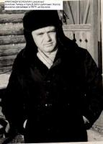

1. Bolonkin in the exile (Village Malovskii, Siberia, 1977)

What could one write about a person, who didn’t speak about the present power at all? Afterwards when I read the testimonies of so-called “witnesses” produced as accusatory, I understood that KGB had special samples of phrases like: “was slandering heavily about the home and foreign USSR policy”, “propagate slandering ideas, denigrating state and social system”, “committed inimical-provocative ideas”, “misrepresented the truth”, “praised foreign way of life”, “was slandering about life in the USSR” and so on which didn’t mean anything in particular. But one wasn’t allowed to rummage in all those things.

In concentration camp in Barashevo of Mordovia ASSR I was surprised how semi-literate supervisors knowing nothing except abusing language could write such a thorough report. It was when I refused to carry corpses and they wrote (in general words) that they tried to educate me in true soviet spirit, rendered pedagogical work with me, tried all humanistic methods but I, being a hard case, didn’t listen to their exhortations and sink into rejection of labour. And poor they had to demand punishment for me. I understood that they had patterns of reports which they just had to insert the surname and sometimes the misdeed itself.

However not only former criminals such as Ardyneev, semi-literate neighbours, Armenians, CPSU members and the heads wrote those reports, but a local “journalist” some Gilbuch earning his living by illegal photography in Bauntovsk region too. I always wondered what set them in motion: naivety, belief that they serve the leading regime in the world or just the desire to have some profit in service, some fringe benefits or security of KGB. How could they look in their victims’ eyes? Why were they the main support and hope of the “leading” power in the world? How many of them appeared, came to the surface and flooded the whole country. And their quantity increased from one generation to another!

Somewhere in 1969-1970 I had given my book ***“New methods of optimization and their usage”*** devoted to mathematic method of optimal regulation worked out by me to the publishing house of Bauman MHTU. In 1972 it was edited and published. Then thundered my arrest and accusation on the most seditious soviet asset “anti-soviet agitation and propaganda”, related to especially dangerous state criminals. One might think that mathematical book has nothing to do with it. But the authority wanted to sponge out the memory even of the names of disagreeable people. Almost the whole edition was obliterated. My works were prohibited to quote and to refer to. When I was in exile I asked the publishing house to return me my manuscript. But only the remains of my rough copy were returned. Than I brought an action against them requiring to give me my manuscript back, to pay me author's emoluments or to repair the damages caused by the breach of contract. After long wranglings and complaints I received a subpoena. I rushed along to police to get an exit permit according to the law. But there was no law in that country. They promised to find everything out and in a day they showed me the telegram from judge Sorina of Bauman region of Moscow, where it was written in black and white that the subpoena was sent for the sake of appearances. I began requiring the investigation of the case in my presence according to the code of civil procedure. But the court didn’t care a damn for a law and for the code. In spite of my protesting telegram they held a court session in my absence. I was refused in all items of my list at the ground that my manuscript had never been published. I couldn’t find my book neither in any soviet library, nor in a book chamber. Twenty years later approximately in 1983 I managed to get my book out of KGB archive. In Moscow Lenin library only book’s microfilm encoded as item number F-801-83/809-6 remained.

Many dissidents, convicts’ relatives and just strangers wrote to me in exile. They expressed their pity, offered their help. I received about 2-5 letters a day and answered them. Sometimes letters from abroad reached me. It was clear from their contents that only small part of these letters came to me. My letters, especially foreign reached their destination even more rarely. In concentration camp the post paid me 50 kopeck for every lost letter after check-up on my writ. I based my requirements on such fundamental postal documents as “the USSR Communication Statute”, the “Postal Rules”, the “Rules of Compensation Payment for Lost International Postal Mail” and made an interesting revelation that the Post must pay 11 rubles 76 kopeck for every lost international registered letter, while the price of sending it off was 16 kopeck. I ascertained that only 30% of my international letters reached their destination. By the way even my most innocent letters which included only one soviet post card failed to achieve their address.

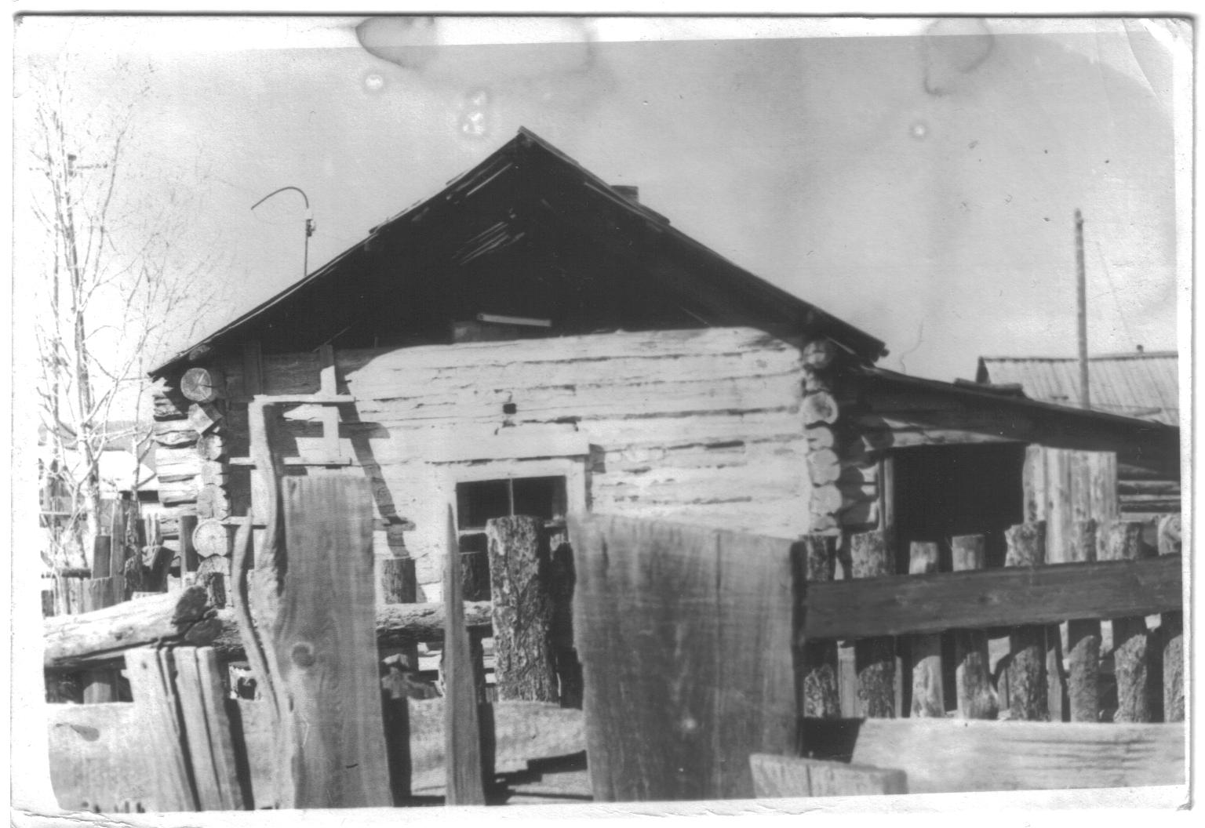  
 The hut in which lived Bolonkin in exile (Siberia) and two local families

I read in the “USSR Communication Statute” that if a person doesn’t receive an answer to the writ for international letters during half a year he has a right to bring an action against the Post enclosing the application and a copy of a writ (or a receipt of mailing such an application).

As the Post didn’t answer my writs during the required term at all I brought an action against the Post to the regional Court of village Bagdarin according to paragraphs 99, 103-105 of the “USSR Communication Statute”.

Judge Vinogradov requested all the Postal rules and documents and assured that I was completely right. The head of Bagdarin Post Tudypov couldn’t say anything clear except the thing that the Central Post Office didn’t answer their inquiries. But Soviet International Moscow Post Office situated in Komsomolskaya square, rather Central Reclamation Bureau of this Post Office considered answering the inquires of subordinate office beneath its dignity.

Evidently it was the first time when in that state of slave psychology appeared a man who took it into his head to raise a claim against the post for the lost international letters. It is clear to the meanest intelligence WHO “lost” those letters and the name of that organization inspired fear to the soviet people.

The post couldn’t produce any receipt of handing over my letters to the foreign postal department. Vinogradov temporized but was compelled to call court examination. In court Tudypov declared that the post lost my letters. Vinogradov had nothing to do but to adjudge me 50 rubles for the lost 5 letters.

Second time I declared for 150 rubles and the court had to find it correct. Third time I got 300 rubles. After that I decided that it would be fair if I received my Doctor’s wage - 500 rubles every month. So I began sending 48 similar registered international letters every month. Many of them had nothing except the soviet post card; others sent, for example, to the Academy of Sciences in Socialistic countries, contained just one phrase: “In accordance with Helsinki agreements I ask to render me assistance in departing the USSR”. Other letters sent to the Embassies of Western countries included postcards with the following text: “I congratulate the Women of the Embassy on the 8th of March”. I usually sent such letters as insured and valued them at 30-50 rubles. Just imagine what an insane person could congratulate the Women of the American Embassy on the 8th of March? Soviet propaganda alleged them to be cruel materialists, warmongers! KGB just threw them away. I decided to take that occasion.

But when the sum I required for increased the budget of the local Post office bawled out murder, KGB tried to wangle. Post lingered about a year with my next claim for payment about 2 thousand rubles. By that time I was arrested again. Finally after numerous complaints I was adjudged that money but I was not informed about that. Court decision came into force but was reversed in two months. Apparently, the court received an instruction to reject similar claims. The repeated Court of Oktyabrskiy region in Ulan-Ude (judge Belyak) rejected all my claims saying *“Bolonkin didn’t prove that his letters were lost!?”* I tried to appeal to their logics, to the common sense. I told that it was not me who had to prove that my letters were lost, but the post had to prove that it handed over the mail and produce recipient’s receipts or at least foreign Post Offices’ receipts. But all was in vain. I even showed the letters of the recipients where they wrote that they hadn’t received the given mail! It seemed to me I was in a deaf-mute society. A communistic court could trample on any logics if needed.

All the following claims were rejected on the same basis. And appellate organizations didn’t answer at all.

During my exile to Bagdarin I began writing my memoirs about the investigation, the court, about staying in Brezhnev concentration camps, about the things I experienced and saw from the moment of my arrest, about the acts and literature over which I was arrested. After half a year I had written out in small hand 10 pupil copybooks. I titled my manuscript as ***“Ordinary Communism”.*** I showed it to nobody and kept it in the yard heap of garbage under the wash-basin. I understood that I couldn’t publish it in the USSR terror. I wanted to keep it till the better time or at least to hand it over to the posterity when those times came.

The main task of any dictatorship, especially the bloody regime, was to conceal its own evil deeds and to slander its victims. Stalin was extremely well in doing that. He brought to the grave tens millions people. The major weapon and defense of those victims was publicity, informing the community about the murderous acts of the powers.

In 60-70 the bloody repressions hadn’t reached Stalin’s scale due to one reason. There were people who collected the information about the persecutions and arrests of dissidence and brought it to publicity. They were caught, arrested, accused of anti-Soviet thinking, slandering and put to prison. But other people took their places. Just remember the illegal bulletin “The Chronicle of the Current Events” that made known the political cases and repressions. Hundreds of people suffered from publishing that bulletin, many times KGB arrested its publishers, but every time there appeared new people who continued the deed of their associates. The bulletin existed about 15 years in spite of numerous KGB’s promises to put an end to that in half a year.

And all the leaders’ efforts to show the USSR as some socialistic heaven where the workers enjoy their happy lives in the pauses between the heroic labours and glory their communistic benefactors went to the dogs.

Many trading organizations of the settlement had stored up great quantity of out-of-order appliances for several previous years: they were refrigerators, radio sets, watches, and so on. All these things were the dead-weight to the balance.

Some part of those appliances arrived defective, other part (for example, refrigerators) was crushed and scattered on the journey. Some details were just stolen. Once I saw a radio-gramophone which pasteboard back cover was pierced and all valuable details were taken out. One had to pay a pretty penny for sending it back to repair. Besides there was no guarantee that the equipment would come back in a good state after a long traveling by awful Siberia roads. I was a real treasure to such organizations. They began importuning me with requests of repair.

To make assurance doubly sure I went for consultation to the local lawyers, in particular, to regional judge Vinogradov A.N. I was assured that everything was legal and I had to reach understanding in writing. I signed several contracts with the organizations where it was clearly stated that those organizations are responsible for the accuracy of payment and that they *“are obliged to pay for my work in accordance with the present prices”.*

The repair was difficulty because of lack in details. I had to write to the plants, to “Posyltorg”, buy up fallen out household appliances to get the required component. Usually in transportation refrigerators’ doors got deformed and nobody wanted to buy such units. Some deformed doors I replaced by the doors from the bought old refrigerators or by the doors my fellow driver brought me from Ulan-Ude menders. In November 1977 I left the service in the service centre and went on the contract work. At the very least I saved considerable sums of money to our state by that repair although my income was paltry. In total for 2 years I was in exile I earned about 1000 rubles, 600-700 of them was spent for buying repair parts. Thus I was paid for my work about 300 rubles or 15 rubles a month.

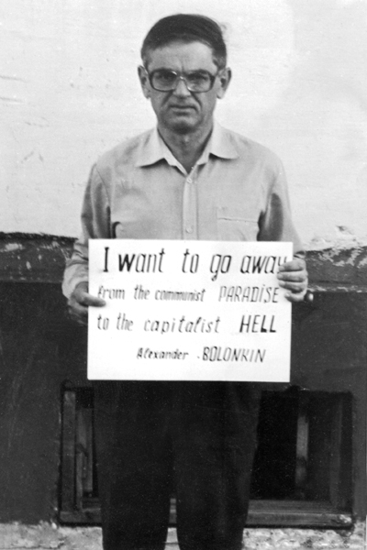

**13. Second arrest**

In the beginning of June 1978 my period of staying in Siberia came to an end. It was so because they were driving me to the exile destination more than a month and set me free only in the end October 1976 instead of 21st of September. And every day of imprisonment was equal to 3 days of exile.

From other exiled political prisoners’ experience I knew that at the end of the term KGB usually made provocation and fabricated new case. I behaved warily, without getting involved in any conflicts. In general I stayed at home. Moreover a month before the end of the exile term I planned to disappear, to settle secretly at my friend’s and to depart from Siberia after the end of the exile so that they couldn’t impute me an escape. If so the most they could accuse me off was that I didn’t register myself in police for have a year. And that was an administrative delinquency.

But as it turned to be, someone had already guessed about that. Anyway, the authorities took the lead over me. On the 15th of April, 1978 a women from the accounts department of the service center came to me and asked to go with her there to clear up the vagueness in some book-keeping document. I went there suspecting nothing. There was a police investigator Kornev Anatoliy. He showed to me the certificate of audit. It was said there that the repairs I made for the organizations were illegal as there were no contracts in the accounts department. I saw KGB’s idea. All the contracts were taken from the accounts departments and destroyed. Now they could accuse me of anything they wanted. I said to Kornev that I had the second copies of the contracts at home. It was bolt from the blue to him. He cursed that they loaded him with that case and ordered that I had to go with him to the police station to clarify everything. In police they searched me, took my documents and set in a single lockup.

Next day after sleeping on the plain wooden plank bed I was brought to a public prosecutor Bargeev A.A. who signed the search warrant at once and they brought me to my house for a search. The lock on the door was all twisted, someone tried to get into the house.

I found the second copies of the contract and demanded from Kornev to include them in the search protocol. We wrangle with him for about half an hour. But all was in vain. My copies of the contracts bossed up the whole show and he didn’t agree to include them. Many other documents were not inserted. The only thing I managed to press was to write the numbers of the receipt copies for the fulfilled work. But that fact didn’t prevent the disagreeable receipts from disappearing. The court was deaf to my requests about finding out where they went or just to compare the search protocol with the present receipts. Many shop and sending receipts for the components disappeared or was left without any attention, because if the court took them into account the sum of earnings (“theft of socialistic property” in their words) would be too scanty.

The only thing I managed to defend – they didn’t do away with the second copies of the contracts and they were included into the papers of the case. I achieved that by writing tens of claims and applications to all the organizations and threatening with the total hunger-strike. Obviously, KGB didn’t dare to eliminate them and fabricated the accusation that I repaired fewer appliances than I was paid for. An investigator from Ulan-Ude sent to help Korneev after my notice: “If I was paid more than I had to get, you must put to prison those who “overpaid” me and deduct the excess from me” boldly answered: “We need to can you, not them!”

**14. Ulan-Ude remand prison**

Approximately on the 20 of April, 1978 I was brought from Bagdarin to Ulan-Ude remand prison. There I was delivered to the guards and locked up in a preliminary box of the guard department. Soon two people Gavrilov and Oleichik as drunk as David's sow were brought to the prison. They were bawling and behaved outrageously, Oleichik especially. But the warders treated them quite well. If an ordinary prisoner could be beaten for the slightest objection, for wry glance or just for fun, so handling with Gavrilov and Oleichik was extremely surprising. As I knew afterwards they were “third years” used by the criminal investigation department in prison and in lockups to terror the prisoners and to give false evidence if needed. They were paid by tea, vodka, drugs and judging from their state, the inspectors didn’t grudge vodka for them. Those people were brought because of my arrival and put to my cell.

I was interested in where officers of the criminal investigation department took the drugs and money to “thank” “third ears” for their activity. Alexandr Gavrilov, who shared the cell with me for several months (longer than anybody else), finally stopped pretending. He explained me that the officers were taking the potion from the drug addicts, finding in parcels or just getting for handing over to prisoners from their friends.

As for vodka and tea, they were bought on those 15 rubles of the salary which was set for “third ears” “work”. Officially that fund was called “The encouragement fund of the best” or “reformed”. If supergrass’s salary were transmitted on his banking account and they could buy the things in the stall as the others, but in that case officers could take that money from the cashier as if to supply the “best”. Alexander Gavrilov and many other supergrasses told me that they are swindled by the officers who give them one bar of tea cost 1.5 rubles and making them sign that they received the products cost 15 rubles. The rest they put in their pocket. If the “reformed” began arguing, he received nothing at all, as there were lots of people willing to take his place.

But sometimes officers of the criminal investigation department behaved even more mean. The supergrass got the bar of tea, signed, and then a supervisor searched him, took the bar and returned back to the officer. He rewarded the next supergrass with it who was later searched and taken that bar too. Sometimes the same thing was done with the drugs, with the only difference that a disagreeable supergrass or a person who made a slip could be accused of taking or distributing drugs.

However officers “thanked” the supergrasses not only buy tea, vodka and drugs. It was not the only and the main way to express their “gratitude”. Supervisors and officers got a substantial profit from robberies of people on trial by supergrasses’ or prisoners’ hands. A person was arrested in ordinary clothes, which was expensive. It could be mink cap, sheepskin coat, expensive coat or jacket, import suit, pullover, cardigan, running shoes or foreign shoes. When the arrested person was brought to the prison, he was taken all money, valuable things, made to leave watches in the check-room. It was proper to leave valuable civilian clothes in the check-room in return for prisoner’s clothes. But usually it wasn’t done. And the storekeeper was the same prisoner who could steal and sell to officers good clothes dirt-cheap. As the keepers constantly changed it was impossible to prove anything or to find the tracks.

Thus the majority of people under trial came to the cells in their civil clothes. If they had anything valuable, supervisors set them for some time “by mistake” to the cell with supergrasses or prisoners who skinned him. I often saw and experienced the same thing myself when I was sent warm socks and mittens.

Supergrasses passed all those things to the supervisors for a bottle of vodka or for a bar of tea. Even officers were disposed for profit from that sinecure. After such robbery a person under investigation was returned back to the common cell if there was no need to pump some information out of him.

Other way of “feeding up” supergrasses was to robber the parcels. Those who brought parcels to people in prison know what harassments, humiliations and insults it was connected with.

Sometimes mother or family shocked by arrest of the relative and got in a tight scraped up some money for a monthly parcel (if the investigator deigned not to forbid). It was hard not only to procure a bit of sausage or 500 grams of butter for them. They had to rise early, spend whole nights in prison queues, listen to wardress’s insults; beg her not to throw away these or those foodstuffs which suddenly become “forbidden”. Cut up foodstuff, opened factory-made cans, which were usually searched in hope of finding something prohibited finally got to the prisoners. On her way the prison matron could take or change some food. The supervisors wouldn’t mind to profit by that – anyway a prisoner couldn’t check what was missing.

The officers fed the supergrasses in the following way. Before giving the parcel they transferred the prisoner to supergrasses’ cell and then they brought a parcel there. The “third ears” pounced on the parcel together with its owner (they said everything in the cell was common), after that the person was brought into his cell back. Good if they permitted him to take something with him from his own parcel (they said it wasn’t right to take the parcel with you).

But the most awful rumors were about so-called press-huts, special cells with informers were people were thrown to admit the accusations. They were subject to mockeries, beating and terror, and sometimes even to murder. Officers just called it a “self-defense”. Subsequently in hospital I faced one of such cases when the person beaten within an inch of his life in a “press-hut” had died.

On some occasions officers went on direct infringement of the law, throwing informers to objectionable juvenile offenders, i.e. arrested children. It appeared that we in the Soviet Union could arrest children beginning with 14-years of age. But they had to be contained separately till 18 years according to the law. They broke that law and set children in cells to “third ears” who had only one desire - to rape, satisfy the lewdness, to learn them smoke, to transform them into informers, criminals, to become their "heroes", serve as an example for them.

Many informers tried to hide their surnames and used nicknames, which they had invented themselves. In particular, Oleichik had a nickname "Dark blue". He used it in dialogue with other arrested people and in talking through the broken windows with other cells. He never used his surname and was terribly dissatisfied, when one of the supervisors declassified him, having named him by his surnames in my presence.

In general the mania to nicknames drew in all criminals. Once I heard when a young guy got in prison for the first time and could not think up a nickname and shouted in a window: “Prison, prison - give me a nickname?” What only an obscenity was heard in the answer from the cheered up criminals. They frequently supplied with nicknames others, even political prisoners, placed in their environment. They knew that I was a Doctor of Cybernetics, but they confused that title to the doctor and frequently addressed me for medical advice. When I tried to explain to them, that I was the expert on cybernetics they hardly understood it and a word “senior lecturer” was a deep dark secret to them. However, in a concentration camp (on official terminology in correctional labour colony) they addressed to me “San Sanych” though behind my back they named me “professor”.

In Ulan-Ude prison I faced with direct false evidence. Once some Suponin and three informers Alexander Gavrilov, Ilya Isanjurin and Oleichik were placed in the cell with me. He told us that he was accused of a murder, but he wasn’t related to that crime. The conversation took part in my presence. Several months later I learned that Suponkin was convicted on the basis of Oleichik’s, Isanjurin’s and Gavrilov’s testimonies. As though Suponkin had told them that the murder was made by him. It was a usual reception for the cases when a person was arrested, but nothing could be proved. Not admit to the mistake, not set him free and not to spoil the reporting on disclosing crimes they acted in that way. And when such serious crime as murder took place the "guilty" should be necessarily punished. I know, that sometimes tens innocent people suffered, those who were not connected to the given crimes and were arrested simply on suspicion. By finally investigators cooked up charges against all of them. The accusation frequently had no relation to the reason of arrest as it was in a well-known case of Peshehonova (atrocious murder) in which about 30 of her passing acquaintances suffered. The chief of Ulan-Ude criminal investigation department Ivanov was especially impudent and put thousand people out.

**15. Second trial. Concentration camp ОV-94/2**

The court headed by the judge Zhanchipov E.B. took place in the beginning of August, 1978. I made a statement that it was ridiculous to judge the person for paying him more, than it was necessary, I spoke about criminal methods of investigation, destruction of disagreeable receipts, forging of documents, false examination, political underlying reason of that "case". I was roughly interrupted and that very day they took all my extracts from the case; notes to legal process, copies of complaints, all paper and pens. My oral protests in court were interrupted by public prosecutor Bajborodin who started to shout that I was the anti-soviet criminal, the slanderer and wasn’t going to correct. In short they condemned me to 3 years of concentration camps. I hadn’t admitted myself guilty.

They sent me from Ulan-Ude to a tree felling at concentration camp in Irkutsk area. About2 hours they carried us in North direction from station Resheta of Siberia highways by the branch line which hadn’t been marked on any map. That entire time along the railroad way stretched concentration camps. The official address of the camp:

*665061, Irkutsk region, Tajshetsky area, Novobirjusinsk settlement, Institution N-235/12.*

In that concentration camp I stayed for about one month and due to the sympathy of the head of first-aid post, almost all this time I was in hospital. Then the camp authorities and Correctional Labour Colony Management of Irkutsk area decided that they didn’t need one more political and sent me back to Buryatiya (both places are located in Siberia).

There they brought me in concentration camp mail box ОV-94/2 in settlement Southern near Ulan-Ude. The chief of this "exemplary" concentration camp Leonid Druj distinguished oneself by awful cruelty. Once I had counted up, that for several years of taking his position he had written out the prisoners about 150 thousand man-days of stay in a cold punishment cell, not counting hundreds thousand man-days in intracamp prison of special regime.

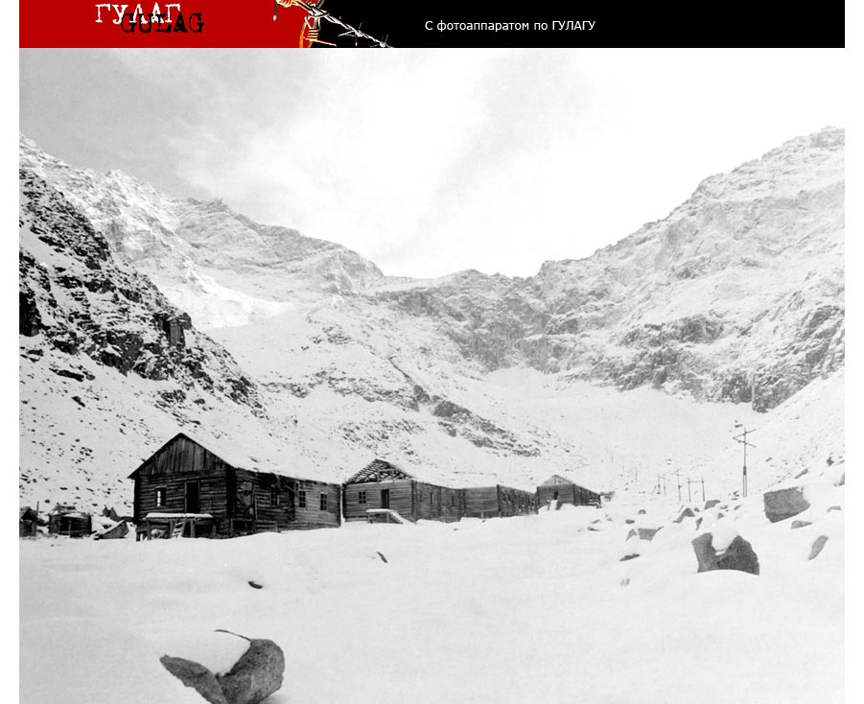

Typical barrack (houses) for communist prisoners in Soviet concentration camps.

He gave only one kind of punishment – 15 days in a punishment cell – being the reason of it a ridiculous official report of supervisors or simple toadies-prisoners (“arm-band wearers”, “red”). Any attempt to explain something, was answered by the growl: “And you... are dissatisfied! 15 days more!!”

As a result about 90 % of prisoners suffered gastric diseases, about 20 % - tuberculosis, about - 10 % venereal illnesses. The cases of suicide were quite frequent, especially in isolation wards and penalty cells*.* For example, prisoner Bogdanov couldn’t endure tortures and hung oneself in the punishment cell.

The tyranny of the “red” reigned in a concentration camp. They beat “muzhiks”[9] and those who did not want to enter in SIO (section of the internal order) i.e. to become "red".

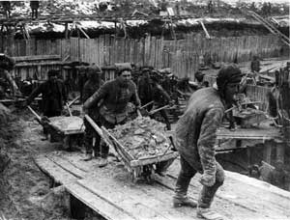 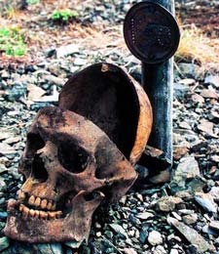

Works in communist concentration camp

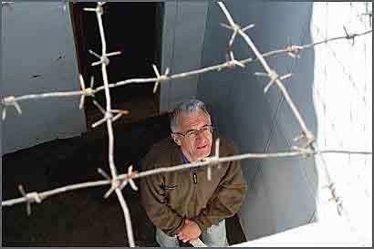  
 “Well” for 30 – 45 minutes per day walking in political concentration camp #36 (Perm region). Below is excursionist. In same “well” A. Bolonkin walked more 3 years.

Druj didn’t disdain every possible fraud. In particular, using work of prisoners, he produced under the orders of the nomenclature (communist and soviet commanders) for a symbolical payment wonderful furniture sets, repaired motor vehicles, sold “written off” materials and thus held in dependence the Heads of the Ministry of Internal Affairs, Office of Public Prosecutor and top management Buryat ASSR, including a regional committee. And as a matter of fact all management of the Buryat republic was connected by cover-up and represented a united mafia.

Finally (already after my discharge) Druj was caught on bribes, but got off an easy fright and was sent on pension with honour. Nowadays he lives in a 3-room apartment in Ulan-Ude, 670000, Borsoev street, 29-37 (Phone: 2-93-12).

But even being a pensioner he keeps those habits and he treats people as cattle. Once I saw when he ignoring huge queue in the shop gave the check to the seller. When I asked: “Why haven’t you stood in a queue?” He answered with a children’s naivety: “I have not noticed it!”

Convicts told, that Druj ordered to collect all cats in correctional institution in a bag, threw a bag in a fire-chamber of boiler-house and observed as they shout and rush on fire. Other event took part in my presence. Someone found prisoners’ bowls in a hole of isolation wards toilets (excrement pit). Druj ordered to put the food in them.

However his deputy Kruglov N.J. living now in Ulan-Ude in avenue of 50 years of October 22-19, phone: 9-46-07, and also the chief of criminal investigation department Bykov B.А. (Ulan-Ude, 670033, Krasnoflotskaya street, 26-15) didn’t differ from him much. Cruelty was inhering especially to ACC (the on duty assistant to the chief of a colony) Polyakov (settlement Southern, Bagdata street, 15, 30083, 248), who studied at Ulan-Ude Technology Institute where I worked during the second exile. He wanted to put me in a punishment cell because I had picked up the scraps of “Rules of behaviour of prisoners” in dust.

It was surprising, that all these people when casually meeting me after the discharge did not feel any confusion even in the period of perestroika. They didn’t even think that their actions towards political prisoners could be estimated as criminal.

From all the maintenance staff of the concentration camp only doctor Baklanov Nikolay Artemjevich was kind to me. But his possibilities were rather limited.

Druj, being a Jew, tried especially hard to gain favour of KGB. He headed for my direct destruction. About 9 months (285 days) he kept me lightly dressed in a cold punishment cell on a pound of brown bread and water; and the rest of the time, almost 2 years, I spent in an intracamp prison.

It is impossible to describe those tortures and mockeries I endured. I was held in cells with ice-covered walls in shabby prison clothes, placed in not heated box which external door was covered with ice and was opened for 2-hour “airing” when the temperature outside was 400C degrees below zero. They placed me in the dark damp cell with wood louses, cockroaches, smelly close-stool. The 6 sq. meters cell was filled with 6-8 people so we had to sit and sleep on a dirty floor.

Criminals, especially “red” ones were encouraged to beat and terrorize me. My requirements of the single maintenance got the answer: “it is not supposed”. And my complaints were simply thrown out.

I recollect my stay at Druj concentration camp as a continuous nightmare. The matter wasn’t only in the constant famine which led up to hungry faints. The main torture was cold causing a fever and spasms of the exhausted organism. It was allowed to wear only pants, a T-shirt, thin cotton prisoners’ trousers and a jacket. And it was all. The walls were covered with ice, the door to the corridor was opened for “airing” and the batteries were cold. The temperature in the cells could keep only due to bodies of prisoners. And what heat the hungry person and his spoiled stomach could evolve?

It was especially cruel at night. One had to lie curled up, having pulled jacket on head and trying to breathe under it so that the heat was kept. One needed to wake up in 1.5-2 hours of a wild fever, to jump on, skip and wave hands to warm up a little and to stop the shakes.

By all these tortures KGB and Druj tried to achieve only one goal: Do repent, speak on television.

All my complaints in the Office of Public Prosecutor, other institutes and personally to the public prosecutor on supervision for Correctional Institution Grishinu I.A. (Ulan-Ude, 670015, Pavlova street, 65-30, ph. 2-11-32) were thrown out or remained without the answer.

1. **Third arrest and fabricating “a new case”**

Ten days before the end of the second term they brought me all ill hardly keeping on legs from penalty isolation cell and presented new accusations. They said I agitated criminals in concentration camp against the Soviet authority. But how could I agitate being constantly in a one-man punishment cell, and why did I have to agitate those who were put to terrorize me and how could multiply convicted people, spending all life in concentration camps undermine poor Soviet authority? However these reasons were ignored.

About 40 “active” criminals signed the testimonies necessary to KGB. They received their parcels, sendings, and appointments to relatives at once. Among them there were such especially trusted, appointed to cushy lobs prisoners as robber Smirnov S.V., gangster Nizhmakov J.L., murderer Rabzhuev V.D., bribe taker Mironov V.E., the homosexual (“cock”) Tolstonogov S.M., etc.

Many of them, for example, Smirnov S.V., Rabzhuev V.D., Nazarov V.P., Rybikov V.D., scribbled the false denunciations even earlier. I didn’t speak a word to many who signed the testimonies against me. Moreover I didn’t have any idea of agitating them against the Soviet authority (which majority of them hated anyway), of undermining it or of killing communists. Democratic movement would have discredited itself forever if began to involve criminal elements like Bolsheviks (communists).

But the logics was not necessary to the KGB inspector Kozhevin V.A. He was not ashamed to charge me even corresponding with Ginzburg A.I., Korsunskaya M.V., Shihanovich J.A., Ljubarskiy K.A., Podrabinek A.P., Romanova A.J., etc. when I was in a concentration camp and in exile, denunciations of KGB agents Vannikov E.K., Polienko G.S., Tugarina L.A., Erdyneev A.B., Gilbuh, and others during my stay in settlement Bagdarin. It was typical, that they had not charged those denunciations when fabricated the second case in 1978, and kept them for the following one.

However my neighbours in settlement Bagdarin Armenians Akopjan G.B. and Oganesyan G.A., who were caught on hook by KGB for frauds with gold, had signed false indications too.

The manuscript of memoirs ***“Common communism”*** about my stay at Mordovian concentration camps and the photo where I held a poster “*I Demand departure from a communist heaven to a capitalist hell”,* found by Najdanova T.B lodged in my room after my arrest caused special hatred.

For the sake of justice it is necessary to note, that not all criminals agreed to become perjurers. Prisoners Avramenko I.V., Kurenkov V.R., Vlasov M.P. refused to sign the “necessary” evidences and had suffered cruel torments and tortures in penalty isolation wards and penalty cells.

In investigatory prison of Ulan-Ude I was kept in full isolation only with informers, subjected to continuous terror and tortures. I recollect all my stay there as a continuous nightmare. I had seen enough and had heard such things that even Nazi prisons and concentration camps would seem a toy in comparison to those mean and hypocritical methods used by communists Ivanov, Kodenev and others.

Being sick and completely exhausted I denied all accusations and solicitations of KGB about the repentance and appearing on TV during eight months of investigation. On 9-th month Kozhevin has brought thick volumes of the “testimonies” of “witnesses” collected against me and said: “Here is your case. Confess or you will receive 15 years, and we shall create conditions that you won’t live more than one year, or do appear with repent and become free!”

I was condemned on case alone, my “repentance” could damage only my own reputation, all intellectual dissidents knew what methods it was usually achieved by. After several days of thinking I decided to agree. Taking into account, that it was 1982 and the period of “publicity” and discharge of political prisoners was still very far, I can absolutely truly tell, that if I had not agreed, I would not be alive now.

Certainly, then I met people who blamed me for that, but usually they were those who weren’t imprisoned, or the people repenting and betraying others on investigation, but whose repentance was not given to publicity. Usually publicity was given to the repentance of the dissidents who were widely known abroad and in the USSR. I can accept condemnation of those who spent the same years in prison, were subject to tortures, torments and pressure as I was. But I do not know such people. The repentance of the overwhelming majority was not brought to publicity not to make an impression, that there were a lot of political prisoners in the USSR, and for the proof of sincerity of these people they were forced to spy on their friends.

They treated and fattened me in prison hospital more than a month so that I looked decently. Then they brought me to KGB, and forced to dress a clean shirt, a tie, a jacket, made me sit down to table so that prison trousers and tarpaulin boots were invisible and gave me the text 5 minutes before the record. Having fluently run it I asked to exclude mentioning dissidents, but I was strictly answered, that the text is given from Moscow authorities and it had to be read precisely in that way. During record I tried to omit, to change something but Kozhevin followed on a copy and forced me to read the text again.

I do not know what they arranged from those two records for I was in prison during the broadcast. Having discharged I ascertained that communistic scribblers quoted in their articles ostensibly my statements which I never said, and by virtue of the belief could have never said. Nobody informed about those articles and I learned about some of them only after my arrival to the USA.

I have brought an action against authors of the articles known to me being in Ulan-Ude, but all my applications were not taken into consideration at all.

Nevertheless despite of my repentance and promises of KGB I was judged for the third time and convicted a year in correctional labor colony (the period of investigation and court procedure) and 5 years of the exile.

**17. Second exile.**

They placed me in the second exile to Ulan-Ude and employed me as a senior scientific employee in East-Siberian Technology Institute (ESTI) on the faculty of computer engineering, which was headed by the senior lecturer Muhopad Jury Fedorovich.

At that time I was the only Doctor of Science in Buryatiya. Basically I cooperated with factory "”Teplopribor”, ( Heat Devices) rather with its engineering department (under the management of Gluhoedov J.N.) and a department of new techniques in development of new devices and appliances. There were contacts with huge Ulan-Ude aviation factory, ship-building and locomotive-carload factories, with the Buryat office of the Siberian branch of the Academy of Sciences. They were compelled to send me on scientific affairs in business trips to an academician city in Novosibirsk and even sometimes to Moscow.

For the period of the exile from the moment of the discharge (the end of April 1982) and up to the end of 1987 I had made 13 inventions in the field of astronautics, engines, heating engineering. Some of them had been made secret at once.

Certainly I was exposed to continuous spying of KGB. The employees of faculty had been ordered to watch me. Any my statement, even like “the weather is bad today”, was interpreted as running down the conditions of life in the USSR with the purpose of undermining the Soviet authority. The informer of KGB senior lecturer Zubritskij E.V. tried especially hard. Some heads of institute and even KGB curator in ESTI Leskov A.S. (Ulan-Ude, Geologicheskaya street 16-15, ph. 3-68-32) told me about his denunciations to me and other employees.

As soon as so-called “perestroika” in 1985 began I wrote the application for refusal from television performance, said in what methods it had been received*,* and declared, that there was none my word in the text composed by KGB. That application was sent to many central newspapers, but none of them published it.

In 1986-87 that application was handed over to Sergey Grigorjanets, the editor of the newspaper “Glasnost” (Publicity) and to Peter Starchek, the associate editor of “Express-Khroniki” (Express chronicles). The brief message on it appeared in the annual “Messages from the USSR”, 7-19, 1987.

As it was already said, I tried to prosecute communistic newspapers and authors of the pasquinades covering my case and quoting ostensibly “my” statements, but my applications were not accepted.

After all that and after handing in an application to departure from the USSR the management of the institute, regional committee of the CPSU had worsened their attitude to me. I was refused in departure and KGB began to fabricate a new case. On behalf of criminals of the concentration camp Druj organized the collective letter with the requirement to bring to me to court as not going to reform and continuing to slander the Soviet authority. Soon he was caught bribing and was transferred as an instructor to a juvenile colony, and then he was with honour sent on the personal pension. He even kept all his militia ranks. However by that time perestroika gained sufficient force, the authorities began discharging political prisoners and chairman of Buryat KGB department Vereshchagin G.I. hadn’t dared to make a new political case. Probably he was prohibited to do it from Moscow.

In the determined 6 months after the refusal in departure I wrote the new application in a very sharp form. I remember there were such phrases as: *“Why do you seize me as dogs. Anyway I was and I would be an enemy to your fascist-communist regime and I would always struggle against it”.*

In some months the departure clearance came, I left to Moscow and in the beginning of June 1988 I left the USSR.

Already after my departure Anatoly Golovkov's article ***“Time for reflection”*** appeared in “Ogonyok” #4, 1989, page 6. For the first time in official Soviet press was put a question about the illegal condemnation of dissidents of Brezhnev period and labeling them as “apostates”, “slanderers”, “and agents of world imperialism” and “enemies of the people”. My “case” was described and the question from rehabilitation of all victims of Brezhnev’s arbitrariness was put.

After my arrival to the USA I published a number of articles in the Soviet and foreign press in defense of political prisoners. These were the articles ***“About rehabilitation of victims of communistic arbitrariness”*** (the newspaper “The Soviet Youth” fromAugust, 7 1990), interview ***“While the Communist Party is in power there cannot be a true democracy in the USSR”*** (“The Soviet youth” from October, 19 1990), article ***“Memorial Day of victims of the Bolshevism"*** (the newspaper “The New Russian Word” from September, 7 1991), etc. There were organized demonstrations near the Soviet representative office at the United Nations and letters in protection of people, whose cases were concocted on political causes. Certainly it is difficult to expect something from former communists who “recoloured” themselves to “democrats” with the purpose of retaining the power and began to wreck national economy, to worsen conditions of life of the population, to cause revolts and to come to totalitarianism again.

We cannot but hope that they won’t manage to do that and the republics entering the former Soviet Union will become democratic, civilized and prospering states closely cooperating among themselves and observing human rights; cannot but hope that the victims were not vain.

**Alexander Bolonkin**

Ph. /Fax 718-339-4563 USA. E-mail: aBolonkin@juno.com ,

or aBolonkin@gmail.com

http://Bolonkin.narod.ru or http://geocities.com/Bolonkin1

Address: A. Bolonkin, 1310 Avenue R, #6-F, Brooklyn, NY 11229 USA.

**Communist concentration camp in the USSR**

<http://www.memo.ru/history/NKVD/GULAG/maps/ussri.htm>

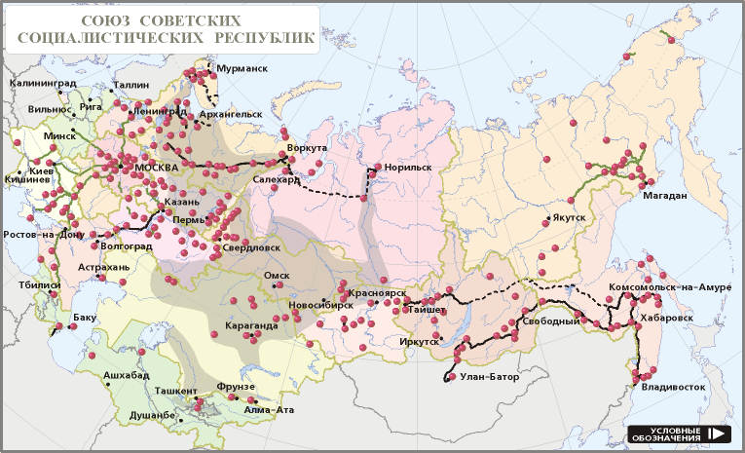

Map of communist concentration camps in the USSR

<http://www.memo.ru/history/NKVD/GULAG/maps/kazakh.htm>

About 60 millions of Soviet people were obliterated in the USSR

Обозначения:

http://www.memo.ru/history/NKVD/GULAG/maps/legenda.htm

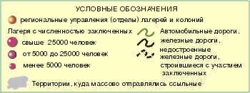

Notations:

concentration camps more 25,000 men

concentration camps from 5,000 to 25,000 men

concentration camps less 5,000 men

**- - -** unfinished railway constructions made by prisoners

regions of mass exile people

**Appendix 1**

**(On the materials of radio station “Svoboda”)**

**1. “AMNESTY INTERNATIONAL” STATEMENT**

13.3.75LONDON In connection with forthcoming visit of chairman of All-Union Central Council of Trade Unions SHELEPIN to Great Britain English branch of the International public organization “International Amnesty” has placed a letter in the London newspaper “Times”.

In the letter, signed by the chairman of branch POLE ESRTREIHER and director DAVID SIMPSON placed information that when SHELEPIN arrives to the Great Britain, it is necessary to tell him politely but firm what Englishmen think of imprisonments in camps and prisons of heterodoxies in the Soviet Union.

In 1973 the senior lecturer of the Moscow Aviation Technology Institute, Doctor of Science ALEXANDER BOLONKIN had been sentenced to four years of the imprisonment for he ostensibly called workers for strike as a token of the protest against economic system in the USSR.

In the end of the letter it is pointed that when SHELEPIN arrives to Great Britain, members of the English branch of the organization “Amnesty” should make attempt to meet him and to express their concern about similar cases of violating human rights in the Soviet Union.

Radio ***“Svoboda”***

1. **THE LEAFLET OF CIVIL COMMITTEE**

*The three leaflets of Civil committee published further were distributed in Moscow in the beginning of June, 1972. On June, 19 messages on these leaflets were transmitted to the West by the foreign correspondents accredited in Moscow.*

*The editors of “The Free word”*

On the night of June, 1 1972 more than 3.5 thousand similar leaflets were spread in letter boxes in 8 areas of Moscow

CITIZENS!

We hardly make both ends meet!

June, 1 1972 is 10 years from the date of increase in prices. They have been raised right after the XXII congress of the CPSU on which “the Program of construction of communism” was accepted. Talkers promised: “within first ten years all strata of Soviet people will be prosperous, will be financially secure… we’ll do away with lack of dwellings by that time”.

And suddenly in 62— rise in prices! They began to whine:

“This is an interim measure... There is no doubt, that in the near future it will be possible to reduce retail prices”.

And we had a hard fight to make the two ends meet!

Ten years passed. The prices still grow. We are being robbed everywhere! The Soviet and party top devours huge means. Closed sanatoria, cars “Chaika”, special food ration, dachas, and special hospitals— here are their privileges!

And we hardly make both ends meet!

To "Friends" abroad — grain, oil, meat, sugar, fabrics, guns, tanks, rockets.

And we hardly make both ends meet!

Citizens! Struggle! Let the struggle of workers of capitalistic countries be an example to you! Let Poland of December, 1970 be an example to us! Let strikes and statements of workers of Moscow, Leningrad, Novocherkassk, Temirtau, Chirchik and Kaunas be an example to us!

STRIKE! GO TO THE STREET! FREEDOM! FREEDOM! FREEDOM!

1. **А. BOLONKIN’S APPEAL TO N.PODGORNYJ**

**The most bloody, false and hypocritical regime!**

*To chairman of Presidium of a Supreme Soviet of the USSR Podgorny N.V. Copies:*

*To the governments of the countries which have signed the Helsinki agreements*

*from the former political prisoner, Doctor of Technical Sciences Bolonkin A.A.*

*Address: 671510, settlement Bagdarin of Bauntovskiy area Buryat ASSR, poste restante, to Bolonkin A.A.*

Mister Podgornyj!

As I know, the instruction to fabricate against me any (most desirably criminal) “case” is given to the local KGB office.

Not having satisfied with a fabrication of political “case” against me in 1972, beatings, tortures, mockeries and hard labour in your prisons and camps, you do not want to leave me alone even after my 4-year stay in the confinement, to enable me to leave your “socialist heaven” for “a capitalist hell”. This is the roughest violation of the Helsinki agreements, the General Declaration of Human Rights of the United Nations, the International Pact on the Civil and Political Rights, the Soviet Constitution.

Once and again I confirm my refusal of the Soviet citizenship, I continue to demand departure from your “heaven” and I still think your totalitarian regime to be the most bloody, false and hypocritical one from all which had existed in a history of mankind.

Damn it forever!

May, 1977 ***A. Bolonkin***

**4. Appeal of academician Sakharov in A. BOLONKIN’s defense**

АS №4319. Andrei Sakharov. “Appeal in A. BOLONKIN’s defense”, Gorky, 3.5.81.

**Appeal in Alexander BOLONKIN’s defense**

Alexander BOLONKIN is arrested in a concentration camp in ten days before the end of the second term. He is accused on second part of Asset 70, of the Criminal Code of the RSFSR /slanderous lies with the purpose of undermining or weakening Soviet public and a political system/, that threatens him ten years of the confinement and five years of exile more above those nine years of the most severe tortures and unfair reprisals through which he has already passed. Mathematician - cybernetician BOLONKIN was arrested for the first time soon after he defended his thesis for a doctor's degree on the theory of control. He was accused of distribution samizdat magazine “Chronicle of the current events” and then, in 1973, he was condemned for four years of camps and two years of exile. That verdict was completely illegal, as the “Chronicle” is just an informational magazine and it does not have purposes of undermining or weakening the system. BOLONKIN’S thesis for a doctor's degree wasn’t approved by the Certifying commission, and the manuscript of his monograph was stolen. On way to camp he was beaten, his arm was fractured. After 4-year stay in camp and almost full term of the exile, one month to the end of it, he is arrested and condemned on falsified accusation for three years of camps. And again he will be judged, this time in a camp court - with usual in such cases false evidence of other prisoners, caused by threats, beatings or promises of inspectors.

I address to mathematicians – Alexander BOLONKIN’S colleagues in the USSR and in all countries, to all scientists, to all honest people. I address to the Heads of all governments which have signed the Helsinki Act, to all state and public figures, art and business workers who can influence the Soviet heads, I address to Amnesty International. Speak in support of Alexander BOLONKIN.

**May, 3 1981** **Andrei SAKHAROV**

**Nobel Prize winner**

**5. Appeal of Elena Bonner and other members of Moscow group “Helsinki” in A. BOLONKIN’s defense**

АS №4333.- 4 members of Moscow Group (Е.Bonner and others). Document

№166. “Alexander BOLONKIN’s Imprisonment become termless”

(Moscow), 30.4.81.

Moscow group of assistance to execution Helsinki Agreements in the USSR

April, 30 1981 Document №166

**Alexander BOLONKIN’s Imprisonment become termless**

Alexander BOLONKIN is arrested on April, 10 1981, ten days before the end of the second term of holding in custody verdict in concentration camp near to Ulan-Ude. The chief of KGB investigatory department PROZOROV informed BOLONKIN’s wife, that legal proceedings against him on the second part of Asset 70 of the Civil Code of the RSFSR is instituted and investigation is conducted.

Alexander BOLONKIN /1933/, the mathematician - cybernetician, Doctor of Technical Sciences /his brilliant dissertation wasn’t approved by Certifying commission in connection with his arrest; in 1973. Certifying commission deprived him a rank of the candidate of sciences /.

In September 1972 BOLONKIN was arrested and condemned to four years of confinement and two years of exile on the basis of the second part of Asset 70 of the RSFSR Criminal Code /anti-soviet agitation and propaganda / for possession and distribution samizdat literatures and documents.

After the dischargefrom concentration camp BOLONKIN was in exile in settlement Bagdarin of Buryat ASSR where he worked in a workshop of a service centre.

On April, 20 1978, 26 ten days before the end of the exile term, BOLONKIN was repeatedly arrested and condemned on artificially created accusation in private business activity and theft to three years of the confinement and 26 days of exile. During stay in concentration camp Alexander BOLONKIN **/**on the first, and on the second verdict / was repeatedly exposed to persecutions of administration: placed in penalty isolation wards and penalty cells, deprived of appointments, etc.

BOLONKIN declared hunger-strikes of the protest time and again.

On April, 20 1981 the wife (1) and the 14-years son (2) waited for Alexander BOLONKIN’s discharge. Instead of the news about his liberation they received the message on his new arrest, for the third time already.

As none active propaganda including “anti-soviet” one is possible in the conditions of concentration camp, the accusation on Asset 70 of the Civil Code of the RSFSR is simply absurd.

Second part of the Asset 70 of the Civil Code of the RSFSR stipulates imprisonment for the term up to 10 years with the subsequent exile up to five years.

As Alexander BOLONKIN had already served time on that Asset he will inevitably be declared a dangerous recidivist that will cause serving punishment in inhuman conditions of a camp of special regime.

After 9-years stay in camps and exile BOLONKIN’s health is fully undermined /chronic gastritis, a cholecystitis, rectal inflammation /, and a new long term can become a lifelong term for him.

We draw attention of the heads of the governments which have signedthe Helsinki Act, scientists of all countries and world community to Alexander BOLONKIN’s tragic destiny to make all possible for his discharge.*\*

Members of Moscow group "Helsinki":

Elena BONNER

Sofia KALISTRATOVA

Ivan KOVALEV

Naum MEIMAN .

- - - - - - - - - - - - - - - - - - - - -

1. Margarita (Chronicle 40:20, 46:109).

2. Vladimir; 1965, according to the verdict to A.Bolonkin and V. Balakirev of Moscow City Court from 22.11.73 (АS №2631:1); 1968 ("The list of USSR political prisoners... News from the USSR").

Reprint of the original photocopy from AS.

**6.From radio broadcast of radio station “Svoboda”(RFE-RL)**

RADIO SVOBODA: ANCILLARY MATERIALS OF RESEARCH DEPARTMENT РС 86/81 **May, 8** **1981**

**ALEXANDER BOLONKIN IS THREATENED THE THIRD TERM**

Vishnevskaya

The Nobel prize winner academician Andrei Sakharov has addressed to the scientists and to the governments of the countries of free world with an appeal to support Alexander Bolonkin who is threatened with a new term - up to 10 years of imprisonment with five years of the subsequent exile - on accusation in “anti-soviet agitation and propaganda” /Asset 70 part 2 of the Civil Code of the RSFSR /. That new (already third) accusation had been presented to him 10 days before the end of the term on his second verdict, on April, 10 1981 /I/.

Alexander Aleksandrovich Bolonkin was born on March, 14, 1933. Before the first arrest he had been the senior lecturer of the Moscow high technical school of Bauman, Doctor of Technical Sciences., the author of about 40 scientific works. Bolonkin was first arrested on September, 21, 1972 andsince then he wasn’t free for a day, but was in confinement with almost 2-years break to the exile in Transbaikalia in Eastern Siberia.

The first court procedure on Bolonkin’s case took place in Moscow on November, 22, 1973. Bolonkin and his sidekick Valery Balakirev were accused on Asset 70 part 2, the Civil Code of the RSFSR. Particularly Bolonkin was incriminated: listening to and distribution of transfers of foreign radio stations in Russian; producing of the multiplying device mimeograph and copying “the Chronicle of the current events”, magazine “Democrat”, a leaflet signed by “Civil committee”, “My Testimony” by Anatoly Marchenko, “Will Soviet Union exist till 1984?” by Andrey Amalrika, translation of the book of Robert Konkvista “The Great Terror” and other materials.

Besides in 1971-72 Bolonkin distributed approximately 15 his own samizdat works signed by various pseudonyms with criticism of social regime and standards of living of workers in the USSR. In particular, under A.Vasiljev pseudonym Bolonkin wrote the great work under the name “Comparison of standard of life of workers in Tsar Russia, in the USSR and in the capitalist countries. Statistic data” /2/.

Together with the accomplice Balakirev Bolonkin issued samizdat magazine “Svobodnaya mysl” (*Free Thinking)*. On November, 22, 1973 the judicial board on criminal cases of the Moscow city court sentenced him to 4 years of concentration camps of a strict regime and 2 years of exile/З/.

At the end of September, 1976 Bolonkin was banished to settlement Bagdarin in Buryat ASSR. Before the end of the exile he was arrested for two months on accusation of “theft of his own salary”. During investigation Bolonkin was beaten “and threatened to be killed by the hands of criminals” if he didn’t confess to a crime. The court took place on August, 4, 1978 in settlement Bagdarin. In court he was deprived of texts of the law, extracts from the case, and wasn’t allowed to speak. According to Bolonkin’s words many of the documents presented by him had disappeared from the case, and a number of other documents were forged by the inspectors. That time Bolonkin was sentenced on the basis of Asset 93, part 2 of the Criminal Code of the RSFSR “the theft of the state or public property accomplished by swindle” to the maximal term of punishment according to that Asset - to 3 years of camps of strict regime and 26 days of exile/4/.

The punishment on the second verdict Bolonkin spent in “institution” ОV-94/2-B in a settlement Southern of Buryat ASSR. In this camp Bolonkin was several times placed in penalty isolation ward/penal isolator where it is possible to put a person for the term up to 15 day / and twice for 6 months in penalty cell / a room of cell type6 / . As a result of cruel treatment Bolonkin caught dysentery, was ill by chronic bronchitis, radiculitis, gastritis and other diseases.On May, 6,1980, almost one year before the third “arrest”, Bolonkin sent a letter to the General public prosecutor of the USSR and Minister of Internal Affairs of the USSR where he warned:

The administration without ceremony says that for the remaining year of my confinement they will bring me to my grave, undermine my health, or fabricate a new case/5/.

- - - - - - - --

1. AS №1670.

3. Verdict on Balakiriev and Bolonkin’s case **see** АS №2631; about the court **see** “Chronicle” # 30, page 5.

4. АS1*3624; РС 125/78 “Second trial of Alexander Bolonkin”; “Chronicle” # 51, page 31-32.

5. “Chronicle” # 53, page 95, “Chronicle” # 55,page 28; “Chronicle” # 56.page 112-113; “Chronicle” # 57, page 87-88; “News from the USSR”, editor Kronid Ljubarski, 1980, ##18-41 and 20-30.

6. In total Bolonkin was 1 year in penalty sell (SHIZO) and 2 years in penalty ward (PKT – special camp prison)

**7. To Alexander Bolonkin (poems)**

**Valeriy Rubin**

Перед пропастью страшной

обмирает душа...

Я Болонкина Сашу

обнимаю, спеша.

То ли передо мною

он на миг постарел,

то ли перед страною,

где он столько сидел.

Вот он — в сером костюме,

поприбавил морщин...

Я его после тюрем

провожаю один.

Объявляется вылет

и не выдержать мук,

сколько в карцерах вынес

этот доктор наук.

Не подумаешь, встретя,

что колючкой крещен...

Это в наше-то время?!

А в какое ж еще?!

Вот уже он с вещами,

переходит черту...

Невиновных — прощают,

никогда — правоту.

Вот его у оконца

человек обыскал...

На энергии солнца

он поднимает корабль.

Вот он встал вдруг и замер,

поднимает кулак...

Мол, уходит не насмерть!

Но для нас это так.

Вот он издали машет,

как на том берегу

и помочь тебе, Саша,

я уже не могу.

1988г.

Valeriy RUBIN (1938-1991) is a famous soviet poet and writer. He published his works in the leading Soviet literature magazines “Noviy mir” (*“New world”*), “Znamya” (“*The Banner*”), “Unost” (“*The Youth*”). In 1981 he published series of the critical poems in the western magazine “Continent”. Then they were read on radio “Voice of America”. He was persecuted for that in the USSR. He died in 1991. In 1994 his book “Obysk” (“Search”) was issued.

**Michael Litvin** (2004)

Ты страною своею был бит и гоним.

Много лет лагерей, а финал:

Никогда не вдыхать больше родины дым,

Где за правду полжизни отдал.

Помнишь, БУРов мордовских зловонную пасть?

Был унижен ты, но не сражен.

Хоть и маску сменила преступная власть,

Может зря все же лез на рожон?

Ты уже не внутри, но еще и не вне,

Чтобы памяти голос затих.

Кто у власти был – тот и сейчас на коне,

Ну а прочие все – при своих.

Ты прости если что-то сказал я не так.

Надо нам эту песню допеть.

Выпьем водочки, вспомним проклятый Сиблаг,

Шахты клеть, произвола плеть.

Рано тлеть нам, душа еще хочет гореть,

(Ей до срока не выгореть в шлак)

Ведь свободы приспущен истерзанный флаг

И России пока - болеть…

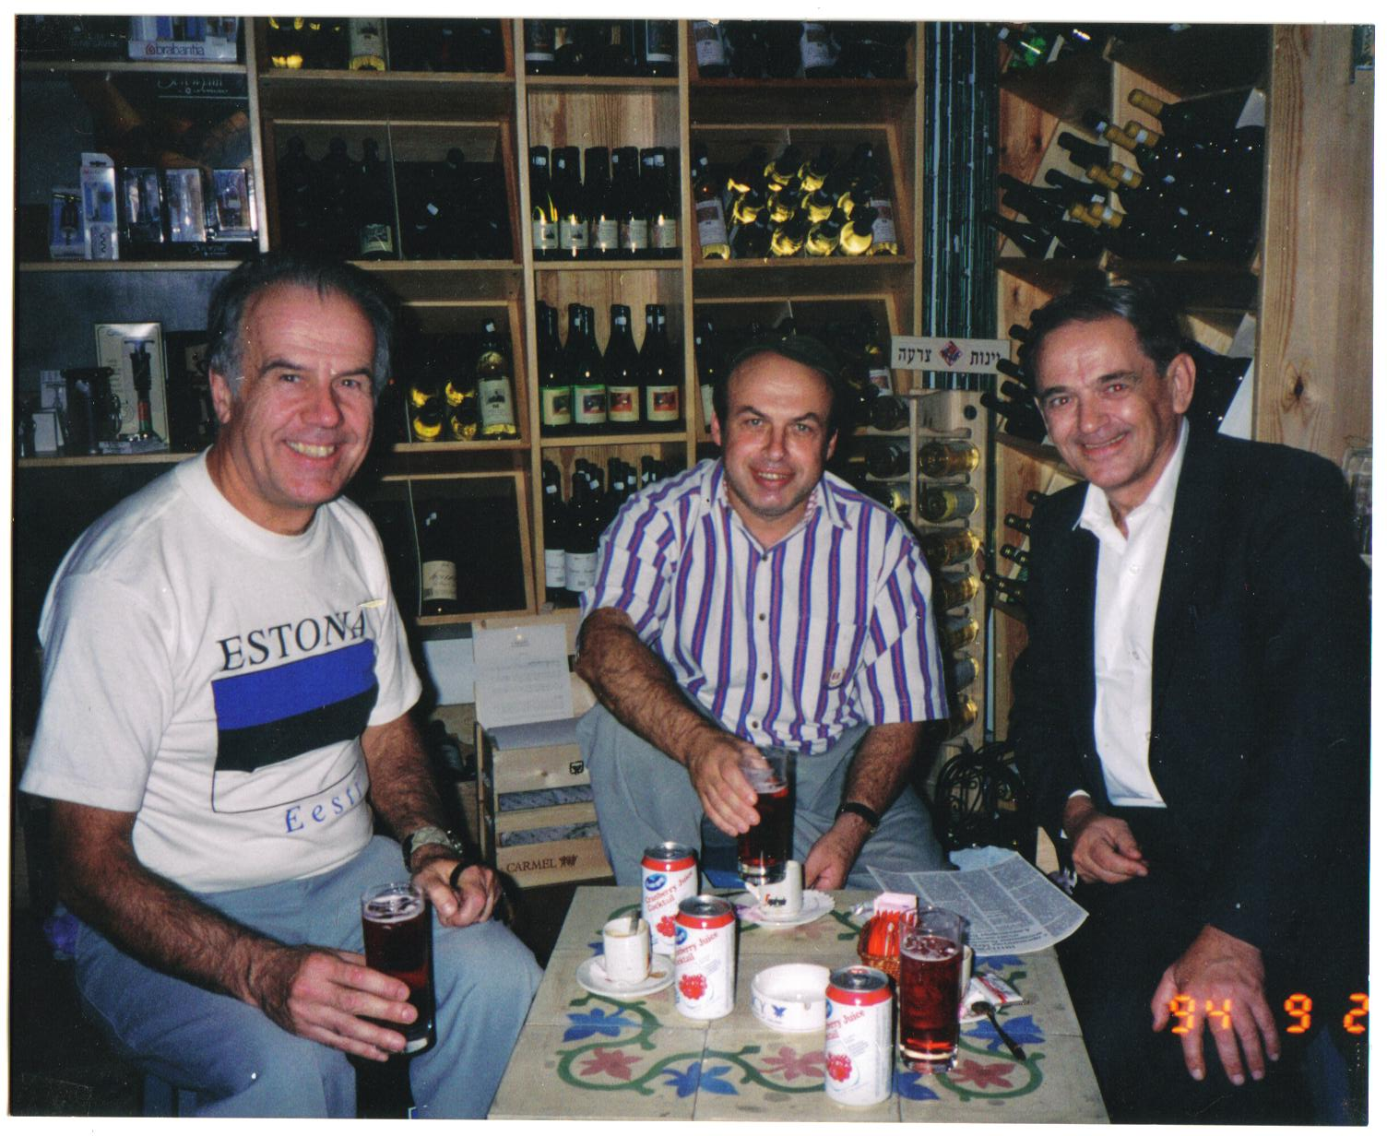

Meeting of former Soviet political prisoners in Israel 1994. Right is Alexander Bolonkin, middlie is Anatoly Tsceransky (later he will be an Israel Minister for Industry), lest is member of Estonia parliament .

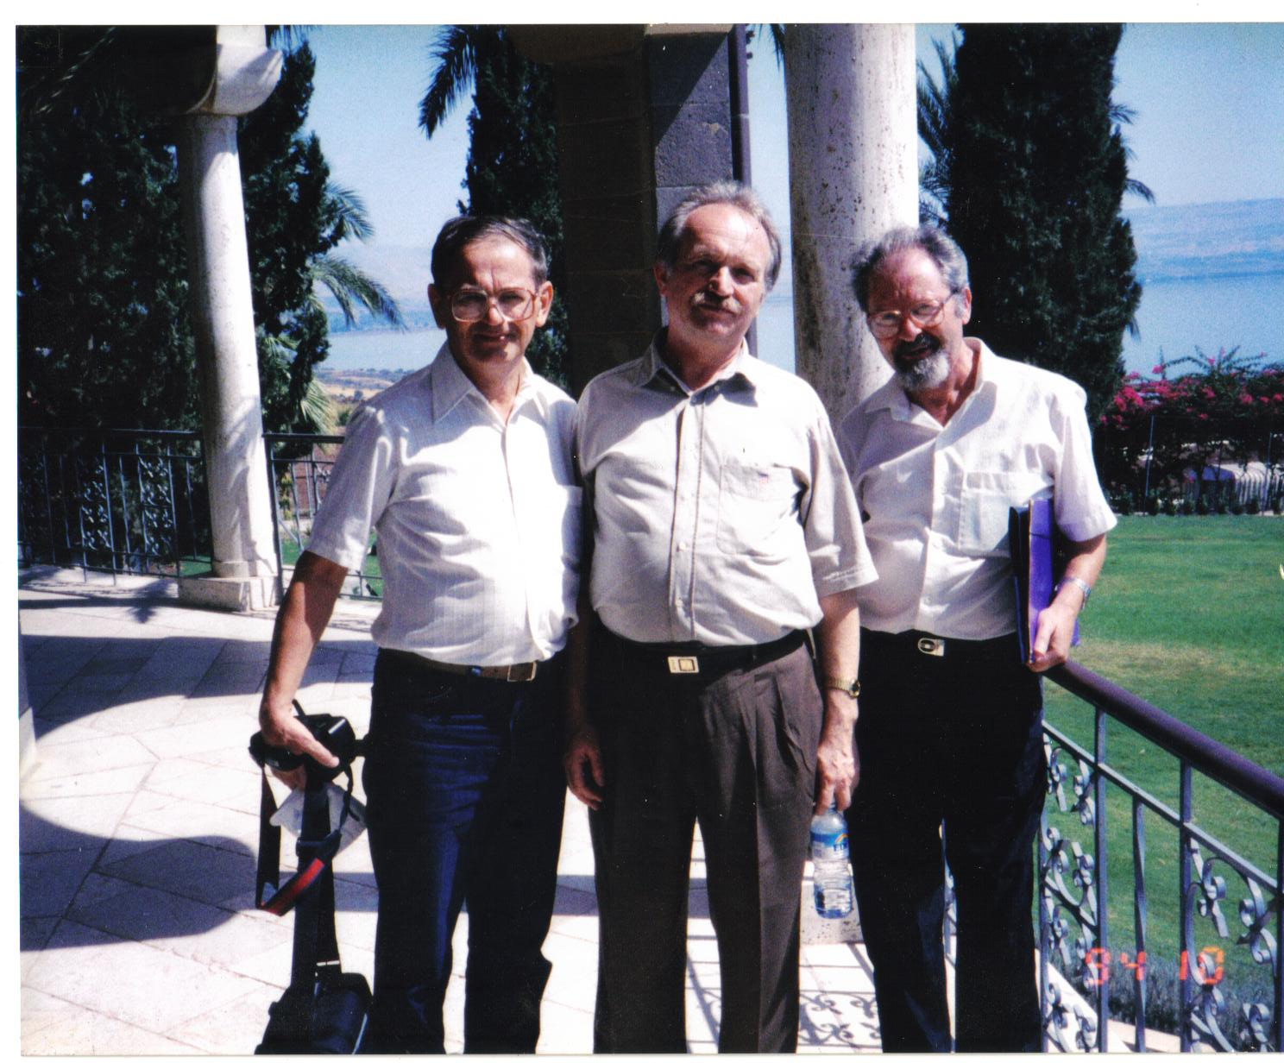Meeting of former Soviet political prisoners in Israel 1994. Left is Alexander Bolonkin, middle is Viacheslav Chornovil (he was candidate in Ukraine President), right is Suslensky – president of Israel-Ukraine Association.

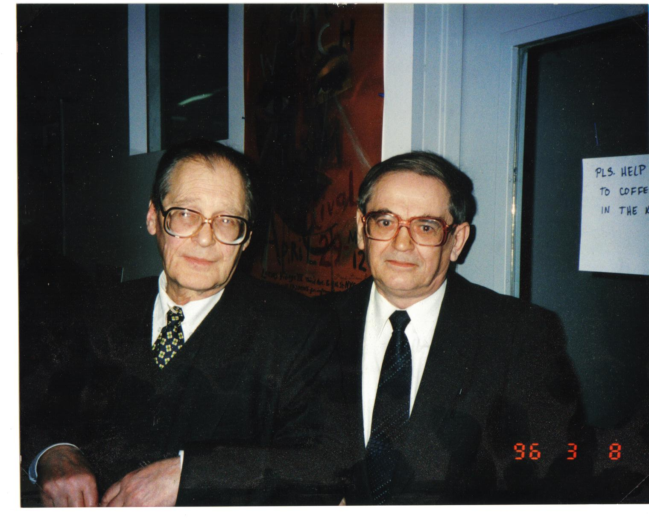Left is former Soviet political prisoner Sergei Kovalev – former member of Russian Congress (Duma) and adviser for Human Right of Russian President Boris Elsin. Right is Alexander Bolonkin, 1996.

**Appendix 2**

**Barbarities of communist secret police in the USSR**

After getting the Ukraine independence the authorities disclosure some barbarities of communist secret police in the former USSR. Below are pictures of some grave excavations.

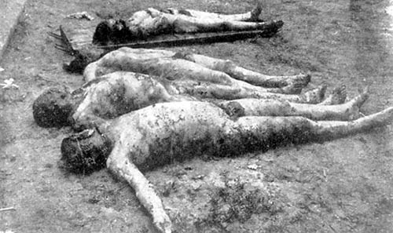

Corpses of 4 peasants-hostages (Bondarenko, Plokhikh, Levenets, and Sidorchuk). The faces are terrible cut, genitals are awful maimed.

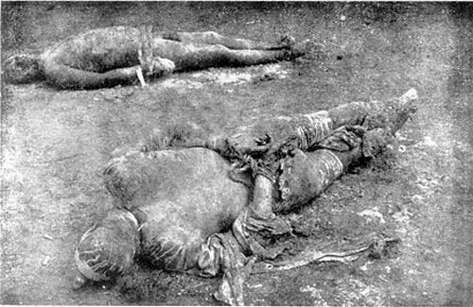

Peasants I. Afanasuak and S. Prokopovich were alive scalped. Afanasuak (he is close) has scorches from a red hot cabre.

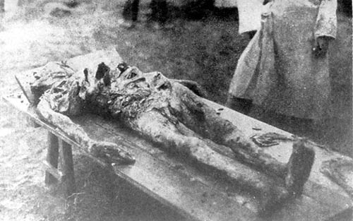

Corpse of hostage Ilia Sidorenko (from c. Sumi). He has fractured hands, ribs, cut genitals. He was torment to dead by communists in Kharkov.

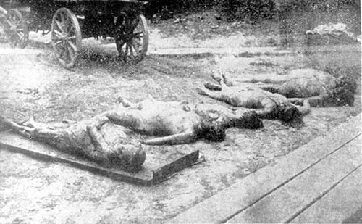

c. Kharkov. Corpses of women-hostages tormented to dead. The second from left is S. Ivanova. The third is A.I. Karolskaia. The fourth is Khlopkova. All were alive cut off the breasts. The pudendal fissures are parched and have carbons.

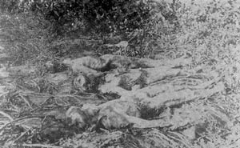

Corpses of 3 worker-hostages from a strike works. A. Ivanenko (in middle) burn out the eyes, cut out the lips and nose. The others have cut out the hands.

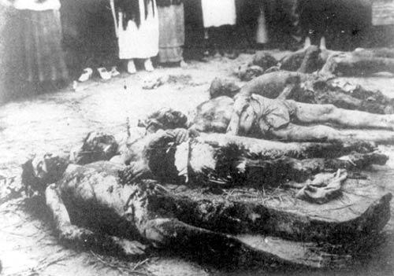

Corpses of hostages found in Tyalpanov house of Kherson communist secret police.

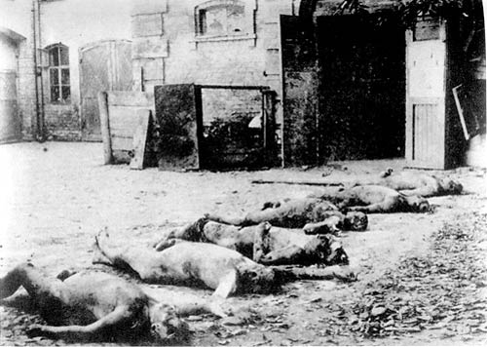

Courtyard of Kharkov communist secret police (Sadova Str. 5) with the corpses of executed people.

**Appendix 3**.

**Short Information of some persons mentioned in this book and in book A.Bolonkin "Ordinary Communism”.**(more recent data from Wikipedia and other sources are included. Yandex translation from Russian)

**Andrei Dmitrievich Sakharov (Сахаров А.Д.)**

(Born May 21, 1921, Moscow — December 14, 1989) — Soviet physicist, academician of the USSR Academy of Sciences, one of the founders of the first Soviet hydrogen bomb. Subsequently — public figure, dissident and human rights activist; people's Deputy of the USSR, author of the draft Constitution of the Union of Soviet Republics of Europe and Asia. Winner of the Nobel peace prize for 1975.  
 For his human rights activities he was deprived of all Soviet awards, prizes and in 1980; was expelled with his wife Elena Bonner from Moscow to Gorky. At the end of 1986 Mikhail Gorbachev under pressure from the West allowed Sakharov to return from exile to Moscow.  
 Sakharov's name is worn by 60 streets in cities and villages of Russia.  
**Biography**.  
 After graduating from high school in 1938, Sakharov entered the physics Department of Moscow State University. After the beginning of the war, in the summer of 1941 he tried to enter the military Academy, but was not accepted for health reasons. In 1941 he was evacuated to Ashabat. In 1942 he graduated from the University with honors.  
 In 1942 he was distributed at the disposal of the people's Commissar of arms, where he was sent to the cartridge factory in Ulyanovsk. In the same year he made an invention for the control of armor-piercing cores and made a number of other proposals.

**Scientific work** In late 1944, he entered the postgraduate school of the Physical Institute of Academy Science (scientific supervisor — I. E. Tamm). Employee of FIAN Lebedev remained until his death.  
 In 1947 he defended his thesis.   
 In 1948 he was enrolled in a special group and until 1968 he worked in the development of thermonuclear weapons, participated in the design and development of the first Soviet hydrogen bomb under the scheme called "Sakharov puff". At the same time Sakharov together with I. E. Tamm in 1950-1951 carried out pioneer works on controlled thermonuclear reaction. He taught courses in nuclear physics, relativity theory and electricity at the Moscow Energy Institute.  
 Doctor of physics and mathematics (1953). In the same year at the age of 32 he was elected a full member of the Academy of Sciences of the USSR, becoming the second youngest at the time of election as an academician in history (after S. L. Sobolev). The recommendation accompanying the presentation to the academicians was signed by academician I. V. Kurchatov and corresponding members of the USSR Academy of Sciences Y. B. Khariton and Y. B. Zeldovich, Sakharov was elected from the academic stage of passing the corresponding member.   
 In 1955 he signed the "Letter of three hundred" against the infamous activities of academician T. D. Lisenko.  
 Since the late 1950s, he has actively advocated the cessation of nuclear weapons tests. Contributed to the conclusion of the Moscow Treaty banning tests in three environments.

Since the late 1960s, he was one of the leaders of the human rights movement in the USSR.  
 In 1966, he signed a letter to twenty-five figures of culture and science to General Secretary of the CPSU Leonid Brezhnev against the rehabilitation of Stalin.  
 In 1968, Sakharov wrote a pamphlet entitled "Reflections on progress, peaceful coexistence and intellectual freedom", which was published in many countries.  
 In 1970, Sakharov became one of the three founding members of the Moscow human rights Committee (together with Andrei Tverdokhlebov and Valery Chalidze).  
 In 1971, he addressed the Soviet government with a "Memorandum".  
 In the 1960s and early 1970s, he went to trials of dissidents.  
 In the 1970-ies — 1980-ies in the Soviet press campaigns were carried out against A. D. Sakharov (1973, 1975, 1980, 1983).  
 August 29, 1973 in the newspaper "Pravda" published a letter from members of the Academy of Sciences of the USSR condemned the activity of A. D. Sakharov ("the Letter of 40 academics").  
 August 31, 1973, in the newspaper "Pravda" published a "Letter writers" with the condemnation of Sakharov and Solzhenitsyn.  
 In 1974 Sakharov has collected a press-conference on which has told about the Day of the political prisoners in the USSR.  
 In 1975 he wrote the book "About the country and the World". In the same year, Sakharov was awarded the Nobel peace prize. In the Soviet Newspapers published a collective letter of workers of science and culture with a condemnation of the political activity of Andrei Sakharov.  
 In September 1977, Sakharov wrote to the organizing Committee on the death penalty, which called for its abolition in the USSR and worldwide.  
 In December 1979 and January 1980, he made a number of statements against the Soviet invasion of Afghanistan, which were published on the front pages of Western Newspapers.  
 On 22 January 1980, on his way to work, Sakharov was detained, and then, together with his wife Elena Bonner, he was exiled without trial to Gorky — a city at that time closed to foreign citizens. Sakharov himself linked the link with his speeches against the Soviet invasion of Afghanistan. Then by the decree of the Presidium of the Supreme Soviet of the USSR, he was stripped of the title three times Hero of Socialist Labor and the order of the Council of Ministers of the USSR — the title of laureate of Stalin (1953) and Lenin (1956) awards (also of the order of Lenin, the title of member of the USSR deprived was not). In bitter Sakharov spent three long hunger strikes.   
 In 1981 he, together with Elena Bonner, withstands the first, seventeen-day - for the right to travel to her husband abroad L. Alekseeva (daughter-in-law Sakharov).  
 In July 1983, four of the academician (Prokhorov, Alexander Skryabin, Nikolai Tikhonov, Dorodnicyn) signed the letter "When you lose honor and conscience" condemning Andrei Sakharov.  
 In may 1984, Sakharov held a second hunger strike (26 days) in protest against the criminal prosecution of E. Bonnaire. In April-October 1985 — the third (178 days) for E. Bonner's right to go abroad for heart surgery. During this time, Sakharov was repeatedly hospitalized (the first time — forcibly on the sixth day of the hunger strike; after his statement on the cessation of the hunger strike (11 July), he was discharged from the hospital; after its resumption (25 July), two days later he was again forcibly hospitalized) and forcibly fed (tried to feed, sometimes it was possible). During the entire time of A. Sakharov's Gorky exile in many countries of the world there was a campaign in his defense. For example, the square five minutes ' walk from the White House, where the Soviet Embassy in Washington was located, was renamed "Sakharov Square". Since 1975, "Sakharov Hearings"have been held regularly in various world capitals.  
 Sakharov was released from exile in Gorky with the beginning of perestroika, at the end of 1986, after nearly seven years of imprisonment.  
 On December 23, 1986, together with Elena Bonner Sakharov returned to Moscow. After his return, he continued to work at the Physics Institute Lebedev.  
 In November-December 1988, Sakharov made his first trip abroad. He held meetings with U.S. presidents R. Reagan and J. Bush, France, Francois Mitterrand, Prime Minister Margaret Thatcher.  
 Died on the evening of 14 December 1989 from sudden cardiac arrest in his apartment on Chkalov street.  
 Sakharov buried at Vostryakovskoye cemetery in Moscow.

**Vyacheslav Chornovol (Chornovil)(Чорновол В.М.)** (Ukr. V'yacheslav Maksimovic Chornovil; 24 Dec 1937 — 25 Mar 1999).  
 Chernovol — Ukrainian politician, Soviet dissident, journalist, one of the founders of the People's Rukh of Ukraine, Hero of Ukraine (2000).  
 In November 1967, Chernovol was first sentenced to six years in high security concentration camp. The reason was his book "Woe from Wit."  
 Since 1970, he published an underground magazine "Ukrainian Herald", for which in 1972 he was sentenced for the second time — six years in prison and three years of exile. He served his sentence in Mordovia and Yakutia. In 1978 he was released.  
 On May 22, 1979 the cascade became a member of the Ukrainian Helsinki group.  
 In May 1980, he was arrested for the third time and sent to Yakutia for five years.  
 8-10 September 1989 with the participation of the street was created the "People's Movement of Ukraine for Perestroika" (later People's Movement of Ukraine).  
 On 30 March 1990, he was elected people's Deputy of Ukraine, receiving 68.60 % of the votes with 7 candidates (in the single-seat district). In April 1990, he was also elected head of the Lviv regional Council.  
 In October 1991, the Great Cossack Rada elected Chernovol the Hetman of the Ukrainian Cossacks.  
 On 1 December 1991, he took second place at the first election of the President of Ukraine, gaining 7 420 727 votes (23,27 %).

**Paruyr Arshavirovich** **Hayrikyan (Айрикян П.Ф.).** (Born July 5, 1949, Yerevan) — Armenian statesman.

**Biography**• Hayrikyan studied at Yerevan Polytechnic Institute (1966-1969) and worked as an electrician at a knitting factory.  
• He was a member of the underground "National United party of Armenia" from 1967. To 1969 he was arrested. He received 4 years of imprisonment, he served in the colonies of strict regime in Mordovia.  
• In 1973 — upon his return to Yerevan, he was placed under administrative supervision.  
• February 5, 1974 — for violation of supervision he received 2 years of the strong concentration camps, after the trial he was placed in the KGB detention center.  
• Since 1987 — Hayrikyan returned to Yerevan and together with his colleagues created the party "National self-determination".  
• In February 1988 — Hayrikyan accused the Soviet authorities of organizing massacres of the Armenian population in Sumgait, was deprived of citizenship and deported to Ethiopia, but then illegally returned to Armenia.  
• 1988-1992 — he was the leader of the national people's movement of the USSR, elected Chairman of the international organization "Democracy and Independence".

• 1990-1995 — Hayrikyan was Deputy of the Supreme Soviet of the Armenian SSR. He is a member of the standing Committee for the establishment of state independence and national policy. He is the Secretary of the Deputy group "Free parliamentarians".  
• 1992-1993 — he is the commander of the Gori district, took measures to ensure effective protection and organization of resettlement of refugees in Syunik Marz.  
• 1995-1999 — Hayrikyan is member of Parliament, Member of the standing Committee on foreign relations. Leader of the national self-determination party.  
• 1998-1999 — he headed the Commission on preparation of constitutional amendments under the President of Armenia.  
• 1999-2002 — Chairman of the human rights Commission of Armenia.  
• Since 2002-Hayrikyan is the leader of The United self-Determination party.  
• February 2003 — he was a candidate for President of Armenia.  
• In December 2012, he again announced his candidacy for the presidential elections 2013.   
• On January 31, 2013, he survived an attempt by being shot in the shoulder.  
  
 **Sergey Ivanovich Soldatov (1933-2003)(Солдатов С.И.)** engineer, teacher, writer   
 (The reference is made on memoirs of the wife, Lyudmila Gryunberg-Soldatova)

1933, June 24. — Soldatov was born in Narva (Estonia).   
1941-1944. — He's living in occupied territory.  
1950s — He worked at the mine, at gas-generating furnaces, as a factory electrician.  
1954-1960. — Soldatov studied at the Leningrad Polytechnic Institute. After graduation, he worked   
 in engineering positions in Tallinn: at The Volta plant, at the excavator plant. Lecturer at the  
 Department of mechanical engineering of Tallinn Polytechnic Institute. Work on the thesis on the   
 wear of metal-cutting tools.  
1960s, mid. — The beginning of persecution. For the spread of "bourgeois nationalism" among   
 students dismissal from teaching positions.  
1968. — Foundation of the underground group of the Estonian Democratic Movement (DDE) and later the "Union of moral and political Revival" with like-minded people. Work on the main documents of the DDE, articles and essays for Samizdat, the editorial Board of illegal magazines "Democrat" and "Ray of Freedom".  
1969. — Writing "Program of the Democratic movement of the Soviet Union (DDSS)", transfer for publication to the West.  
1970. — Writing work "Tactical fundamentals DDSS".   
1975, January. — Arrest.   
1975, autumn. — The Supreme court of the SSR sentencing to 6 years of strict regime camps for anti-state and anti-Soviet activities. Maintenance in the camp № 17 Zubovo-Polyansky district of the Mordovian Autonomous Republic.   
1976. — Condemnation of the son, Alexander Soldatov, for participation in a fight, a sentence to five   
 years of strict regime.  
1977. —Participation in a hundred-day strike.  
 Transfer to the political camp № 19 in the village of Lesnoye (Mordovia).  
1978, January 3. — Sending to the Presidium of the Supreme Council of the USSR Declaration on the legalization of DDE. The transfer on a date with his wife the article "The Twelve principles of the Russian business".  
1979. — Firing his wife from work.  
1980. — Transfer to the camp ЖХ-385 village Barashevo (Mordovia). The refusal of the offer to leave the Soviet Union after the end of the term. Stage in Tallinn prison "Battery". Hunger strike before the end of the term of imprisonment.  
1981, January 3. — Release from prison. Settlement with his wife in Tallinn. Administrative supervision. Deprivation of Soviet citizenship by decree of the Presidium of the Supreme Soviet of the USSR. Forced emigration.  
Receiving an invitation in Vienna from the German Amnesty international group to settle in West Germany. On the recommendation of A. I. Solzhenitsyn's getting journalistic work for radio Liberty: radio programs in the Estonian language.  
1984. — Awarding of the gold Medal of Honor at the meeting of the Estonian National Committee in Sweden. Speech in Italy to the participants of the Christian democratic movement.  
1987. — The Foundation of its own publishing house "West-OST Renaissance": the publication of all German-language works, four books in Estonian and most of the works in Russian.  
1988. — Trip to Tallinn and Leningrad. Publication of "Catharsis" magazine.  
1992. — Obtaining German citizenship.   
1995, February. — A trip to Moscow to meet with A. I. Solzhenitsyn.  
2000 . — Return to Estonia. Release of 4 books in Estonian and several almanacs.  
2003, January 24. — Soldatov died in the city of Tallinn. He was buried in the cemetery of Alexander Nevsky.  
2006. — Transfer of the heritage and archive of Sergei Ivanovich Soldatov to the national Library of Estonia. Publication of works under the title "Heritage and archive" in 15 volumes.  
2008. — Writing wife, Lyudmila Gryunberg-Soldatova the book of memoirs "The Dotted line my life."

**Ogurtsov, Igor Vyacheslavovich (Огурцов И.В.).**Ogurtsov I. V. ((b. 1937) — Russian political and public figure, leader of the anti-Communist underground in the USSR, founder and leader of the all-Russian Social-Christian Union for the Liberation of the People ((ВСХСОН)), a former political prisoner.

**Biography**

Ogurtsov was born August 22, 1937 in Stalingrad in the family of engineer-shipbuilder V. V. Ogurtsov a teacher of music Evgenia Mikhailovna Ogurtsov (Derevenskoi).  
 He studied at the philosophical and Oriental faculties of Leningrad State University (LSU), from which he graduated in 1966. He worked as an editor in the Central research Institute of information and technical and economic researches.  
 In 1964, Ogurtsov along with their peers (M. Y. Sado, E. A. Vagin, B. A. Averochkin) founded and led the underground anti-Communist organization — the All-Russian Social-Christian Union for the Liberation of the People (VCXCON). He is the author of "Program of VCXCON, PART two" (1964), "People's Charter".  
 On February 15, 1967 Ogurtsov was arrested by the KGB and on December 3, 1967 he was sentenced to imprisonment under Art. 64 p. "a", 72 of the criminal code of the RSFSR for 15 years with serving the first seven years in prison, and the rest of the term — in a penal colony of strict regime with subsequent reference to 5 years, without confiscation of property for lack of such.  
 Ogurtsov served a prison term in Vladimir prison (7 years) and Chistopol prisons (3 years), and camp — in the Perm region (political zone Perm-35 - 5 years). For participation in a strike of prisoners the term of imprisonment was reclassified — 10 years of prison instead of seven.  
 In 1987, he served a full sentence of imprisonment and exile (in the amount of 20 years). He was forced to emigrate and, together with his family, was unlawfully deprived of citizenship. He lived with his family in Munich (Germany). While in exile, he led a large socio-political work.  
 In 1992, Ogurtsov returned to Russia. In February 1992, he participated in the Congress of Civil and Patriotic Forces, was elected a member of the Central Duma established at the Congress of the Russian People's Assembly. In 1997 he founded the charity Fund "Mercy" in St. Petersburg. President of the international charity Fund "Mercy" from 1997 to the present.  
 In 2006, I. V. Ogurtsov, among a group of leaders of Russian Patriotic organizations, signed an appeal to PACE "Russians — in support of the idea of international condemnation of communism", aimed at supporting the resolution of the Council of Europe.  
 For his work Ogurtsov was awarded honorary French citizenship (AIX-EN-Provence), honorary citizenship of the city of Ann arbor (Michigan, USA), the title of member of the PEN club, honorary member of the Union of Russian Whites and their descendants in Bulgaria and other awards.  
 Currently Ogurtsov live in Saint-Petersburg. The authorities of the Russian Federation are not rehabilitated. (The Russian authorities were forced by the court to officially recognize only the fact of illegal deprivation of citizenship of I. V. Ogurtsov and his family members).

**Stus, Vasily Semyonovich (Стус В.С.).**(Ukr. Vasil Stus; 1938 — 1985) — Ukrainian poet, dissident, political prisoner. Hero of Ukraine (2005 — posthumously).

**Biography**

Stus was born on 6 January 1938 in Rakhnivka village (now Gaysinsky district, Vinnitsa oblast, Ukraine).  
 In high school Stus worked part-time on the railway, then got acquainted with the banned literature in the USSR Ukrainian "Shot Renaissance". After graduating from school (1954), he entered the historical and philological faculty of Donetsk state pedagogical University, where he studied in a literary Studio under the direction of T. Dukhovny; then he worked in a rural school as a teacher of Ukrainian language and literature.  
 A year later, he was drafted into the Soviet Army, served in the southern Urals (where, as a result of an accident, he lost a finger phalanx). In 1963, the center becomes a student of the Kiev Institute of literature named Taras Shevchenko.  
 "Khrushchev's thaw" became a new starting point for Stus, from which he began his active creative and political activities. On September 4, 1965 together with I. M. Dzyuba and V. M. Chernovol before public viewing of the movie "Shadows of the forgotten ancestors" in the Kiev cinema "Ukraine" publicly protested against a wave of arrests of the Ukrainian intellectuals. As a result, Stus was expelled from graduate school, and he was forced to look for temporary work. In December of the same year he married Valentina Popelyukh.  
 In search of temporary earnings, he was an employee of the construction team, a Stoker; six months worked in the historical archive, and later — an engineer of technical information. He participates in protests against the arrest of Ivan Svetlichny, was one of those who signed the "Letter of protest 139"; publicly accuses the KGB of killing the artist and dissident A.A. Gorskaya. At this time, the poet was never published, except for his several translations of I.-V. Goethe and Garcia Lorca, published under the pseudonym Vasil Petrik.  
 Stus actively protested against the restoration of the cult of Stalin personality. Known for his letters to the Bureau of SPU, editor of the "Literature Ukraine" L. Dmiterko with sharp criticism of his performances against Ivan Dziuba (1969), the Central Committee of the Communist party and the KGB to the Supreme Soviet of the USSR, where he proved the harmfulness of infringement of democracy, abuses of human rights.  
 On January 12, 1972, he was arrested along with a number of other Ukrainian dissidents. In September, a trial was held on charges under article 62 of the criminal code "anti-Soviet agitation and propaganda." After serving five years of camp imprisonment in Mordovia and two years of exile in the Magadan region, the poet in September 1979 returned to Kiev, where he continued his activities, speaking with the support of Western organizations in defense of "prisoners of conscience". Since 1978, he has been an honorary member of the English Pen Club.  
 At the beginning of 1980 Stus was detained for the second time. "Appointed" lawyer Stus was a young lawyer V. Medvedchuk, later Ukrainian politician. Stus was deprived of the last word in violation of the procedure and removed from the courtroom; his sentence was read in his absence: he received 10 years of forced labor and 5 years of exile. In the camp Perm-36 near the village of Kuchino, Perm region Stus continued to write and translate. In 1983, the administration of the camp forbade him to send poems and translations in letters to his relatives. Stus died on 4 September 1985 after a hunger strike in the punishment cell on 27 August. After his death, poems and translations written in recent years were not handed over to relatives; whether they have survived is unknown.  
 In 1989 the remains of Vasyl Stus was solemnly transferred to Ukraine and was buried in Kiev baykove cemetery. Stus was posthumously rehabilitated in 1990. (Resolution No. 2381n90 of the Plenum of the Supreme Court of the USSR (1972 case) (available for download, *.pdf), the Decision of the judicial Board in criminal cases of the Supreme Court of the USSR (in the case of 1980) (available for download, *.pdf)

**Memory**

• In 2001, a memorial bas-relief to the poet V. Stus was installed on the building of the philological faculty of Donetsk National University. Sculptor Piskun Victor Fedorovich, architect Leonid Brin.  
• In 2008, the national Bank of Ukraine issued a commemorative coin in 2 hryvnia, dedicated to Vasily Stus. On the reverse of this coin the portrait of Stus is located on the background of a stylized mosaic "Woman-bird" Alla Gorskaya.  
• In Kiev, one of the streets is named Stus.  
• In Odessa, Vinnitsa and Ivano-Frankivsk streets are also named in his honor.

**Rewards**

• November 26, 2005 "for the invincibility of the spirit, sacrificial service to Ukraine and the national Idea, high humanistic ideals of creativity" President of Ukraine Viktor Yushchenko posthumously awarded V. Stus the title of Hero of Ukraine.  
• State prize of the USSR named after Taras Shevchenko (1991 — posthumously) — for the collection of poems "The Road of Pain»

**Creative activity**

Stus is the author of numerous poems and a number of critical articles. Translated into Ukrainian Kipling, Goethe, Rilke, a number of other authors.  
 Notebook with latest poems and translations (total of about 500), called the author of "Birds of Soul", were not returned to relatives after the death of the poet.

**Vlasov Andrey Andreevich** **(Власов А.А.)**(Born September 14, 1901, Lomakino village, Nizhny Novgorod province, Russian Empire — August 1, 1946, Moscow, USSR).  
 Vlasov was a Soviet military commander, a participant of the Battle for Moscow. He commanded the 2nd Shock Army, during the Luban offensive in 1942 was captured by German and went to cooperate with the leadership of the Third Reich against the political system of the USSR, becoming the head of the military organization of Soviet prisoners of war and immigrants — the Russian Liberation Army (ROA). He is the leader of the Russian Liberation Movement, Chairman of the Presidium of the Committee for the Liberation of the Peoples of Russia (1944-1945), commander-in-chief of the ROA (January 28 — May 12, 1945). In 1945 he was captured by the red army, in 1946 he was convicted on charges of high treason, deprived of military rank, state awards and executed.

**The Norilsk uprising** — strike by prisoners Gorlag (Norilsk) in the summer of 1953.

The speech was non-violent in nature, so that the term "uprising" can be applied to it only conditionally; according to the documents of the camp administration, the Soviet Prosecutor's office and the court, the events took place first as an "anti-Soviet armed counter-revolutionary uprising", which is not true, then as a "mass disobedience of prisoners of the lag-administration".  
 This is the longest and most massive performance of prisoners in the history of the Gulag. From 26 May to 4 August disturbances took place in all six laudeline Gorlag. By the end of the Gorlag uprising was supported by two laudeline ITL "Norillag". According to archives at the same time, the number of strikers reached 16 378 people. It is significant that the strike began before the arrest of L. Beria, and its suppression coincided with the news of his arrest. After that, the 3rd lagootdelenie was on strike for another 3 weeks, as the Commission of the Gulag, acting on behalf of Beria and engaged in the preparation of suppression, immediately returned to Moscow.

**Trofimov Anatoly Vasilyevich (Трофимов А.В.).** (he was born 1 June 1940, Moscow region — died 10 April 2005, Moscow).

Trofimov — from January 1995 to February 1997, head Of the FSB (Soviet KGB) Department for Moscow and Moscow region, retired Colonel-General, shot by unidentified persons on April 10, 2005 near his home. One of the main executioners of the Soviet people.

**Facts of biography**

Trofimov - the KGB from 1962. In 1966 he graduated from the 1st faculty of Higher school of the KGB named after F. E. Dzerzhinsky.  
 Trofimov served as an investigator of the special Department of the Turkestan military district, a senior investigator on particularly important cases in the Central Asian military district.  
 Trofimov since 1971 in various positions in the management of the KGB in Moscow and the Moscow region.  
 As the head of the investigation Department of the Moscow KGB Department he conducted political Affairs of many human rights activists: Alexander Bolonkin (Александр Болонкин), academician Andrei Sakharov (Андрей Сахаров), Sergei Kovalev (Сергей Ковалев), priest Gleb Yakunin (Глеб Якунин), Nathan Sharansky (Натан Щеранский), Kronid Lubarsky (Кронид Любарский), Alexei Smirnov (Алексей Смирнов), Yuri Orlov (Юрий Орлов), Victor Orekhov (Виктор Орлов, KGB captain who helped dissidents) and others.  
 In October 1993 Trofimov participated in the arrest of the leaders of the opposition Supreme Council: Alexander Rutsky and Ruslan Khasbulatov.  
 In May 1994, he was appointed to the Academy of FSK to the position of Director of courses of improvement of skills of managers.  
 On January 19, 1995, he was appointed Deputy Director of the Federal security service and at the same time head of the Moscow FSB Department.  
 In February 1997 Trofimov was dismissed, according to some media, as a result of Deputy inquiry of Yu. Schekhochikhin (Ю. Щехочикин).

**Appendix 3** SOME STATISTICAL DATA AND EXCERPTS FROM DOCUMENTS Cheka - OGPU - NKVD - KGB Leninist-Stalinist period   
 Communists (and their followers) have always concealed and destroyed any traces of their criminal activities and governance. After seizing power in 1917, all Russian laws were replaced by the phrases "revolutionary legitimacy", "revolutionary conscience" or "revolutionary expediency". It was a total arbitrariness of power with no appeal, a terrible time. Most of the people locally in charge were criminals. Communists robbed and shot without trial any person simply for the fact that the victim was rich or educated person or a person opposing the unlimited arbitrariness, or a simple hostage. Up to 1926 local authorities were not even required to prepare documents and communicate to the central authorities the number of those executed. Tens of millions of people were destroyed. According to many researchers, during the communist rule, more than 60 million people in Russia (from approximately 180 million Russians) died of repression and an artificial famine, The history of mankind did not know more savage treatment of a nation. Moreover, unlike Hitler's "national socialism" that destroyed 11 million (including 6 million Jews frankly regarded as a kind of national prey or designated victim class), Leninist-Stalinist "socialism" destroyed the very people (including farmers, workers, soldiers and intellectuals), it allegedly governed in the name of—people who theoretically could be dissatisfied with the robbery, food confiscations and the new order's new elite.   
 Information about the vast majority of these crime were not made, evidence was destroyed and details are still considered confidential. Only for a short period in the Yeltsin era (the first President of Russia, 1989), some minor archives were open. But such heinous crimes were being unveiled that the archives was closed immediately and again cleaned.   
 So I quote below only excerpts from some of the known documents and research historians, who give only pieces of the picture of communist tyranny and a small part of those sacrifices and suffering of the population of the USSR. Materials are mainly drawn from radio broadcasts, "The name of Stalin." The reader will find more comprehensive materials on the site “Ekho Moskvy” and the “Memorial”.   
  
Radio transmission: Statistics of repression Archivist N. Pobol   
  
*About the shooting*.   
In during 15 months in years 1937 - 38 special meetings of secret police and other courts murdered about 700 thousand people.   
  
*On the death of prisoners in concentration camps:*   
N. Pobol: Many people were killed in concentration camps and exile. Mining operations were in Kolyma (Far North of Russia). Here, the powers that ruled extracted gold, polymetallic ores, and later uranium. The prisoners worked in the mines at low temperatures. They died typically within a single season. This is perfectly described by writer Varlam Shalamov. He described the situation of prisoners in book *Kolyma Tales*. If Stalin had not died in 1953, nobody who got there would have returned back to the mainland.   
 On the famine: In 1932 - 1933-- grain was completely removed from the peasants in many regions for sale abroad and for building up the tank industry. As a result, 8 million died of hunger in 1932 – 33. As result in 1934 - 1935 the Soviet Union had more tanks than the rest of the world put together (The Communists call this "industrialization of the country" - *Comment by AB*).   
 N. Pobol: 27 million Soviet soldiers (only military) were killed during the War (WW2) from the latest data. (About 2.6 million German soldiers died on the Soviet front - *AB*). About 4 million were killed in six months. From autumn 1932 to April 1933, 8 million people died from starvation. 8 million people died of the agricultural population of Ukraine, Kazakhstan and North Caucasus. This is two times more than in the same period in during the war. And that's not counting the millions of once affluent (dispossessed) farmers who have been exiled. They too were dying somewhere in this time frame in Siberia.   
  
*Taking care of children*.   
N. Pobol: This is 1934, when it is already the most severe famine took place. There is a document dated July 19, 1934. In the orphanage Rykov District (Uzbekistan), 46 children died in April, 14 children died in May from malnutrition. At the same time, food and money were looted from the orphanage. So, in the 2nd quarter from the 120 kilograms of vegetable oil (for the children) 94 kilos was taken by the communist party activists.   
... Another famous moment: 6000 people were arrested (as underclass people) taken to the island Nazin. Nazin located in the lower reaches of the Ob River below Kolpashevo. 6,000 people were driven to this island. No food. People were handing out at most a little flour. As a result, 3.5 thousands died. That was in May, but it's Siberia. Somewhere in late May and in June it began to snow, and almost all were killed.   
  
*Food norms (limits):*   
N. Pobol: This feeding rate of children dispossessed in Siberia. After the arrest of their parents children were sent to orphanages. In the orphanages, the authorities –on paper--must give a child in a month 7.6 kg of flour, 800 grams of cereal and 1 kilogram of fish. That is, consider: 800 grams of cereal and 1 kilogram of fish per month. These figures from the meeting of the Politburo (the Supreme Authority of Communists) were given. The Commission approved these paltry rates in February 1932. Authorities did this because the mortality rate among children dispossessed reached 10% per month or 80% per year.  
 For example, prisoners are taken to concentration camps: Lithuanians, Estonians, ethnic affairs - in the sentencing category "10 years of imprisonment." And they are, these poor young people, and then they die of starvation within a maximum of 3 - 6 months. All reports of authorities read: "Pneumonia," "heart failure" and the like.   
 Here I speak of induced famine - an enormous artificial demographic catastrophe. And there were three in Russia in XXth century: World War I and the civil war, especially the latter; Dispossession of kulaks (the destruction of the working peasantry) and the Second War (WW2). I say nothing of 'routine losses' in 1932, 1937, 1938, in general, all these years.   
  
 *On caloric intake of the population of the USSR*:   
 Before the Revolution, was 3,000 calories per person per day. When you start the industrialization and collectivization in the late 20's - early 30's, the level of calories on average was little more than 2400 calories a day.

300 known death lists, signed by Stalin personally. This is 44,000 people. But this is a drop in the ocean.   
  
 Radio transmission: the Gulag for great constructions of communism Interviewee - a historian, Ph.D., director of the Center of Economic History, professor of historical faculty of Moscow State University, Leonid Borodkin.   
  
*On the education effort.*   
 Communists were shouting that they re-educate the prisoners by work. Well, what education was received by the prisoners who build Norilsk Combine? The prisoners of the Norilsk camps - about 100,000 prisoners in the permafrost zone, where they often work takes place at minus 40 degrees and winds of 20 meters per second? Few would survive.   
  
*On mortality.*   
 Here you can highlight the peaks on the graph of death. One peak - it is the hunger in the years 1932 - 33. When the prisoners had almost no food. There is a first peak to a 15% mortality rate - is, of course, on the order of 10 times greater than normal mortality. And a huge peak in the 1941 - 42 years. When every quarter of the year 25% of prisoners of the Gulag (General Directorate of concentration camps) died just from diseases associated with hunger.   
  
*On the composition of the prison.*   
 The documentation of the authorities of the Gulag are by the nature of crime reporting, as follows: "For the counter-revolutionary crimes" - is, basically, Article 58 (mostly critical comments. *- AB*), and further: "For the service, officials and other household crimes", and then separately:" Of these, banditry and armed robbery. "So, for example, the January 1, 1939 figures. Here, in the first category, Article 58 - 34,5%. The second category, which was said - 65,5%. But, banditry, armed robbery and so on - 1,4%. That is, in fact, the majority of inmates in 1939 - the people who were under the law of the spikelets (after harvesting the collective farm fields were spikelets—plant matter that was barely edible and would not sell well in normal times.. Hungry people collected them. They are offered fare in concentration camps *- AB*), often sentenced for minor accounting irregularities. (Later, a huge number of prisoners went to this hell for being late for work for 20 minutes. *Comment by AB*).   
  
*On the productivity and contribution to the Gulag.*   
 Contribution to the industrial building was about 10 - 15% in the USSR, but if we take the eastern and northern areas, it is half the building. Performance of management did not suit the NKVD, and Gulag archives hold an entire folder of letters, signed by the People's Commissar of Internal Affairs and to the head of the Gulag, letters to the government "Allow us to pay wages, because the efficiency of labor falls. And we do not condone the cost themselves. “  
 Document, is dated November 11, 1941, Special report said. "Sovsekretno"(Top secret) - written above. A document signed by deputy chief operations officer of the Gulag NKVD captain of the KGB, and the text is as follows: "In the name of the Deputy People's Commissar of Internal Affairs of the USSR, the Commissioner of State Security 3rd Rank Comrade Merkulov. It was reported that when conservation Vatigorskogo camp for sick inmates in 6 district organized a separate area where patients are placed in non-heated, get malnutrition. Among them: Ubiquitous lice appeared daily; 20 prisoners died. The corpses of the dead are not removed within 10 days or more. October 13 this year in the area of the site were 100 corpses. "   
 Known figure: In the camps during the existence of the Gulag died 1.6 million prisoners (it is a lot of more in reality – *AB*)..   
  
Radio transmission: the Gulag during World War II    Guest - Doctor of Historical Sciences, Professor of History Faculty of Moscow State University, Leonid Borodkin   
  
 The essential role of the gulag before the war, and in the years after the war - is the construction of industrial enterprises in the industrialization process (*more precisely, of militarization. -* *Comment by AB*) 30's, and during the war. This industrial building, this lumbering, this production of valuable minerals such as gold in the Far East or in Norilsk Nickel.   
 One of the questions was: "What happened to the gulag, when the Germans began to move quickly and capture new territories?" I must say that much of the camp is in those areas, areas where the Germans had moved. And during the first months of the war was the evacuation of several dozen camps. 750,000 prisoners were transferred from those areas where advanced military action. And the chief of the Gulag in the report wrote that often in difficulties with transportation, they had to overcome the distance on foot up to 1000 kilometers for deployment in new locations. (The majority of the prisoners died. The majority of prisoners and suspects fell from exhaustion and were simply shot on the ground. The Germans opened graves and used it in their propaganda. - *Comment by. AB*).   
 L. Borodkin: A continuing theme of the economy, I still would like to mention that during the war years it was held by the Gulag construction of aircraft plants in Kuibyshev - they still work. Metallurgical plants were built in Nizhny Tagil, Chelyabinsk, Aktobe, Norilsk plant went into operation in these years. Theological aluminum plant, the North-Pechora railway line, a strategic railway Saratov - Stalingrad, in the Kuibyshev refinery, and so on were built. Objects are quite serious. And because the male population was largely diverted to the front, these works were done in the Gulag.   
 I want to clarify that this report (MVD) were carefully hide the facts and figures that give an idea of this catastrophe that has befallen the prisoners of the Gulag in 1942 and 1943. In 1942, 24.9% of all the dead were the Gulag prisoners. It's more than 300 thousand. And next year, in 1943, still 22.5% - it's still about 300,000 - have died in one year. This, of course, to the Gulag unprecedented numbers. Peak before accounted for 1933 the year when 15% of prisoners died in one year - but it was a great famine -- this year died from hunger 7 million of our citizens, and the famine also touched on the Gulag. But in the last 2 years, when over 2 years almost half of the contingent of the Gulag died from hunger, from pellagra from diseases associated with malnutrition, bloody colitis - that are most often seen in archival documents of the diagnoses.   
 From a document drawn up by the captain of the KGB, the chief operations officer of the Gulag, the document is dated November 1, 1941. He writes: "The morbidity and mortality among the prisoners of the North-Pechora camps of the NKVD are rampant. In August of this year, 322 died in the camp inmates, in September, according to incomplete data 692, and so forth, the transfer to a thousand. "The greatest number of deaths have occurred as a result of the disease pellagra, and gemokolitom at full depletion”.   
 L. Borodkin: Well, that's now published archival documents of this fund, the Gulag, about which I have mentioned. Red seven-volume edition "*History of the Gulag*" was released a couple of years ago. One of the volumes called "*The population of the Gulag*." There are published circulars that came out of the leadership of the Gulag to the places in the camp, where described in detail what rules granting inmates a day. Food there is, of course, simply amazing. There, for example, an average of 10 grams per day of meat and 80 grams of fish. (*This does not mean that inmates receive these rates. The standards of the USSR prison also says that prisoners are allegedly on a daily basis get a 30 grams of meat. But for all the years of imprisonment only after numerous complaints were given to me once on the true ration of just 2 - 4 grams of meat in a day. - Comment by. AB).*   
 The document from January 3, 1942, signed by the deputy head of the Gulag NKVD KGB Maj. He writes: "On the question of the admissibility of removing gold dentures from the dead prisoners in the gulag explain. The first gold dentures with deaths in custody are subject to removal. " Next few paragraphs, the procedure is furnished, there is someone who writes the protocol. And in the end stated: "The decision shall be gold in the corresponding nearest branch of State Bank and the receipt of the deposit of gold State Bank attached to the original act."   
 Over the years the Gulag in it died 1.6 million prisoners. How many of them died after leaving camp, we do not know. Someone, perhaps a month, someone in a year - health of all was undermined. But there passed through the Gulag by various estimates 15 - 18 million people (*not counting the exiled, forcibly displaced, deported and raised in the so-called labor army. - Comment by. AB)*. Of them, of course, some were more than once. But significantly, returning to our topic, note: if at the beginning of the war the proportion was political, as we have already noted, 28% by the end of the war, the year 1945, their share reached 43%, and it was already almost half. This percentage has increased even after the war, because in the gulag began to receive large numbers of prisoners from the Baltic states, from western Ukraine, "Forest Brothers" (partisans of the Baltic states and Ukraine).   
 But here I have a few words I would like to add. Where are the products of labor over the years of war prisoners? What kind of work did they do? And so, in a nutshell. Construction of railways - 448 thousand prisoners, industrial construction - 310 000, camp timber industry - 320 thousand, Mining and Metallurgical Industry - 171 000, airport and road construction - 268,000 people. These industries, these objects are, basically, the absorbed labor of the prisoners of the Gulag.   
  
Radio transmission: Stalin and the NKVD   
Interlocutor historian Nikita Petrov   
  
Petrov: The whole Soviet system was kept going solely on total control, ie awareness. In the 20 years there was a clear gradation - the difference between an agent and informer. Informant - a person who just works somewhere in the plant, factory, a handicraft workshop in high school, in social organization, anywhere, and tells everything he sees around him. And nothing more. He says it to a resident (a controller).   
 The agent - a person who gets the job, which usually works in a hostile environment. For example, among the Trotskyists (supporters of former Chief of the Red Army).   
But in the informants took anyone so long as informed that it is necessary and timely.   
I can say that about in 1945 - a figure that is taken by me from the documentary sources - nearly a million informants were in the country and perhaps hundreds of thousands of agents. That is, for example, the application of one guideline security officer at the All-Union Meeting 1954, the year in the KGB has been said so: In Moscow and Moscow region, one of ten people was in the informant or agent networks.. That is, the country was, in fact, just infiltrated by these agents. And when we see some concrete examples of punishment for inadvertently saying a word, we understand that this is the result of informers and agents.   
 At the time, Ezhov had, of course, the maximum number of executions, and 700 thousand killed in only 15 months.   
 "*Memory Books*" were published in each region. These "*Memory Books*" we have accumulated in Moscow, and the Memorial is working, and brings it all into a single electronic disk. And there are now 2.8 million families.   
 One feature of Soviet power that remained constant: -The State never said what she did, and never did what was said. The complete mismatch or disconnect between story and the fact that we have seen in reality. Even this joke alluded to the fact, remember?

* 1. "Heal me, either from the hearing or from the view, because I did not hear what I see."
  2. Stalin defined the role of the OGPU — as a political-military tribunal. The extent of their power and the level of its abuse did not happen in other countries.   
     Radio transmission: **Stalin and the deportation** Visiting **Pavel Polian** - a geographer, historian and presenter of a column in the newspaper Novaya Gazeta.   
       
      Stalin deported entire nations, millions of people scattered to different places, to deprive the country. They were deprived of everything. Up to 40% of them perished during the journey and very much in the new harsh places, where there was no shelter and sustenance.   
      N. BOLTYANSKAYA: So I look that we, our students write: Who were deported: the Crimean Tatars, Chechens, Ingush, Kabardian, Greeks, Turks Meskhetian, Volga Germans. Who has forgotten?   
      P. FIELD: First were the Koreans, then were deported, as I call them, preventive subjects (whose loyalty Stalin questioned) That is, when the war started, Germans and Finns were deported totally. As were some of the North Caucasian peoples and the peoples of the Crimea. If you go by history, we have obtained the Karachay, the Chechens and the Ingush, Vainakhs then Balkars. Yes, before that I forgot to say about Kalmykia.   
      P. FIELD: After the Crimean Tatars and Turks-meshitintsy.   
      N. BOLTYANSKAYA: And the Greeks?   
      P. FIELD: The Chechen-Ingush deportation was prepared the most carefully. It was the the most massive, deliberate action. Beria himself was at this time in Grozny, was 2 or 3 of his vice, including seasoned Serov, who has already picked up a lot of experience, to run operations against the Volgo-Germans. And I must say that, mind you, there is a war, that these 110 thousand soldiers about who carried out the operation, mainly employees of the internal troops of the NKVD, but partially, and the army ...   
      And those who could not be deported, especially the elderly, were burnt in the village Haibach. According to various estimates, 300 - 700 - there are different estimates.   
     For the week of February 1944 was taken, deported 500,000 people, half a million Chechens and Ingush in the freight rail cars. But on the ground were not warned, even the local authorities, in general, nothing was prepared for them. That is, people were thrown directly into the taiga or to the deserts. And people died.   
      AN VERT: In 1948, the year was to check how much is left, for example, people who were expelled from the Caucasus. A quarter already lost over 4 years, ie about 150,000 - they simply are not alive. In general, children and the elderly. And especially was horrible deaths of children. For example, we know that in the year 1930 - 1931 were deported 1.8 million peasants. On January 1, 1932 left an estimated 1.3 million.   
      In the Soviet Union, 6-plus million people were deported to Siberia within the country and the deserts of Kazakhstan. And if we take into account the deported people abroad, much more.   
      P. FIELD: Several hundreds of thousands of civilians were deported to the Soviet Union at the end of the war and in the early period of peace from the south-eastern Europe, mainly but not exclusively, persons of German nationality. Civilians, I repeat, not prisoners of war. So-called mobilized and interned internees arrested. And many people forced to work under the policy for 'Procedure for Closing Gaps in the employment mix'. That is it exactly the same situation as with 'Ost-arbeiters' during the war. (Russian slaves in German war industry)  
       
     Radio transmission: **Stalin's repressive policies**. Interlocutor **Nicholas Werth**, the Center for Scientific Research of France, author   
     "*History of the Soviet State*"   
      The Communists issued a decree on June 4, 1947 against the plundering of the so-called sotssobstvennosti (Act of spikelets). It began to be applied against the starving farmers, who after the harvest gathered in the fields remaining spikelets. According to this decree, a half a million ordinary people have been planted, and very often it was the widow of farmers who lost their lives in war, which simply tried to survive. They were planted on 6 - 7 and even up to 10 - 15 years.   
      For a quarter century, more than 20 million people passed through the Gulag, and another 6 million were deported to special settlements, more than 6 million have fallen victim to famine and so on. Total 32 million. One in four adults from living in this time was repressed in various forms.   
      90% of the people who mined gold, were prisoners. The inmates did all logging. So-called "Construction of communism" basically was a work of the prisoners. More than 50% of industrial enterprises in Siberia, inmates built. Entire cities like Komsomolsk-on-Amur, mostly built by prisoners (official histories claim - "Komsomol volunteers").   
       
      Radio transmission: Victims of Stalinism: mass release and rehabilitation   
     Interlocutor: Mark Ely, Associate Director Franco-Russian Center Humanities and Social Sciences in Moscow.   
       
     After the death of Stalin, Khrushchev asked the prosecutor and Interior Ministry the data on how many people were arrested on the 58 th article charge of alleged attempted counterrevolution. And figure out - "3,770,000 people" from 1921 to 1953.   
       
      Radio transmission: Stalin and the generation of winners (veterans of WW2)  
     Interlocutor historian Dmitry Faust   
       
      In 1947, Stalin cancels the Victory Day. And he resumed only in 1965, on the 20 th anniversary of the Victory, is already under Brezhnev.   
      D. FOSTIER: The fact that ... men returned from the front with the feeling that they deserved another life - absolutely everything in it were convinced: the collective farms will be lifted within a year or two - all were convinced. We are convinced that people's incomes rise, they now earned the confidence of his government - naive people. They did not understand the problems of the Stalin leadership.   
      In 1936 he had established "Orders and money." Each war veteran, returned from the front with medals and awards, and received some minor pennies for those awards that are on his chest. Let's say, "For Valour" - 5 rubles, "Order of the Red Star - 15 rubles - the monthly surcharge, regardless of money. For the "Order of Lenin" - 25 rubles were given.   
      In 1947, Stalin cancel these payments.
  3. During the war, soldiers for every destroyed tank, self-propelled gun, and others allocated to the savings account a large sum. And at the end of the war was made monetary reform and exchange old money for new at the ratio of 1: 10. Tightly inflated *(comment by AB).*   
      The number of Soviet Army on May 9, 1945 was approximately 13 million. Demobilized soldiers slowly for many years. Up to 10% of war veterans turned out in the camps.   
      Disabilities,, without arms, without legs, was a huge amount. Take the figure is not 1945, we take a figure later - in 1954, almost 10 years after the war, Kruglov, Minister of Internal Affairs, reported to Khrushchev: Nikita Sergeyevich, a lot of disabled people begging rides on trains. We are in 1951 arrested a hundred thousand people in 1952 - 156 thousand people in 1953 - 182 thousand people. " 70% of them - war invalids: legless, armless, eyeless. 10% - professional beggars, 20% - sunken into a temporary need." An insane amount of people made crippled by actions and inactions of the State.

And suddenly in front of the population the authorities began to catch the war veterans just like rabid dogs on the yards, on back streets, railway stations. The veterans who no arms, no legs, adorned with decorations. Veterans who are not to blame for their situation: the house looted, destroyed, families destroyed, the family was gone, he was missing - maybe he does not want to go back to the house to not be a burden. And these people are simply caught. Disabled loaded into rail boxcars. The young soldiers simply catch and throw them into wagons, and the injured veterans flew in roughly.   
 In 1946, were evacuated several hundred veterans from Moscow to Valaam. In 1949 - perhaps as a gift to Stalin - for them evacuation was made thoroughly. Thus were cleaned up the streets. Not all people with disabilities were delivered to special homes; some to repression aimed at trying to organize so-called "incorrigibles"   
  
Some communist decrees and data   
  
 Enslaving workers (enslavement of peasants into collective farms has been done before - farmers were without passports and could not go anywhere. The authorities Introduced a system of residence permits - needed to allow to stay in this place. - *comment by AB).*   
 25 June 1940 issued a decree: for 20-minutes late to work and AWOL now assumed from 2 to 4 months in jail. And for absences - six months hard labor with the withholding of wages quarter earnings. At that time it became prohibited without permission to change their place of work.   
 Draconian decree was repealed only 3 years after Stalin's death - in the spring of 1956. April 25, 1956 Presidium of Supreme Soviet of the USSR adopted a decree on the abolition of judicial accountability of employees for voluntary departure from the enterprises and of institutions and for absenteeism without good reason. On 1 January 1941, according to prosecutor Victor Bochkova USSR, the Soviet Union in the courts were opened cases against 2 million 476 thousand 241 people. Of those convicted of 1 million 955 thousand 790 people. Including absenteeism - 1 million 648 thousand 575 people for voluntary departure from work - 299 942 people.   
 Historians say about Soviet proletariat under Stalin that they were serfs. And more and more severe were conditions as time progressed.   
 December 26, 1941 Presidium of Supreme Soviet of the USSR adopted a decree - "The responsibility of employees of enterprises of military industry for voluntary departure from the enterprises, in which the withdrawal from work without permission from his boss is equated with desertion and punished by imprisonment from 5 to 8 years .   
 In January 1941, the decree of absenteeism was extended to the refusal of overtime load, by switching to low-paying jobs and for the emergence to service in a drunken state.   
 October 18, 1942 People's Commissars of the USSR adopted a resolution on reduction of leave entitlement bread industrial workers convicted of truancy. "For those whose daily rate is the maximum of 800 grams of bread ration was cut to 300 grams. And who relied at least 400 grams, lost 100 grams.   
  
**Appendix 4.   
  
NKVD - KGB: Death experiments on humans.**   
  
 Since the early 1920s the KGB was actively engaged in research of poisons for killing people. The First Secret Toxicology Laboratory was established in 1922. It was called the "Special Office". Professor Ignatius Kazakov was the director of this laboratory. He contacted N. Bukharin, a member of the Central Committee (CC CPSU) and an editor of newspaper *Pravda* (main newspaper of communists), G. Yagoda, the Secretary of the Interior (NKVD Chief) and B. Menzhinsky, a Chairman of the OGPU (State Political Department). Menzhinsky had a chemical laboratory in his dacha, where he constantly worked.

The main developer of this method Gregory Mayronovsky was born on 9/24/1988. In 1920, he joined the RCP(b) (Communist Party). In 1922 he graduated from the Moscow 2-nd medical institute in Moscow. Since January 1935 Mayronovsky headed the toxicology laboratory of National Institute of Experimental Medicine (VIEM). In August 1937 Mayronovsky was mobilized by the Central Committee of the Communist Party to work for the NKVD-KGB (secret political police). Mayronovsky was responsible for organizing a special toxicological laboratory of poisons and narcotic substances within the 12th Department of the GUGB NKVD (GUGB - General Directorate of State Security).

Until 1937 that Toxicology Laboratory was formally located in the National Institute of Biochemistry (VIBH).   
 In 1935,Yagoda, the SU Secretary of the Interior had created its own toxicology laboratory of special designation. A Head of this laboratory was J. Serebryansky, a KGB Senior Major. In November 1938 the laboratory was disbanded after an unsuccessful attempt to poison Leon Trotsky (former Soviet leader) in Paris and allegedly wanted to poison the new Secretary of the Interior Nikolai Ezhov according to the orders of G. Yagoda, the former SU Secretary of the Interior. Serebryansky and Yagoda were shot.

The laboratory at VIBH (called "the cell") in 1937 was place under control of M.P. Frinevsky, the Deputy Secretary of the Interior. The laboratory was a part of the 12th Department of the NKVD, which was headed by S.B. Zhukovsky, a senior KGB Major. On February 17, 1938 Frinevsky poisoned an unwanted chief of the Foreign Department of the NKVD Abram Slutsky right in his office. He announced that Slutsky allegedly died of a heart attack. After the removal of Ezhov, Zhukovsky was arrested and executed in 1940.   
 In June 9, 1938 the 2nd Special Department (Opertehniki) of the NKVD was created; it was headed by M.S. Alekhin, Maj. KGB, and the special laboratory was placed under its authority. Alekhin invited doctor Gregory Mayronovsky to work at the laboratory, who used to work with chemical agents (mustard gas) for the Red Army and NKVD. Alekhin was arrested and shot in 1938. E.P. Lapshin became a head of the 2nd Special Dept of the NKVD.   
 Mayronovsky soon became the head of the group (since 09/15/1938), and then the head of the special toxicology laboratory "X" (since 1.5.1938).   
 Mayronovsky successfully moved up the career ladder. On May 14, 1943, he became the Head of the 5th Dept of the Fourth NKGB - MGB Authority (MGB=KGB - Ministry of State Security - the new name of the NKVD).

In February 1943, Merkulov (the First Deputy Secretary of the Interior) submitted an application for conferment of the degree of Doctor of Medicine and the title of professor to Mayronovsky without defending a thesis on top secret papers of great operational significance (for poisoning people and cruel experiments on prisoners. – *A.B*.). Academician A.D. Speransky, Corresponding Member of the Russian Academy of Sciences F.N. Grashenkova and four professors gave a review of praise. Academician Speransky wrote: "His works are of the exclusive value" (we had to have really a huge fear of the NKVD to praise them for deadly experiments on prisoners! – *A.B.).*   
 Thus, on 17 February 1943 Mayronovsky got his PhD, and immediately became a professor. At the same time he received the rank of colonel in the Medical Service.

The laboratory of Mayronovsky was located in Kuchino (a suburb of Moscow) and in Second Meschanskaya Street. Later, the laboratory had received an additional room in Varsonofevskom lane next to Lubyanka street and the Kuznetskiy bridge. The rooms were disguised as some very ordinary hospital. There they were busy not only with poisons investigations but also developed the toxic substances for the Red Army. It was very convenient that the NKVD could supply an unlimited number of prisoners to be used as experimental material. All of them were doomed, even those who managed to survive, because any information concerning such experiments was not supposed to leak out.   
 Among the laboratory staff there were Sergei Anichkov, PhD (he was a prisoner and lived directly in the laboratory); Mikhail Filimonov, Alexander Grigorovich, Emelianov; Professor Muromtsev, the Senior researcher, later an Academician, and Assistant V.M. Naumov. Later the staff of the lab was increased up to 20 people.   
 The laboratory had a large room in a building in Varsonofevsky lane. The room was divided into five chambers. The prisoners were delivered to the lab almost every day. The procedure looked like a regular medical checkup. A "doctor" sympathetically questioned a "patient" about his health giving advice on how to improve the “patient’s” health, and immediately offered to get "cured". Then they watched the man writhing, screaming, suffering torments – sometimes it took few days. If the victim did not die within 10 - 14 days, they would finish him by the conventional method.   
 “Scientists” of the NKVD searched for the poison that could not be detected. They had tested dozens of different poisons. Each poison had been tested on 10 "experimental men" (prisoners). It is just difficult to imagine how many people suffered from those “scientific” experiments.   
 In the end, the researchers found the poison (karbilaminholinhloril) with the desired properties (code K-2). That poison killed the victim within 15 minutes and leaved no trace.

First Mayronovsky gave that poison to a prisoner with food. Immediately began a stomach upset. The burly strong man was dashing around the cell like a wounded animal. Obviously, he understood everything. The prisoner yelled, ran to the iron door with bloodshot eyes, fiercely banged on it with his fists and feet, and then again fled to a close-stool. Saliva was flowing out of his mouth. Independent forensic pathologists made a conclusion that the death was caused by amyocardia (heart muscle weakness). Mayronovsky even didn’t care about asking the name of the man he killed. After that, testing of this poison had started: it was added into food, drinks, intramuscular injections, etc.

Filimonov, who worked in a foreign intelligence service, sent a proposal to make a “stinger” - a walking stick with a built-in poison sting. An implementor was found nearby - in the cells of the NKVD inner prison. He made a light elegant stick - quite a masterpiece. Later many other "stingers" were made. Syringes loaded with poison were made in a form of umbrellas, pens, pencils, lighters and other useful everyday items. Perfecting their “invention” the researchers killed dozens of "accidentally" stung prisoners. Later the NKVD-KGB used this method to eliminate the iconoclastic personalities of the Soviet Union or objectionable people abroad. The NKVD-KGB also developed the poisoned bullets and silent guns. In 1978 the Bulgarian intelligence service in London killed the BBC reporter and dissident George Markov by injecting him a portion of ricin with an umbrella. Soon after in Paris a KGB agent shot in Vladimir Kostov, the former editor of the Bulgarian State Radio, with a pellet filled with ricin. That day Kostov was lucky to wear his thick wool jacket which prevented the poison to penetrate deeply into his skin, and Kostov survived.

After the fall of Zhivkov (Communist President of Bulgaria) in 1989 in the building of the Interior Ministry of Bulgaria the stocks of Soviet stinging umbrellas were found. Note that the Soviet poisons were used in 1978, just several years before *Perestroika* (Restructuring). In a post-Perestroika period some radioactive substances (polonium) were used by Russia in London for the purpose of killing of Litvinenko, a former KGB agent who had refused to return to Russia. And in 2002 a poisoned letter was used by the FSB to eliminate Khattab, the commander of Chechen gunmen.   
 Mayronovsky liked to tryout his methods of killing on victims himself. He had shot in one of the victims with three different poisons. In 1954, during interrogations, Academician Sergei Muromtsev, who killed 15 prisoners, said that he was struck by a sadistic attitude of Mayranovsky to their victims. Note that poisoned bullets were banned by international agreements, but the Communists had never been stopped by any international conventions or agreements.   
 In 1942 - 1944 years Mayronovsky tested on his victims a so-called "truth serum" (hloralskopolamin-CS and fenaminbenzedrin) - chemicals paralyzing man's will, disabling brake centers in a human brain and causing uncontrolled talkativeness. These substances are very harmful to humans, but the KGB or the experimenters never cared about this fact. Interrogators in both prisons of Lubyanka (# 1 and # 2) actively used these medications. In particular, the KGB used these substances in 1946 for "honest and truthful" testimony while interrogating political prisoners arrested in Eastern Europe. In 1973, the "truth serum" was used to make Vyacheslav Petrov, a member of our group, loosen his tongue.

In 1945, Malinowski and the corresponding KGB agents were sent to Germany to study Nazi methods of extermination (poisons, toxic agents, concentration camps). After two months of the study Malinowsky reported home that the Nazi methods were "significantly poorer than ours."   
 One hardly can tell you the exact number of victims of the NKVD-KGB special laboratory since all the documentation was destroyed immediately, the bodies were cremated, and the causes of death stated false. Among them there were not only Soviet citizens, but also German and Japanese prisoners of war, Poles, Koreans, Chinese, etc. For example, we know that the three anti-fascists who had left Nazi Germany for the Soviet Union to fight against Hitler, were used in those experiments. The number of victims was really enormous, but only about 250 people were managed to be identified. The "truth serum" was tested on Japanese prisoners of war and detained diplomats, too.

Perhaps, now you understand why one could hardly work for a long time and keep one’s state of mind more or less healthy in this laboratory. Filimonov began to drink heavily after 10 "experiments". Muromtsev was not able to continue his work after 15 "experiments". Employees Schegolev and Shcheglov committed suicide. Dmitriev and Mag became disabled. Filimonov, Grigorovich and Emelyanov became alcoholics or mentally ill. Filimonov several times found himself in a psychiatric hospital with hallucinations about poisoned dying prisoners, and about those whom he shot.

As to Mayranovsky, who never suffered any pangs of conscience apparently due to its absolute absence, he continued working in the lab and was generously showered with Communist awards. In 1943 he was awarded the Badge of Honour; in 1944 he got the medal "For Defense of Moscow" (?) though in 1944 German troops were about to be defeated – they were defending Berlin, but not attacking on Moscow. In November 1944 Mayranovskiy together with NKVD leaders P. Sudoplatov and N. Eitingon was awarded the Order of the Red Star (Established on 6 April 1930, the Order of the Red Star (Russian: Орден Краснoй Звезды) was an order of the Soviet Union, given to Red Army and Soviet Navy personnel for "exceptional service in the cause of the defense of the Soviet Union). In 1946 he was awarded the Order of the Patriotic War 1st class and the medal "Partisan of the Patriotic War” 1st class (?).

In 1946 Mayranovsky was dismissed and removed from the leadership of the laboratory. And in 1951 in the houses of Mayranovsky and his bosses KGB agents had found a large quantity of poisons and toxic substances stolen from the lab. On December 13, 1951 Mr. Mayronovsky was arrested and accused of committing embezzlement and of preparations of poisoning the whole Central Committee of the SU Communist Party, spying for Japan and illegal (?) killing of 150 people.

He had been sentenced only to 10 (!) years of prison. Of course, he was deprived of all his awards, ranks, and his Doctoral degree and professorship. Over the whole period of his imprisonment he was persistently sending numerous petitions to the authorities asking to allow him to continue his work aimed at building Communism and the brighter radiant future for the whole mankind. In his petitions he wrote: "All my adult life was devoted to the only goal - building Socialism and Communism." Mayronovsky was released from prison in December 1961. He was denied to reside in Moscow, so he settled in the city of Makhachkala, Dagestan and died there three years later in December 1964. After his release, he and then his sons, sought his rehabilitation.   
     Reference: A. Kolpakidi, *KGB Terminators*, Penguin Books, Moscow, 2008.

**Append 5.**   
**Repressive policies of Khrushchev**   
  
Broadcast: Khrushchev’s Repressive policy.   
Interlocutor: **Alexander Cherkasov**, a board member of the Human Rights Society "Memorial".   
  
 After Stalin's death, the number of imprisoned people had been greatly reduced and then increased sharply in 1957. In 1957, 1,798 people were sentenced under Article 58.10 of the Criminal Code (anti-Soviet utterance, anecdotes – *A.B*.). In 1958, about 1,200 people were convicted. In 1959 several hundreds of people were convicted. That's a lot. Only about 3,000 of people were sent to concentration camps and prisons. And then repressions began decreasing. In 1964, only about 200 people were arrested and repressed.

If we take the reports of the KGB made for the CC CPSU, we'll see that there were 100 prophylaxied (intimidated by the KGB) men per one convicted.

People trying to escape abroad had always been considered as traitors of the Motherland. Khrushchev's camps were overloaded with people who had tried to escape from the Soviet Union. Those were the people who realized that here in this state with these political leaders it is hardly possible even to breathe.

There were many riots in different places: in Novocherkassk (1962), Tbilisi (in 1956, in spring right after the XX CPSU Congress), Murom, Alexandrov (I’d add here rebellions of young workers in Temirtau and the events in Grozny, 1958 – *A.B*.).

Three men were jailed for reading poetry in Mayakovsky Square in the end of the 60s.

Many people were placed in psychiatric hospitals and given injections of psychotropic drugs to make them crackpots. It had been often practiced under Stalin. For example, Alexander Yesenin-Volpin, a writer, was locked up in a mental hospital-prison for writing letters to the Central Committee and seeking the truth. Sergey Pisarev (one of the old Bolsheviks, a commissar in a Civil war of 1917) was under investigation in 1937. An investigator of the secret police (NKVD) broke his spine. In those times Pisarev was writing the truth. He was released. Being a commissar at the front, he again was writing the truth as it was. Further, he had regularly been put in a special prison hospital for psychiatric patients under Stalin and Khrushchev and it feels like in Brezhnev times, too.

Head of the Department of Cybernetics of Frunze Academy Major General Grigorenko was trying to creatively develop the decisions of the XX Congress of CPSU. Khrushchev put him in a special psychiatric hospital. Under Khrushchev Vladimir Bukovsky, who along with Kuznetsov and V. Osipov participated in organizing poetry readings on Mayakovka square, was also sent to a mental hospital.   
  
Broadcasting: **Novocherkassk uprising in 1962**.   
Interlocutor: **Vladimir Kozlov**, Deputy Director of the State Archives of the Russian Federation, author of "*Riots in the Soviet Union under Khrushchev and Brezhnev*"

On 1 June, 1962 the authorities announced a sharp rise in prices for bread, milk, meat and all the rest food. Prices have soared to a new record - by almost 30%. A little earlier the people had their wages cut by 30%, too. Workers were starving, living in barracks (wooden apartment houses), and housing problems in the city were not going to be solved.   
 The workers went round the plant calling all the rest personnel to stop their work. The number of protesters grew rapidly, they acted spontaneously; there was the slogan "Khrushchev for meat" and posters "We need meat and butter", “We need apartments to live" (there was no other way for the people in USSR to get apartments but only from state authorities).

The things were hotting up, tensions were growing, and local authorities sent telegrams to Moscow about the anti-Soviet rebellion. Khrushchev ordered Malinovsky, the SU Defense Minister to impose order on the city and, if necessary, to bring in troops. Attempts of the militia to stop the strike fizzled out. Tensions were growing more and more. In the evening national troops tanks and APCs (Armoured Personnel Carriers) were brought in Novocherkassk. In response, the striking workers burned the portrait of Khrushchev, realizing that the government was not going to negotiate with them.

The first arrests began at night. The detained workers were beaten up. On June 2 in the morning the workers organized a meeting at the plant. They decided to go to the City Committee of the Communist Party in the center of Novocherkassk and tell the city authorities about the workers’ troubles and needs. At the same time a high commission from Moscow arrived to Novocherkassk - there were members of the Central Committee presidium.   
 A column of about 5,000 people stretching for hundreds of meters marched to the City Committee house. People were singing revolutionary songs and carrying portraits of Lenin, flowers, red flags so the column looked much like a peaceful demonstration rather than an angry mob of rebels. Some people were carrying slogans demanding to raise wages and lower food prices. There were women and children in the column. People passed 3 cordons with tanks and soldiers, came up to the City Committee building. The troops were in the square already.

When the demonstration came closer to the Committee building the troops opened heavy fire at the strikers from machine guns and sniper rifles from the rooftops and attics of neighboring houses. The Kremlin, Nikita Khrushchev personally ordered to open fire for effect. It was a real massacre. Snipers fired on women and children, several kids who climbed trees to see what's going on were killed. An old man passing by a clubhouse fell down with a bullet in the head. A pregnant woman walking in the city park had also been shot. The soldiers killed a hairdresser in the next door house, a few more people were shot right by the militia building. People tried to hide behind the portraits of Lenin, but this did not save them. That day was called "Bloody Saturday" in Novocherkassk by analogy with “Bloody Sunday” of 1905 in Russia.

26 people were killed and more than 40 injured. The strike was suppressed at the cost of human lives. Dead bodies were taken (secretly under cover of night) out of town and buried on 3 derelict cemeteries in the Rostov region. The dead wrapped in tarp were thrown into a large common pit in one heap. Blood stains in the city square could hardly be washed away. Instead the square was covered with a fresh layer of asphalt. The wave of arrests had started. People marked in the pictures taken by NKVD agents in the crowd, were arrested at night, as under Stalin. 7 people were accused of banditry and organizing the insurgency. They had been given the capital punishment which is the death penalty. Including a worker who spoke at the meeting, but did not participate in the demonstration - his family did not let him out on that day. All the victims were buried in a common unmarked grave 200 kilometers away from Novocherkask. More than 100 arrested people were sent to high-security concentration camps, the majority were sentenced to 10 or 15 years. And the rest country was living with no worry, eager to reach the brighter future and to build Communism. There were no official reports about the tragedy in Novocherkassk, instead people were sharing rumors in their kitchens. Mass media had not published any articles or reports about the event. The first article about the tragedy had been published only in 1989.

Khrushchev ordered to assume all the possible measures so that the news about the tragedy would not leak out to the West. Even any mentioning about the event was forbidden under pain of execution. Five special powerful radio stations were installed in Novocherkask to generate radio interference and prevent radioamateurs from going on the air and telling about the tragedy. KGB agents in civvies were perusing every letter.

There were many other mass riots and rebellions. Some of them are described in the book "*Riots in the Soviet Union under Khrushchev and Brezhnev*” by V.A. Kozlov, Siberian Chronograph, 2009. Some chapters there are devoted to political disturbances in Georgia after the XX Congress of the CPSU, Political marginal mutinies, riots of believers. Much of the book is devoted to the urban riots and unrests of last years under Khrushchev, most of which were unknown to the general public until now or there were only rumors. Among them there are, for example, Krasnodar events of 1961, "burial" riot in Murom, riot in Alexandrov, events in Biysk (still in 1961). A separate chapter is devoted to Novocherkassk riots of 1962 known today. Also the book tells about riots in Krivoy Rog and Sumgait in 1963. The final chapter is devoted to the mass rebellions of the second half of 1960's - early 1980's.

**Annex 6.   
  
SOME DATA about KGB on the post-Stalin Human rights and Dissident movement in the USSR**

* 1. After Stalin's death, a wave of mass repression against innocent people decreases. Some of them were even released. Particularly high-communists were even rehabilitated.
  2. The main work of the KGB became the fight against people trying to know the truth, receiving or distributing the so-called "anti-Soviet slander" information, the literature (ie, the truth about the communist regime), the speakers for the observance of human rights. KGB pursues the common people who expressed dissatisfaction with the existing conditions of life.
  3. Only a small part of the information about the repression of KGB is known at present. Below are the data published in the book "*History of the KGB*” by A. Severny, Moscow, Algorithm, 2008. This is a book of author who sympathizes the KGB and he is trying to whitewash the "glorious" Soviet secret authorities. Therefore, these parts contain very small part of reality. Unfortunately, I must to use the false terminology of KGB (for example, "anti-Soviet" although in fact people wanted to ensure that power has become a genuine Soviet, this is considered "false" even though people have written the truth, etc.).
  4. KGB condemned 1416 people under article 70 of the Criminal Code of the RSFSR (Rasian Federation) (anti-Soviet agitation and propaganda) in 1958 (p. 171). KGB arrested 8664 people for the period 1959 – 1966, and 4,879 persons for the period 1967 - 1974. - (p. 173).
  5. Post-Stalin leader Andropov's KGB presented him as a savior from future prison of hundreds of thousands of people (p. 174). All these people were guilty only of the fact that they expressed dissatisfaction or criticism of Soviet life in the private circle. After intimidation ("conversation") to the KGB, they began to realize that they were surrounded the informers (secret agents) of the KGB. People began to understand that they can not trust thoughts or a vision of negative facts to even friends and relatives.
  6. KGB had 25,375 employees in 1954 in the so-called "counterintelligence." On June 25, 1954 the KGB had 734 branches. Andropov has demanded the creation of another 200 branches and an additional 2,250 people (including 1,750 officers), as well as 500 cars. He organized a fifth (Political) Department of KGB (p.179).
  7. **1967**. In 1967, the KGB reported about distribution of 11,856 leaflets in the USSR. In addition, the Armenian SSR KGB confiscated 6,255 leaflets. During the year, the KGB found 1198 anonymous authors. KGB confiscated more than 114,000 letters and parcels with "anti-Soviet and politically harmful literature" in the international post office (page 94 - 95). In 1967, the KGB recruited 24,952 agents, which is about 15% of the entire intelligence apparatus (p. 96). In 1967 the KGB had prophylaxis (ie intimidated - ***Comment by. AB*** ) 12,115 people, most of which allow speaking the anti-Soviet and politically harmful nature (that is objectionable statements. Think of the denunciations of secret informer - AB .) (p. 97). In 1967, the KGB took 11,103 people to work in agencies and to serve in the troops of the KGB, of which 4,502 people taken by the officer positions. KGB selected and appointed 601 people at the senior of the nomenclature of the CPSU Central Committee (CC) (p. 100). (Note that the CC itself, therefore, was literally filled with KGB agents -***Comment by AB***)). In 1967, 5,665 of the KGB has been awarded orders and medals of the USSR. 24 officers and generals assigned to the generals and the military ranks. (What is merit? The period was peaceful. It is means, they arrested and put into prison the discontented people. -***Comment by. AB***).
  8. **1975**. In 1975, the KGB confiscated 290,000 ideologically harmful materials. KGB intimidated 20,000 people. 25 active Zionist and other anti-Soviet inspirators shares were expelled from the country. 114 foreigners were expelled from the Soviet Union for attempting to conduct ideological subversion (contact with dissidents. - ***Comment by AB***). 679 foreigners were not allowed into the USSR (p. 280) (interestingly, through its overseas agents of the KGB identify their critical attitude toward the Soviet Union. - ***Comment by AB***). KGB revealed the formation of 30 groups of ideologically harmful orientation among students (p. 281) (secret informers are everywhere! - ***Comment by AB***). During the year in the country 1729 authors produced and distributed 10,206 copies of anti-Soviet documents (6,476 leaflets, 4,255 letters and 475 titles). In Moscow and other major cities the KGB exposed 1277 authors who produced 6602 anti-Soviet and defamatory document: 3211 leaflets, 3,045 letters, 347 inscriptions (p. 282). In 1975, the KGB found 53 anti-social group, which had 482 members (in 1974 the KGB has established 74 groups with 222 participants) (p. 283). 715 anonymous prophylaxis (ie intimidate -***Comment by AB***) and 135 anonymous users are taken in the design (Shadowing? Arrest? - ***Comment by AB***) and 76 anonymous authors were judged (in 1974 - 95).
  9. **1976**. KGB revealed 98 Pentecostal anti-Soviet sectarian leaders among the believers. KGB compromises some KGB intercepted 11 attempts to create a politically harmful groups in the Soviet Army and Navy. Sought out the KGB found 1318 anonymous anti-Soviet authors. 69 of them KGB prosecuted. KGB intimidated 18,000 people who committed politically damaging actions. During the year the country have been 4,673 cases of the spread of 10,229 copies leaflets (two leaflets everybody? - ***Comment by AB***), 2150 anonymous letters, as well as the perpetration of 540 inscriptions of the anti-Soviet, politically harmful and libelous content (eg, truthful account of lack of meat in the stores. - ***Comment by AB***). KGB found 1,318 authors, extension 6968 "anti-Soviet, libelous, harmful" documents. Suppressed the activity of 65 "hostile" groups. KGB found 104 members and alternate members of the Communist Party and 178 members of the Komsomol (Communist organization for young people), which were anti-Soviet (p. 284 - 286).
  10. **1977.** From the report of the KGB chairman Yuri Andropov to CPSU Central Committee. KGB has taken decisive action against any kind of renegades, disguised as so-called "defenders", "democrats", fighters of civil liberties and human rights who tried to carry out anti-Soviet activities under the guise of various "groups" and "committees". 28 of them brought to justice.
  11. In Ukraine, the Baltic republics and Armenia's KGB, has uncovered 32 nationalist groups. In Moscow, Leningrad and other cities of the KGB to prevent the formation of youth groups of ideologically harmful direction. KGB discovered and thwarted several attempts to establish such groups in the army ... KGB tracked down 1,309 of the authors and distributors of anti-Soviet anonymous Documents ... (p. 286).
  12. **1978.** KGB has arrested four foreigners for their contacts with human rights activists and dissidents, 100 foreigners were deported, many were denied entry into the USSR (ie, the KGB has introduced its agents into foreign human rights organizations. - AB). KGB found 2,088 cases of the spread of 10,708 leaflets, 4,764 anonymous letters, 653 labels of anti-Soviet, politically harmful and libelous content (p. 289).
  13. **1979.** For the year 4660 anonymous authors have proved that in 2150 cases were distributed 11,445 leaflets, labels and letters. KGB found 4,206 authors. KGB has uncovered and stopped the activities of 39 groups. Among the anonymous found 107 members and alternate members of the Communist Party and 144 members of the Komsomol (Communist Union of young men). 55 persons prosecuted into prison (p. 290).
  14. **1980.** From the report of Andropov to Central Committee of CPSU. KGB destroys groups: the "Commission of Inquiry into the use of psychiatry for political purposes", “Group facilitate the implementation of the Helsinki Accords "," Committee to Protect the rights of believers"," Religious and philosophical seminar, "Free trade unions”, revive ... illegal publication "Intrigues", "Chronicle of Current Events", "Jews in the USSR".
  15. In Ukraine and the Baltic republics KGB prevents actions of nationalists, eliminated four illegal publications. KGB forestall the attempt to create a national groups in Armenia. Georgia abolished the KGB national group distributed anti-Soviet “slander” (ie truthful. - *AB*) materials. KGB paralyzed the issue of illegal publications, "Bell."
  16. KGB agents compromised the human rights movement in Abkhazia. At the early stage the KGB preventing the creation of nationalist groups in the republics of Central Asia and Kazakhstan. KGB strangled activity of the Jews, as well as officers from among the Crimean Tatars, Turks and Germans. KGB crushed the guide and printed base Baptists. KGB eliminated the sect of Jehovah's Witnesses. KGB eliminated six the church printing houses, 19 printers, destroying more than 30 bases, warehouses, bookbinding and typesetting departments.
  17. KGB found 1512 the anonymous authors and distributors of anti-Soviet and “slanderous” documents (p. 291).
  19. As we see the dissident movement in the USSR was sufficiently broad. But through the complete control of all information on TV, radio, press, jamming of foreign broadcasts, the prohibition to travel abroad and the iron curtain, the vast majority of Soviet citizens (and foreigners) did not know anything about internal repressions, and most Soviet citizens believed that they are the happiest people in the world. Soviet propaganda was assuring: America's workers are dying of starvation, live in slums and the Negro is hanged in each column. America has occupied the whole World. And the workers in America and around the world are dreaming of the hour, when the Soviet army would come and liberate them from the yoke of capitalism.

**References (2019, free)**

**1.** Bolonkin А.А., **LIFE. SCIENCE. FUTURE (Biography notes, researches and   
 innovations).** Lambert, 2010, 208 pgs. 16 Mb.ISBN: 978-3-8473-0839-3 **.**   
 <http://vixra.org/pdf/1309.0205v1.pdf>, <http://viXra.org/abs/1309.0205>, <http://www.lulu.com>,   
 <http://www.archive.org/details/Life.Science.Future.biographyNotesResearchesAndInnovations>,   
 <https://www.scribd.com/search-documents?query=Bolonkin>,   
[http://www.publishamerica.net/sc/productsearch.cgi?search_field=Bolonkin&storeid=*1ed736148e14b9de8c3184b7f08fb4a634](http://www.publishamerica.net/sc/productsearch.cgi?search_field=Bolonkin&storeid=*1ed736148e14b9de8c3184b7f08fb4a634) , or <http://www.amazon.com/s/ref=nb_sb_noss?url=search-alias%3Dstripbooks&field-keywords=Bolonkin&x=12&y=19>.

**2. Bolonkin A.A., Memoirs of Soviet Political Prisoner,** Publish America, Baltimore, USA, 2010,108 ps. Second Edition. English. ISBN: 978-1-4489-4414-9, 108 Pages, 5.5 x 8.5, $9.95. [http://www.publishamerica.net/sc/productsearch.cgi?search_field=Bolonkin&storeid=*1ed736148e14b9de8c3184b7f08fb4a634](http://www.publishamerica.net/sc/productsearch.cgi?search_field=Bolonkin&storeid=*1ed736148e14b9de8c3184b7f08fb4a634)

3. **Приговор Мосгорсуда правозащитнику Александру Болонкину**. 23 November 1973.   
 <https://archive.org/details/abolonkin_gmail> , <http://intellectualarchive.com> #1657,  
<https://ia601509.us.archive.org/17/items/abolonkin_gmail/%d0%9f%d1%80%d0%b8%d0%b3%d0%be%d0%b2%d0%be%d1%80%20%d0%a5%d0%be%d1%80%d0%be%d1%88%d0%b0%d1%8f%20%d0%ba%d0%be%d0%bf%d0%b8%d1%8f.pdf> , <http://www.twirpx.com/file/1836584/> , [www.IntellectualArchive.com/getfile.php?file=H0HaP3n8lKT&orig_file](http://www.IntellectualArchive.com/getfile.php?file=H0HaP3n8lKT&orig_file) - Приговор Хорошая копия Word 2003.doc   
4. Болонкин А.А., **Обыкновенный коммунизм**. Lulu, USA, 2014. ISBN 978-1-365-81695-6  
 978-1-312-95386-4. (Ordinary Communism. Lulu). Russian.  
 <https://archive.org/details/BookOrdinaryCommunism2122814FromPenskyAfter2NdCorr>   
 <http://intellectualarchive.com/> #1437 , <http://www.twirpx.com/file/1592636/>   
 <http://samlib.ru/editors/b/bolonkin_a_a/bookordinarycommunism102414.shtml>  
5. Short List 5.3s of Bolonkin’s publications in 2007-2018.  
 <https://archive.org/details/List5.3s8518>9 2 18

1. Some documentation published at home and distributed in a closed society
2. RSKHD – Russian Student Christian Movement.
3. MHTU = Moscow High Technical University named Bauman
4. CC – Central Committee (of CPSU).
5. Vlasovets – a traitor of the Soviet Union, a participant of anti-Soviet military formations fighting on the side of fascist Germany during World War II. They received that name after the general - lieutenant A.A.Vlasov, former commander of the 2-nd Shock Troops of Volkhov front, who gave up in July 1942 and began fighting for fascists.
6. MIA - the Ministry of Internal Affairs
7. makhorka – a bad sort of tobacco
8. ASSR - Autonomous Soviet Socialist Republic
9. Muzhik – “a small (non professional) criminal man”. The word is used in this meaning only in Russian prisons and concentration camps.